UNITED STATES
SECURITIES AND EXCHANGE COMMISSION
WASHINGTON, DC 20549
FORM 8-K
CURRENT REPORT
PURSUANT TO SECTION 13 OR 15(d) OF THE
SECURITIES EXCHANGE ACT OF 1934
Date of report (Date of earliest event reported): September 18, 2026
Mercury Systems, Inc.
(Exact Name of Registrant as Specified in its Charter)

Massachusetts |  |  |  |  |  | 001-41194 |  |  |  |  |  | 04-2741391
(State or Other Jurisdiction  of Incorporation) |  |  |  |  |  | (Commission File Number) |  |  |  |  |  | (IRS Employer  Identification No.)

50 Minuteman Road, |  |  | Andover, |  |  | Massachusetts |  |  |  |  |  | 01810
(Address of Principal Executive Offices) |  |  |  |  |  |  |  |  |  |  |  | (Zip Code)
Registrant’s telephone number, including area code: (978) 256-1300
Not Applicable
(Former Name or Former Address, if Changed Since Last Report)
Check the appropriate box below if the Form 8-K filing is intended to simultaneously satisfy the filing obligation of the registrant under any of the following provisions (see General Instruction A.2. below):

☐ |  |  | Written communications pursuant to Rule 425 under the Securities Act (17 CFR 230.425)
☐ |  |  | Soliciting material pursuant to Rule 14a-12 under the Exchange Act (17 CFR 240.14a-12)
☐ |  |  | Pre-commencement communications pursuant to Rule 14d-2(b) under the Exchange Act (17 CFR 240.14d-2(b))
☐ |  |  | Pre-commencement communications pursuant to Rule 13e-4(c) under the Exchange Act (17 CFR 240.13e-4(c))
Indicate by check mark whether the registrant is an emerging growth company as defined in Rule 405 of the Securities Act of 1933 (§230.405 of this chapter) or Rule 12b-2 of the Securities Exchange Act of 1934 (§240.12b-2 of this chapter).
Emerging growth company ☐

If an emerging growth company, indicate by check mark if the registrant has elected not to use the extended transition period for complying with any new or revised financial accounting standards provided pursuant to Section 13(a) of the Exchange Act. ☐
Securities registered pursuant to Section 12(b) of the Act:
Title of each class |  |  | Trading Symbol(s) |  |  | Name of each exchange on which registered
Common Stock, par value $0.01 |  |  | MRCY |  |  | Nasdaq Global Select Market

Item 8.01. Other Events.

On September 9, 2026 and September 15, 2026, the Essex County Superior Court for the Commonwealth of Massachusetts (the “Court”) entered orders granting preliminary approval of the proposed settlement of the stockholder derivative actions captioned Jones v. Aslett, et al., Civil Action No. 2577CV00600 (Sup. Ct. Mass.) and McKinnon vs. Aslett, et al., Civil Action No. 2577CV01299-A (Sup. Ct. Mass.) (collectively, the “Settled Matters”). The parties to the Settled Matters agreed to a settlement to resolve these matters on July 9, 2026 and plaintiffs filed a motion for preliminary approval of the proposed settlement on July 14, 2026, including a Stipulation and Agreement of Settlement.

Pursuant to the Court’s orders granting preliminary approval of the settlement, a copy of the Stipulation and Agreement of Settlement and a Notice of Proposed Derivative Settlement is attached hereto as Exhibits 99.1 and 99.2.

The proposed settlement was previously disclosed in the Company’s Annual Report on Form 10-K for the fiscal year ended July 3, 2026 in the notes to the financial statements under Note K. “Commitments and Contingencies” under the heading “Legal Claims”.

Item 9.01. Financial Statements and Exhibits.

(d) Exhibits.

Exhibit No. |  |  | Description
99.1 |  |  | Stipulation and Agreement of Settlement
99.2 |  |  | Notice of Proposed Derivative Settlement
104 |  |  | Cover Page Interactive Data File (embedded within the Inline XBRL document)

SIGNATURES
Pursuant to the requirements of the Securities Exchange Act of 1934, the registrant has duly caused this report to be signed on its behalf by the undersigned thereunto duly authorized.
Dated: September 18, 2026 |  |  | MERCURY SYSTEMS, INC.
By: /s/ Stuart H. Kupinsky
Stuart H. Kupinsky
Executive Vice President, Chief Legal Officer, and Corporate Secretary
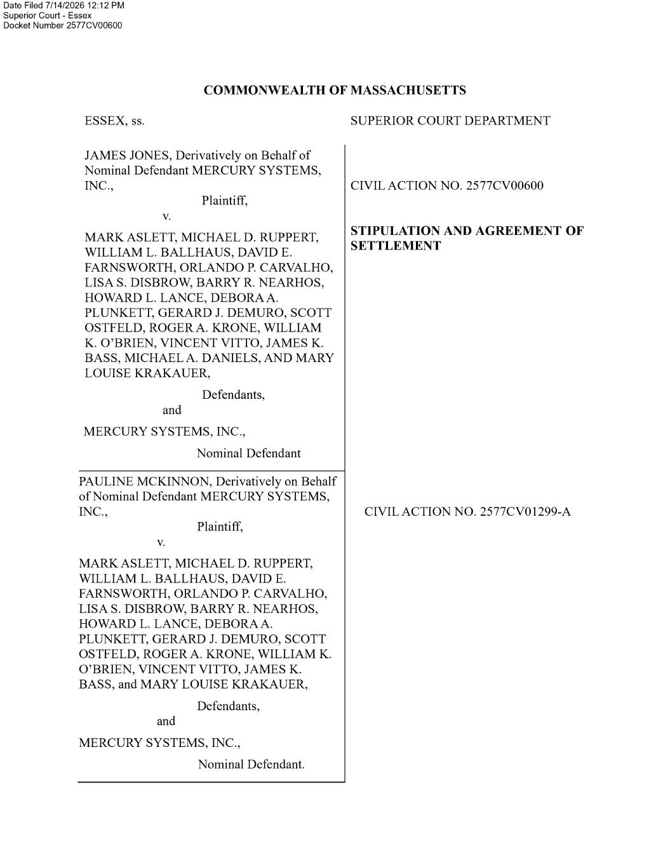

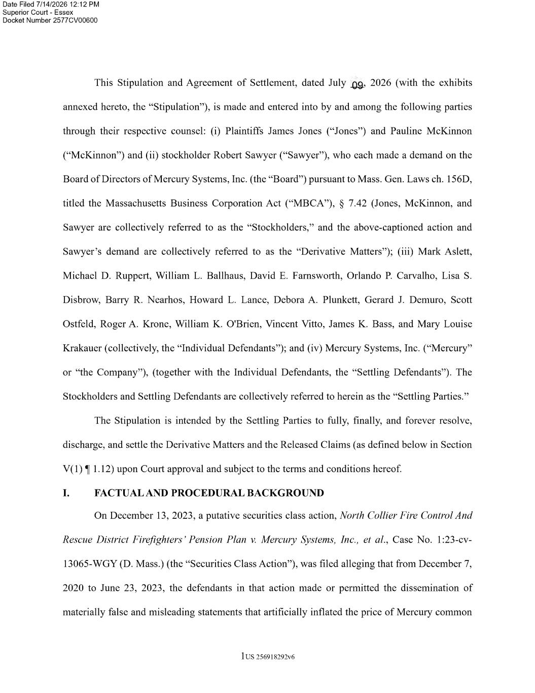

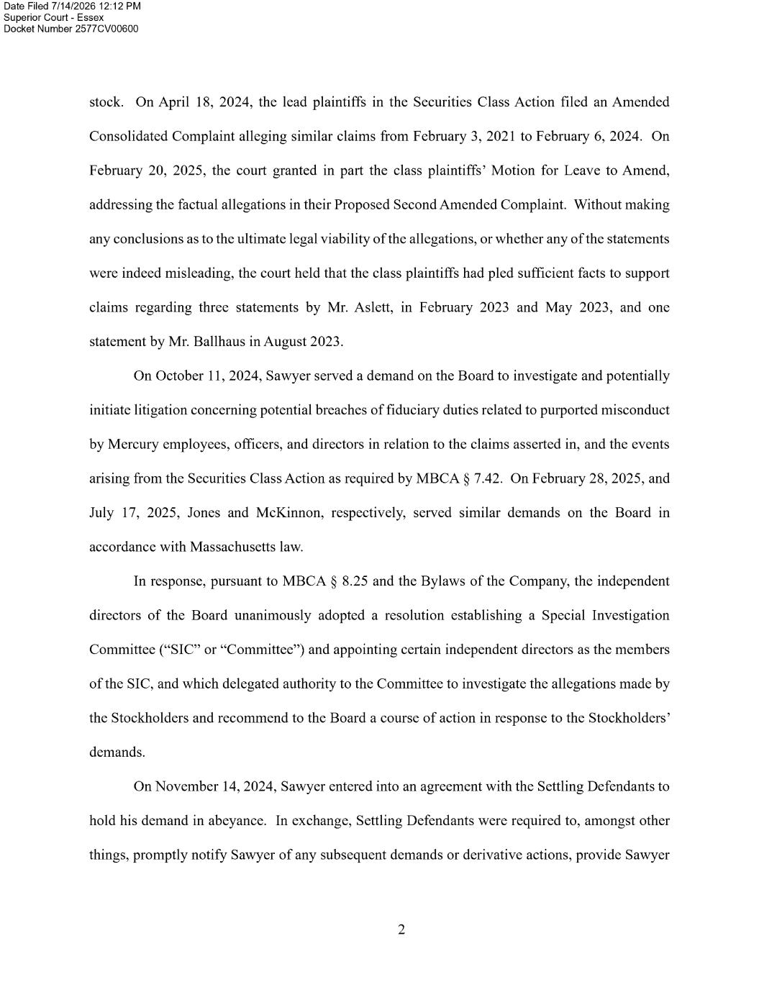

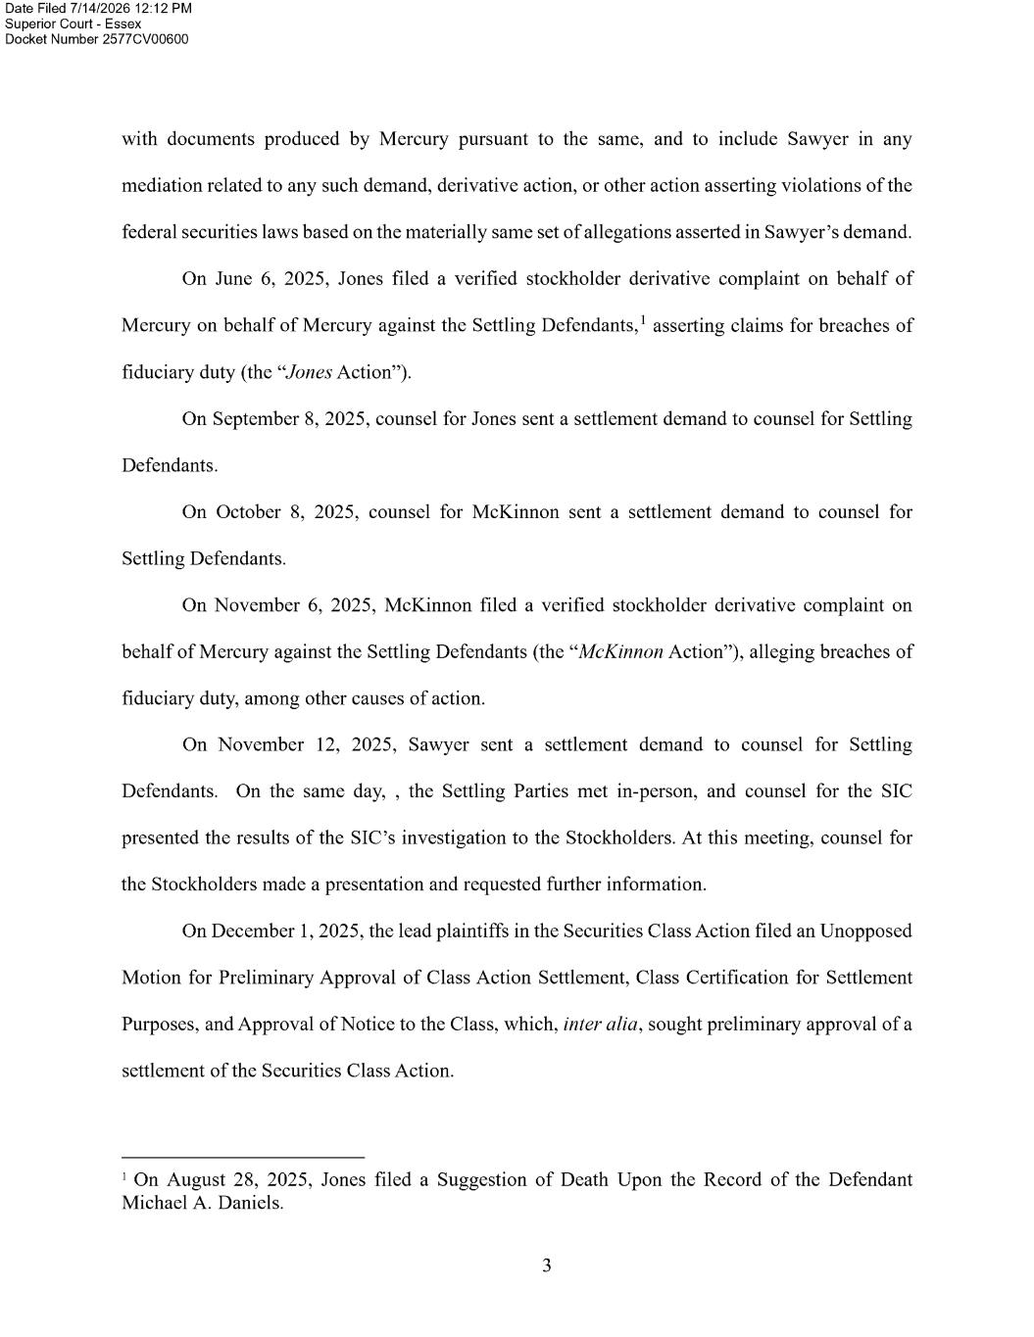

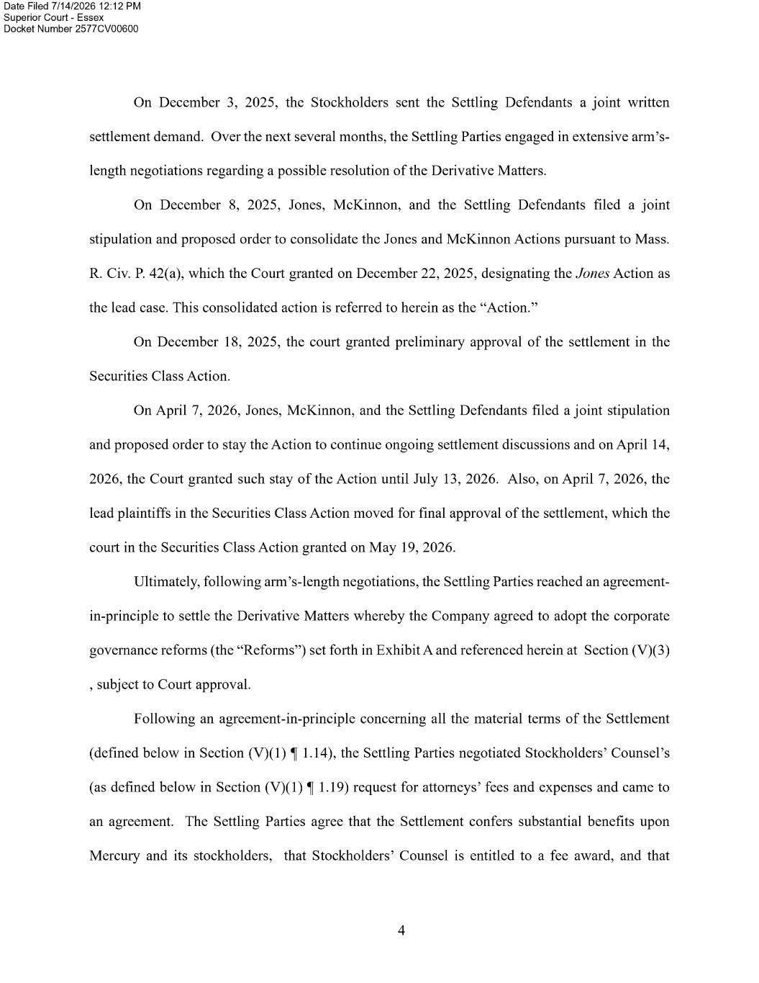

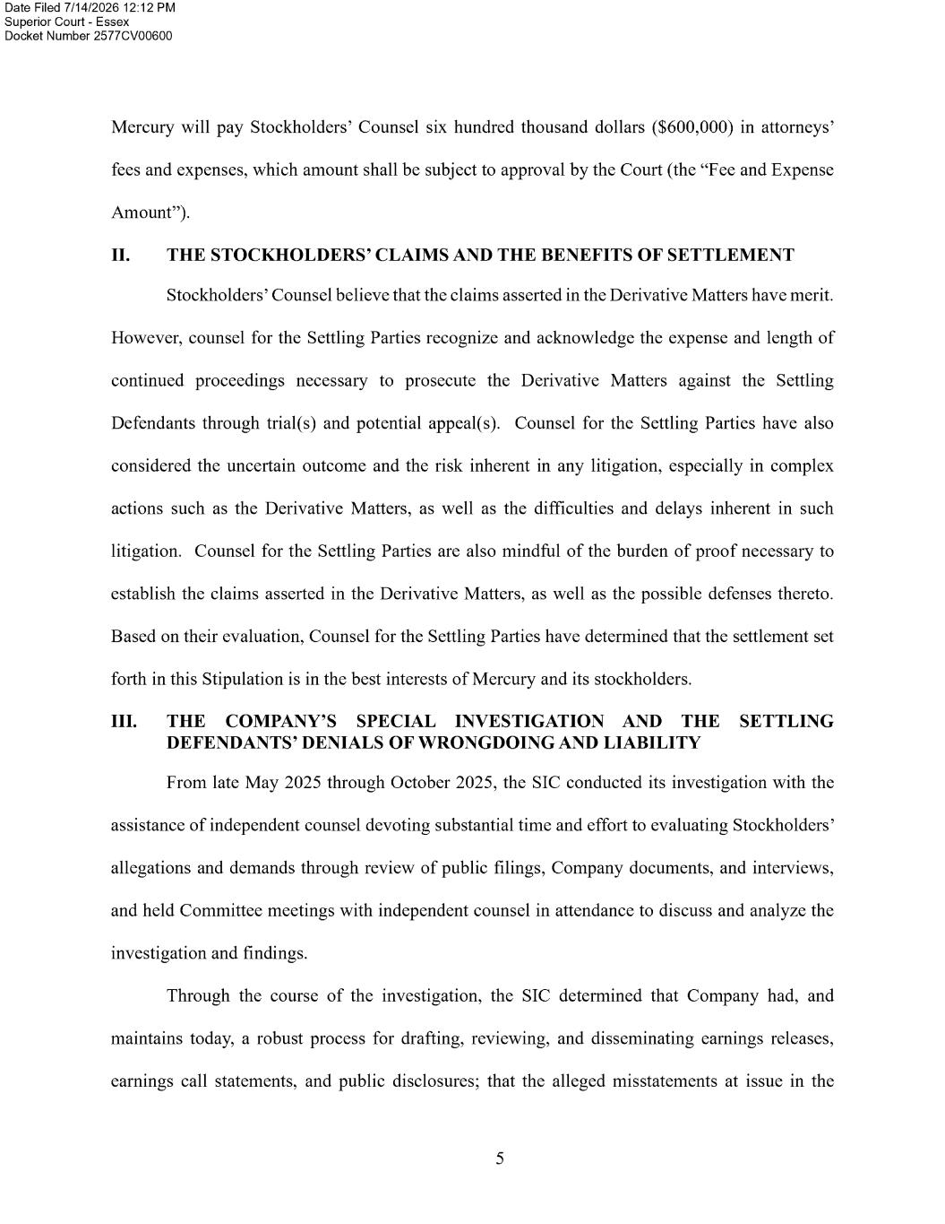

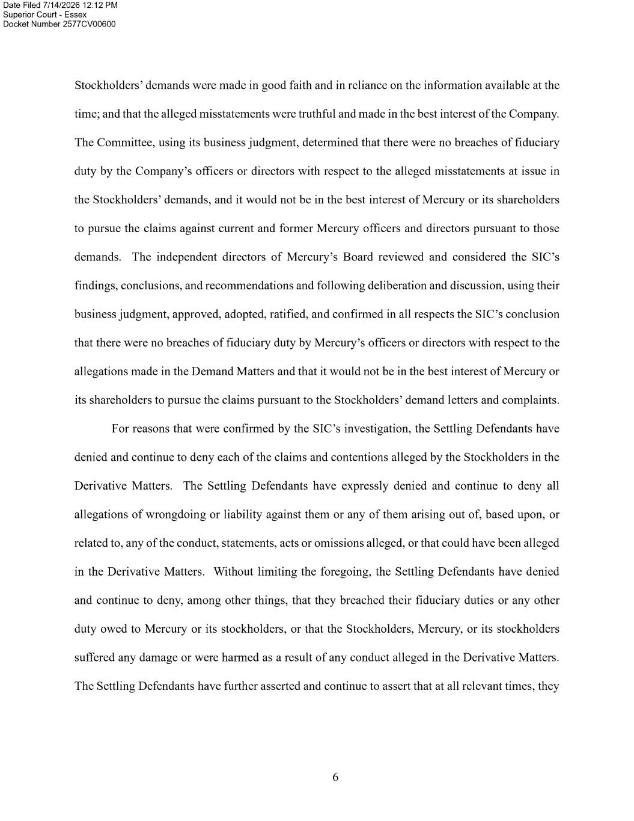

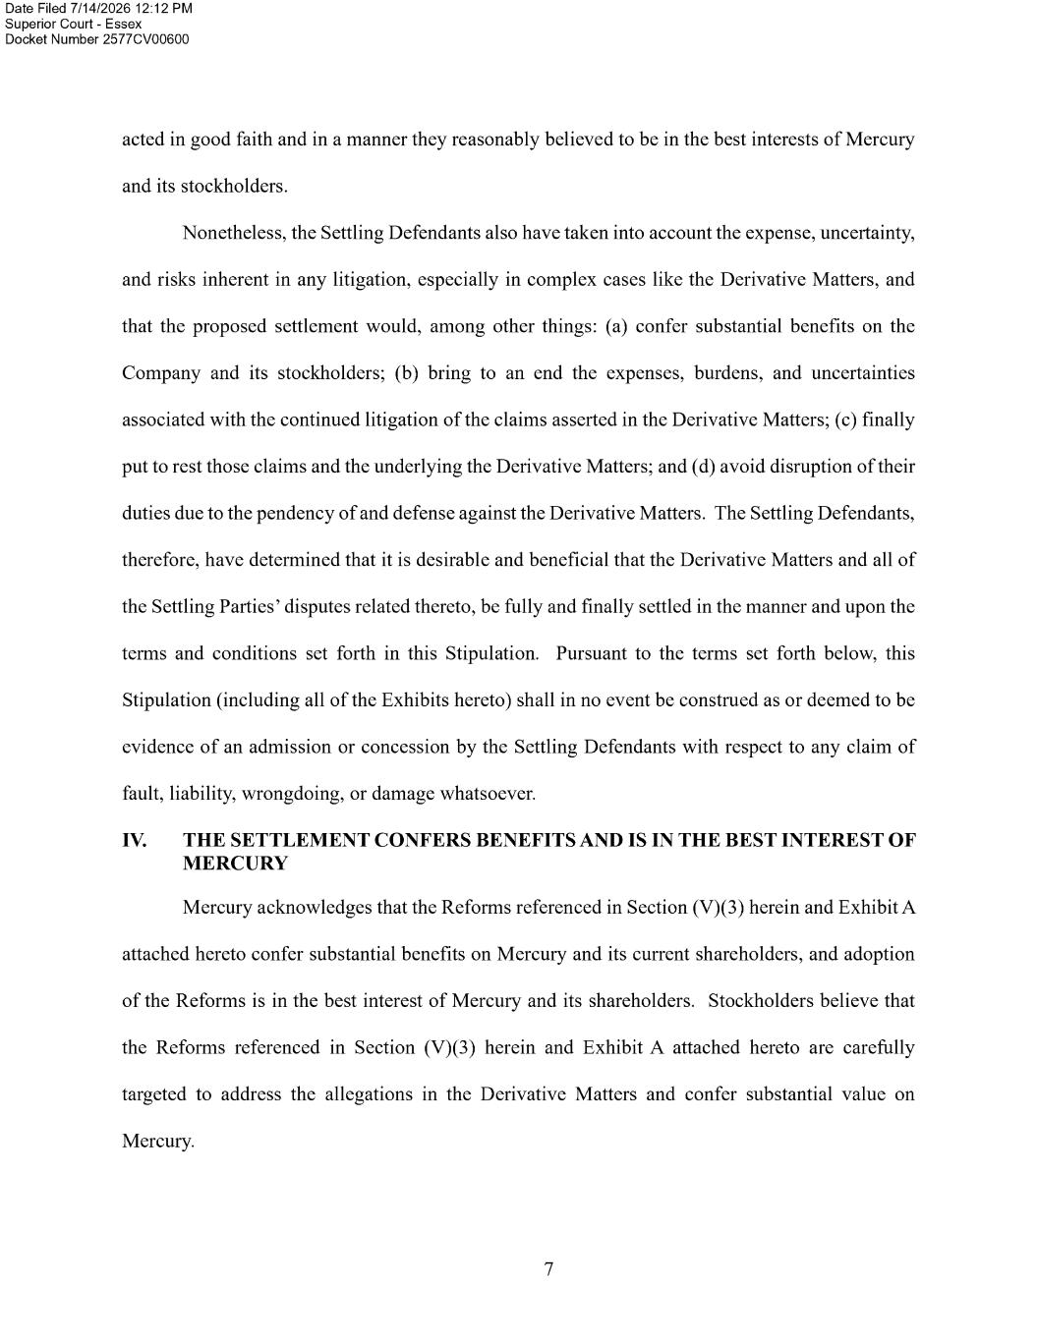

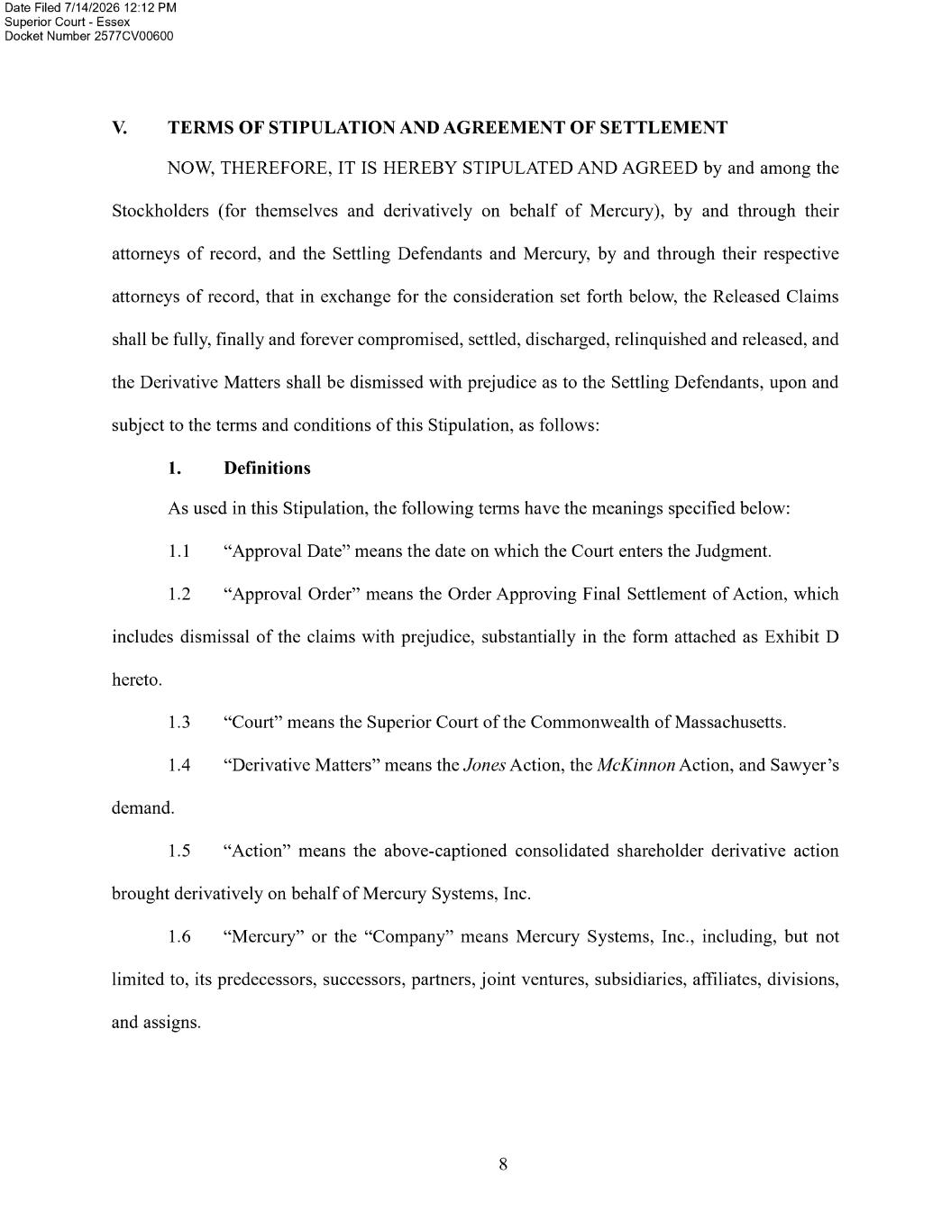

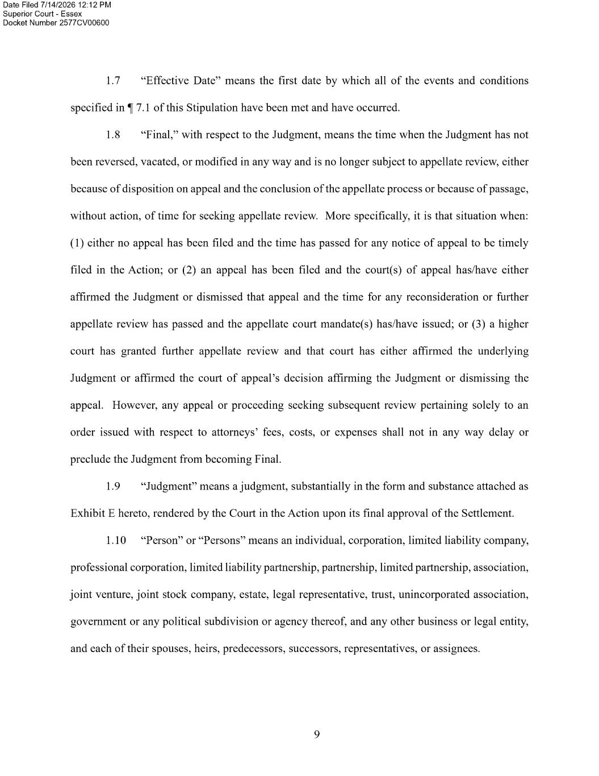

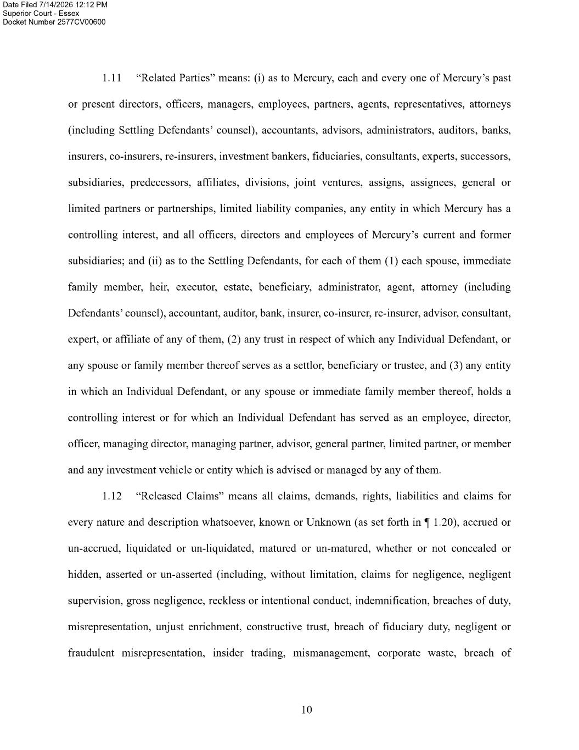

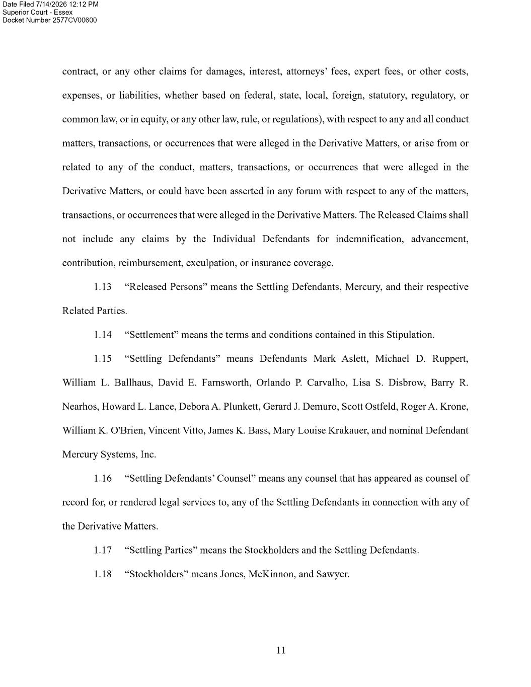

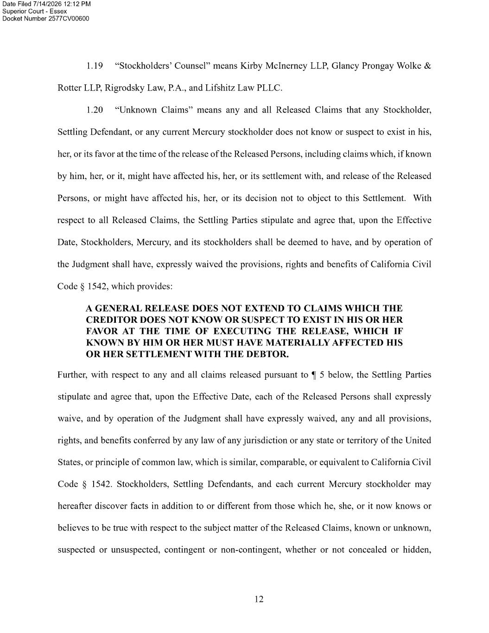

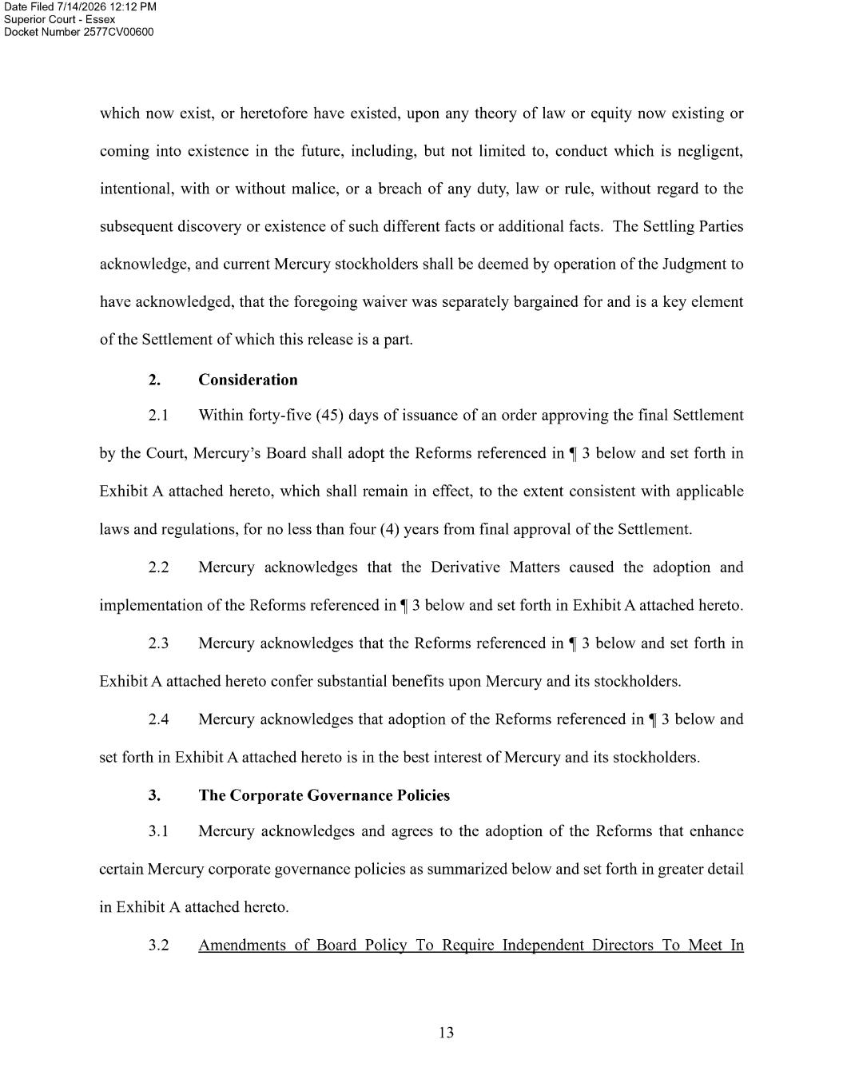

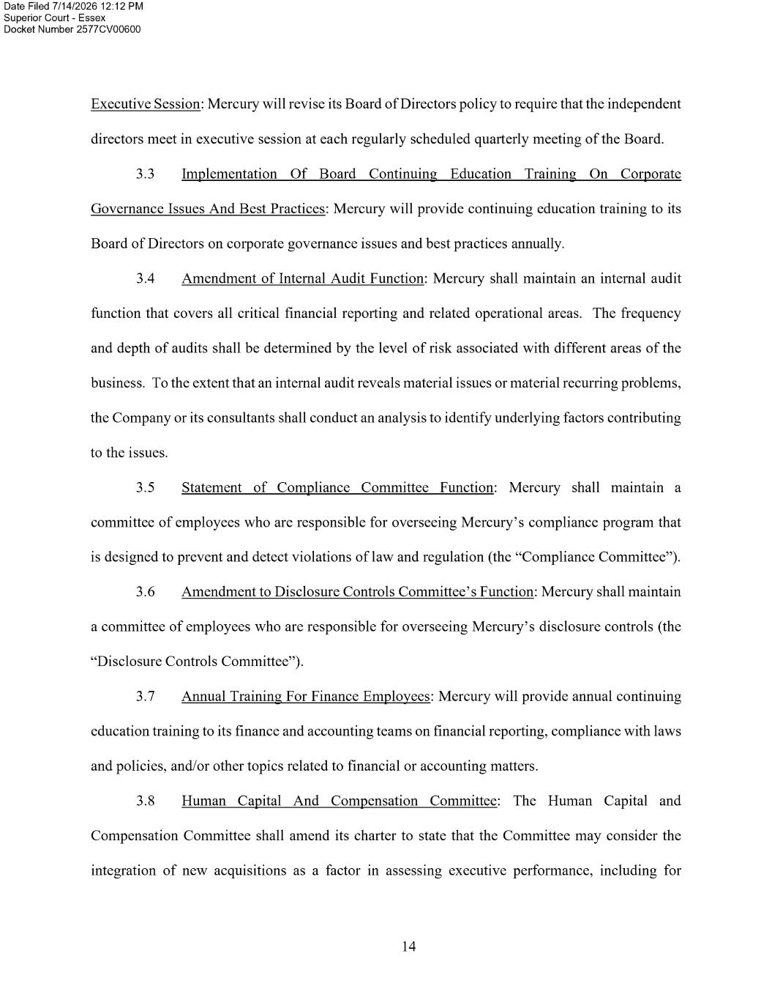

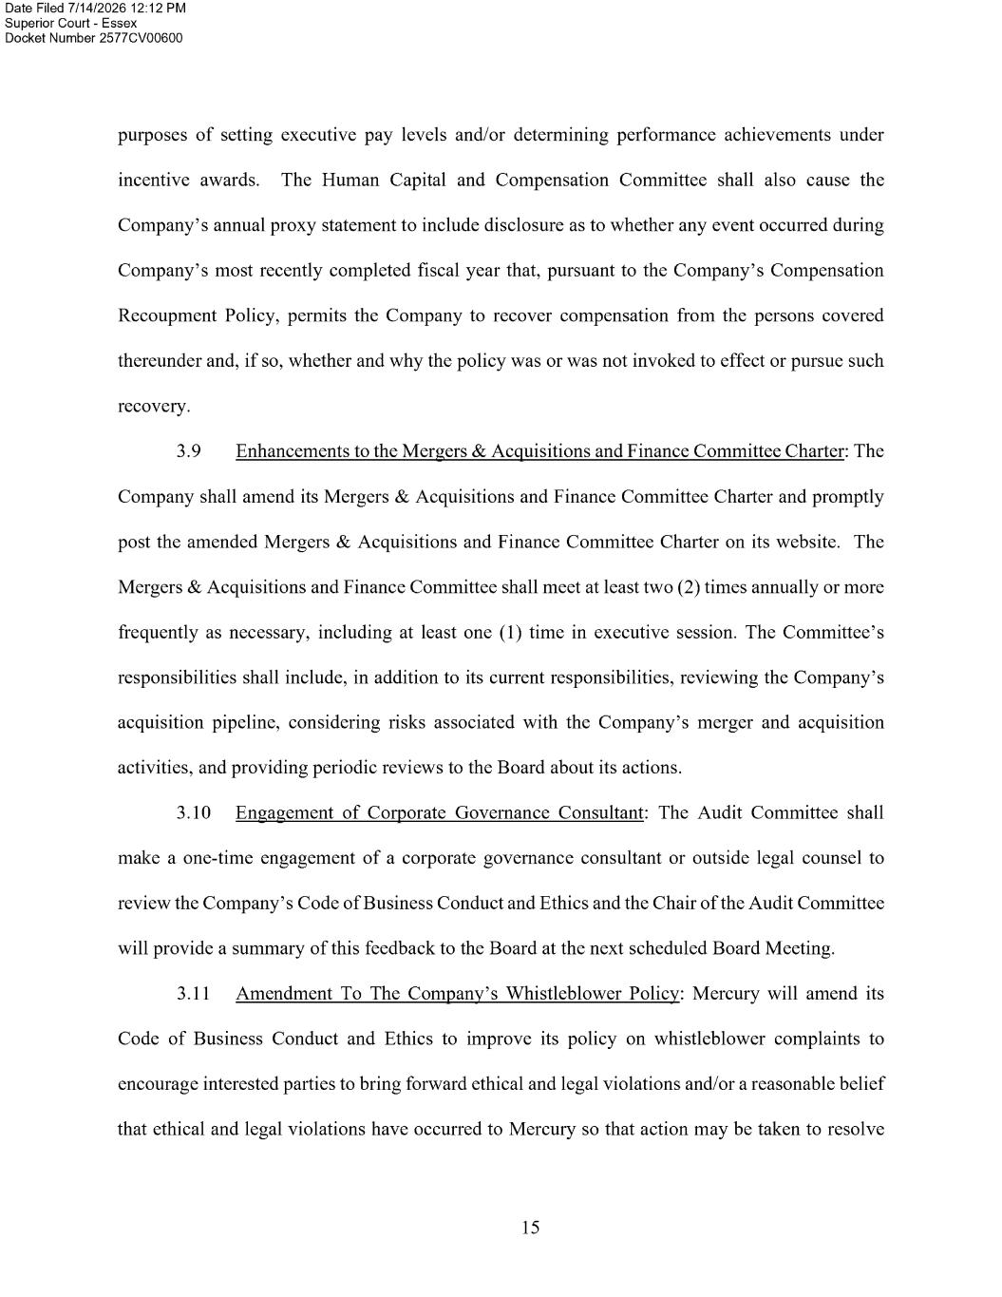

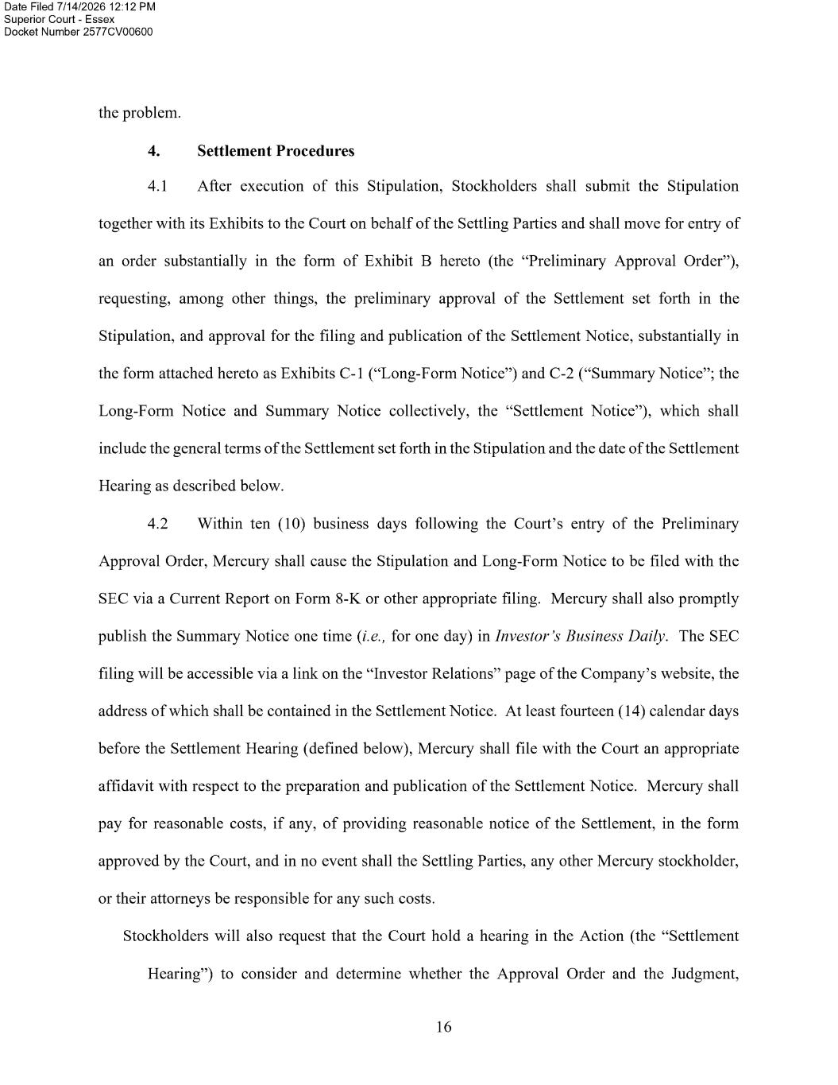

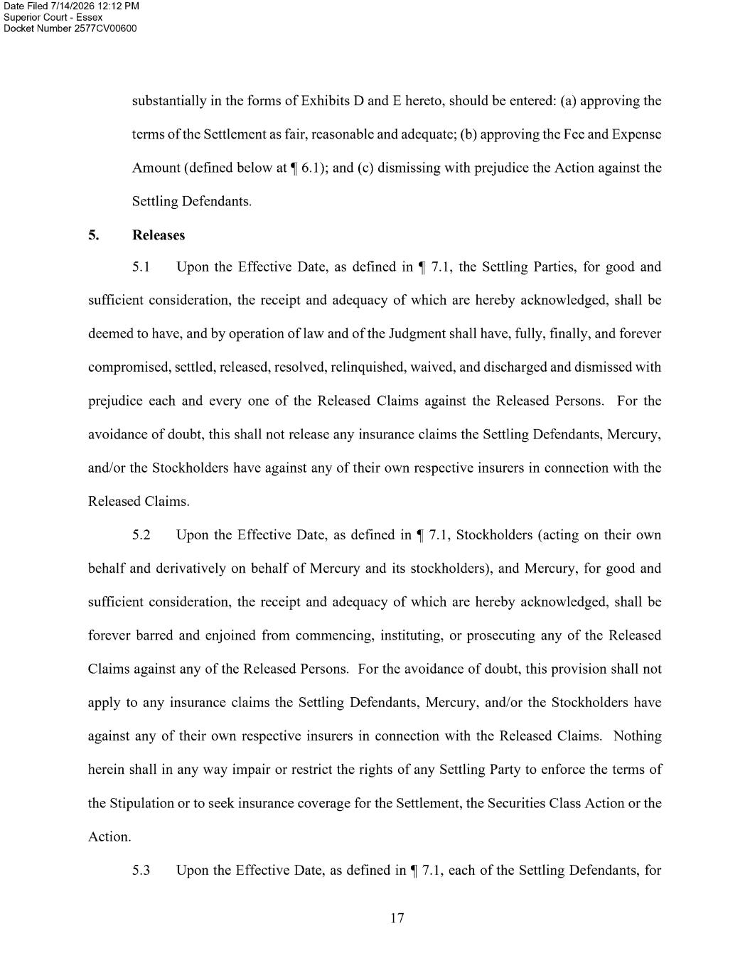

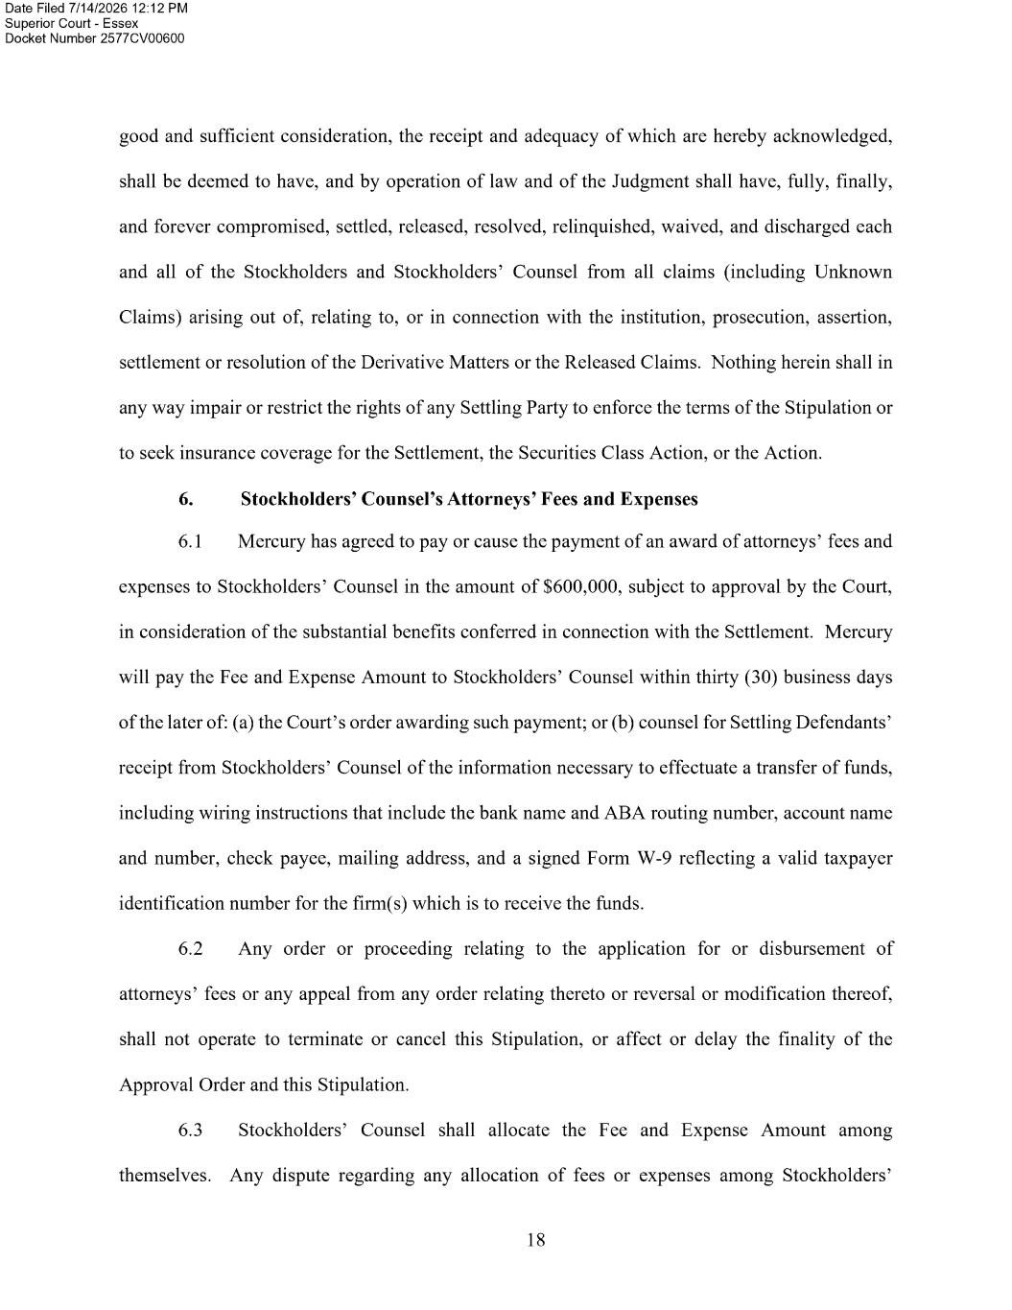

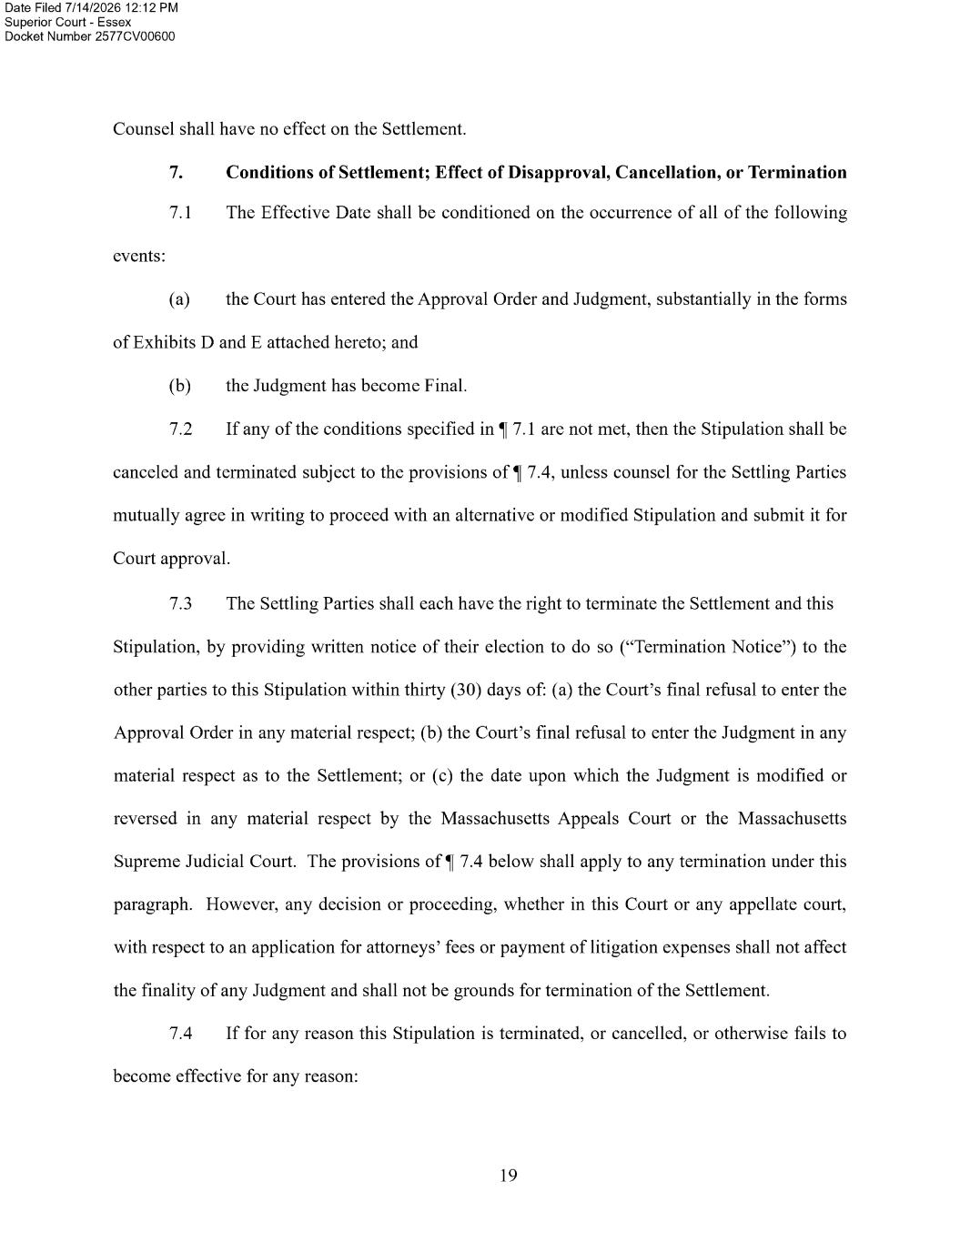

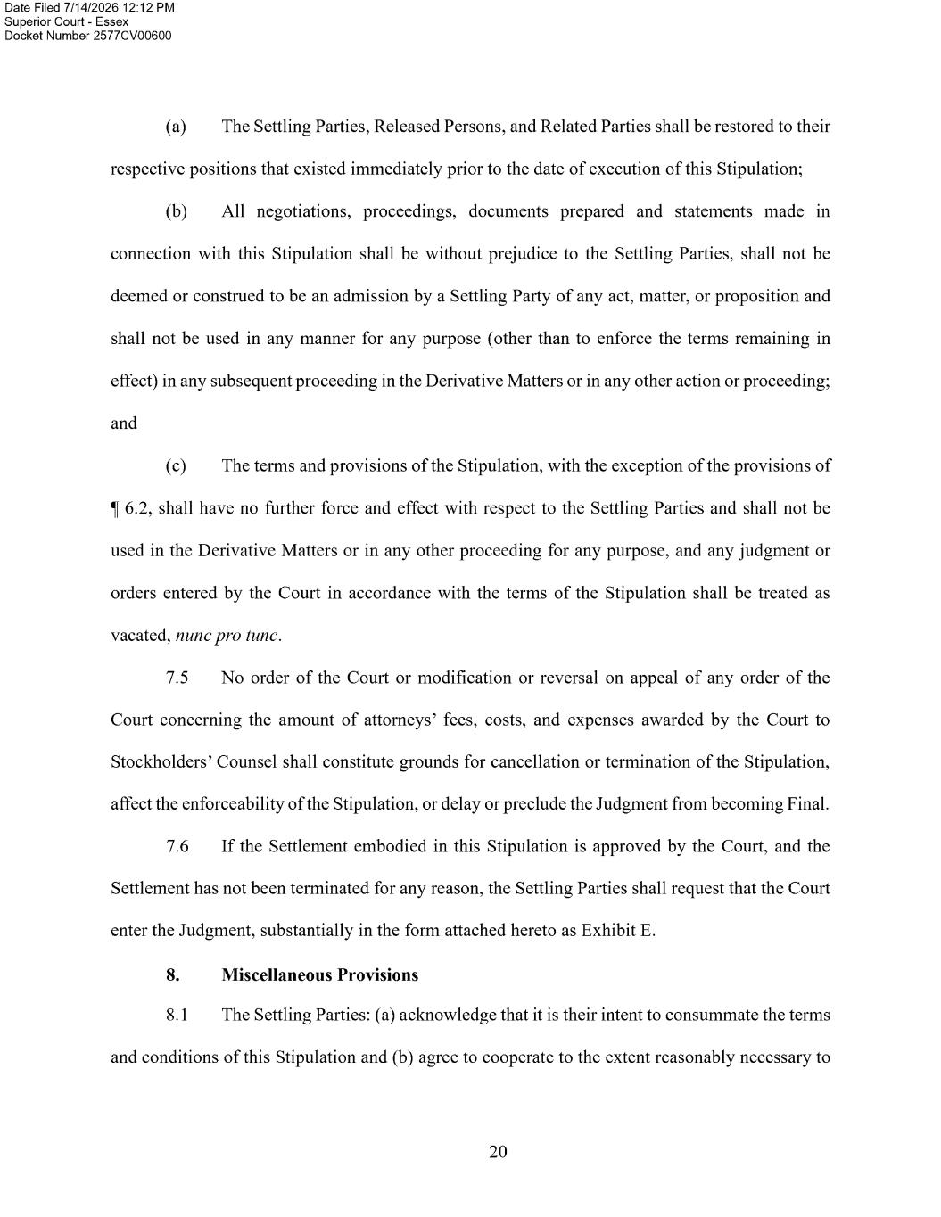

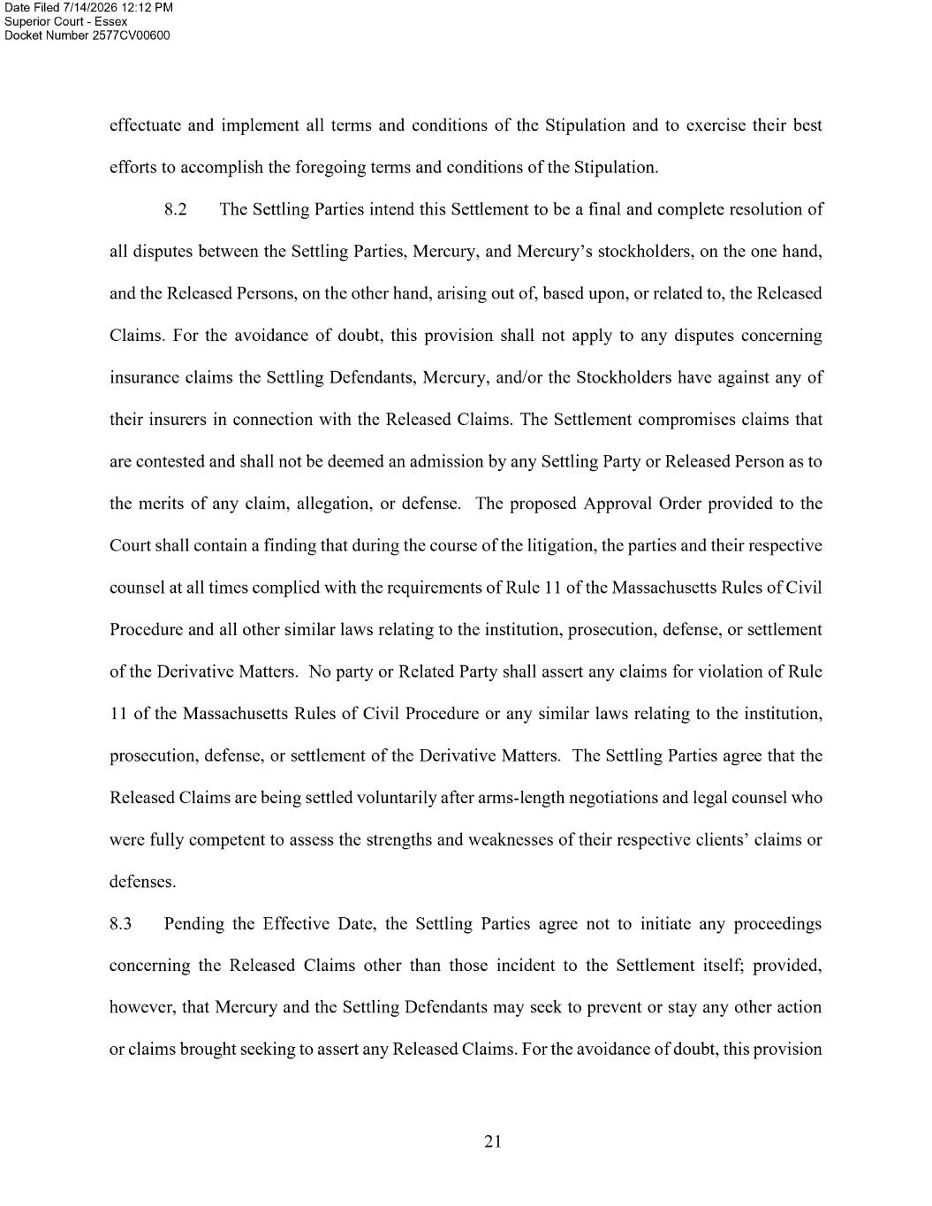

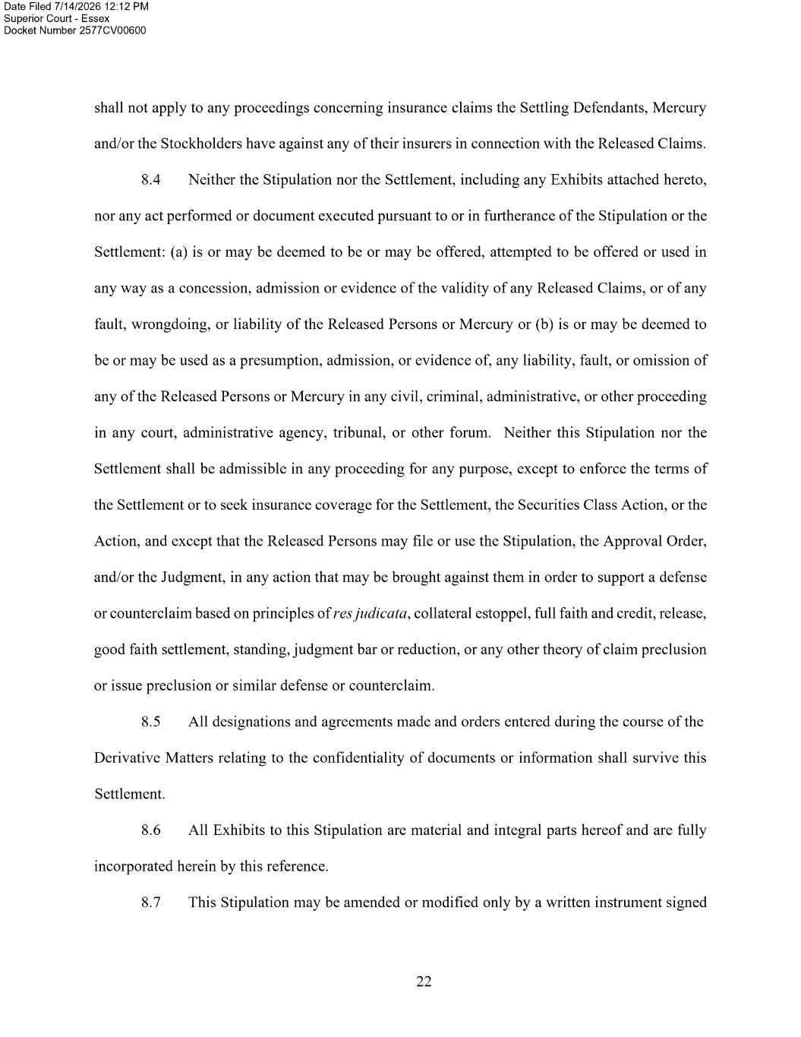

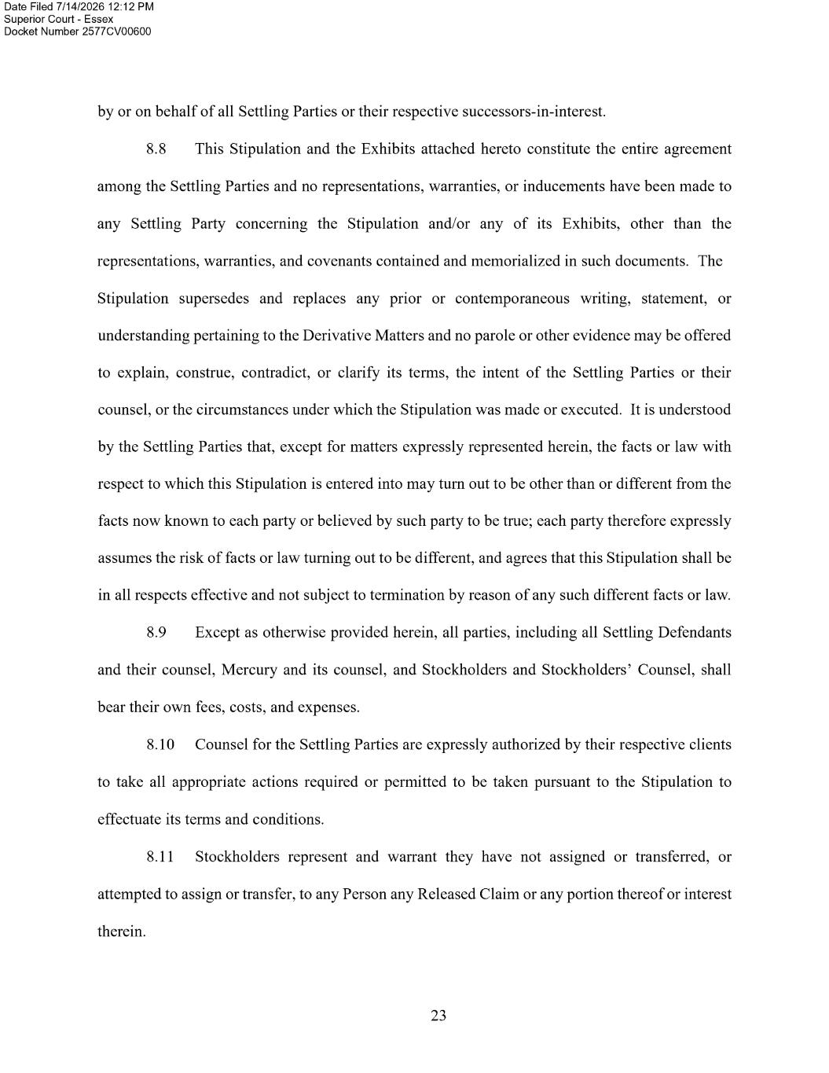

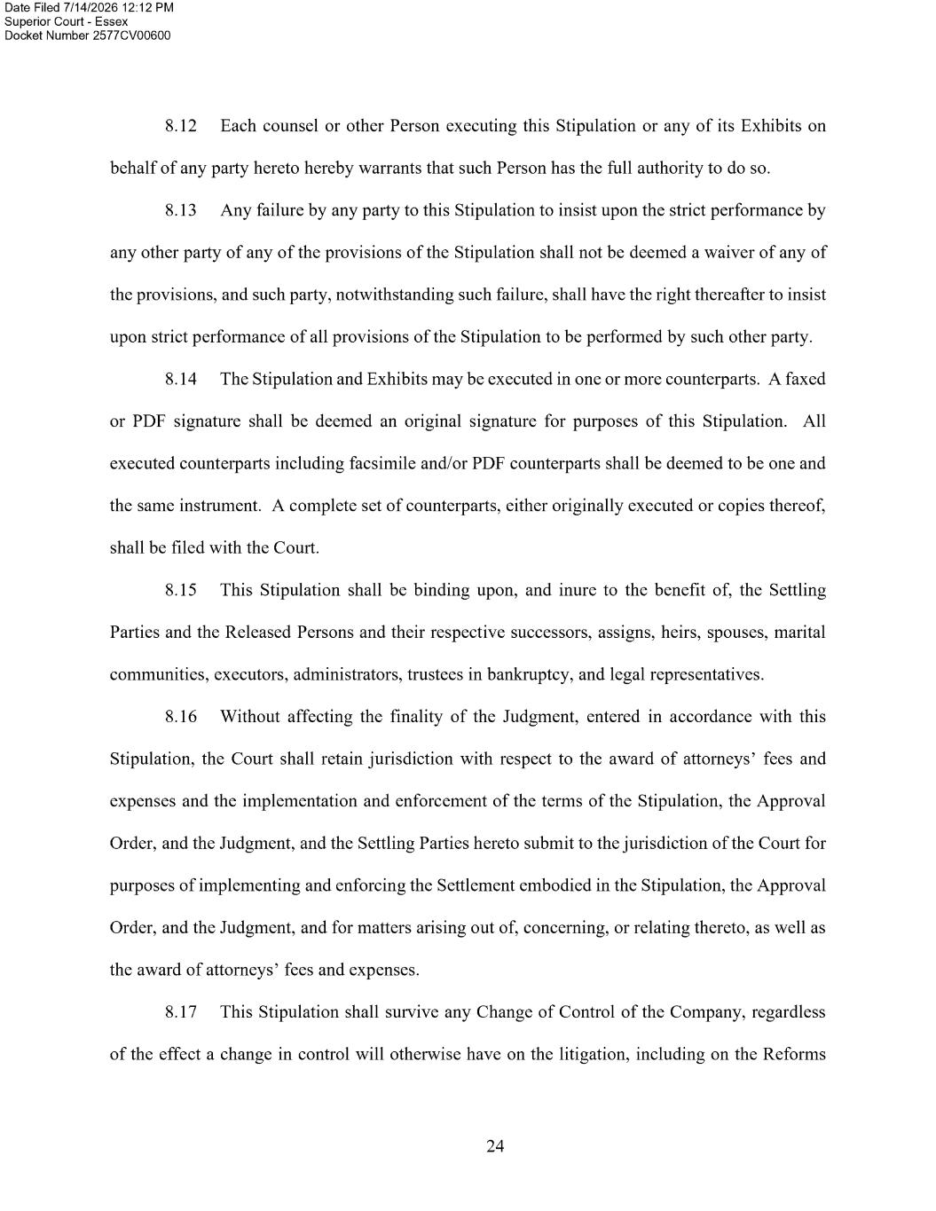

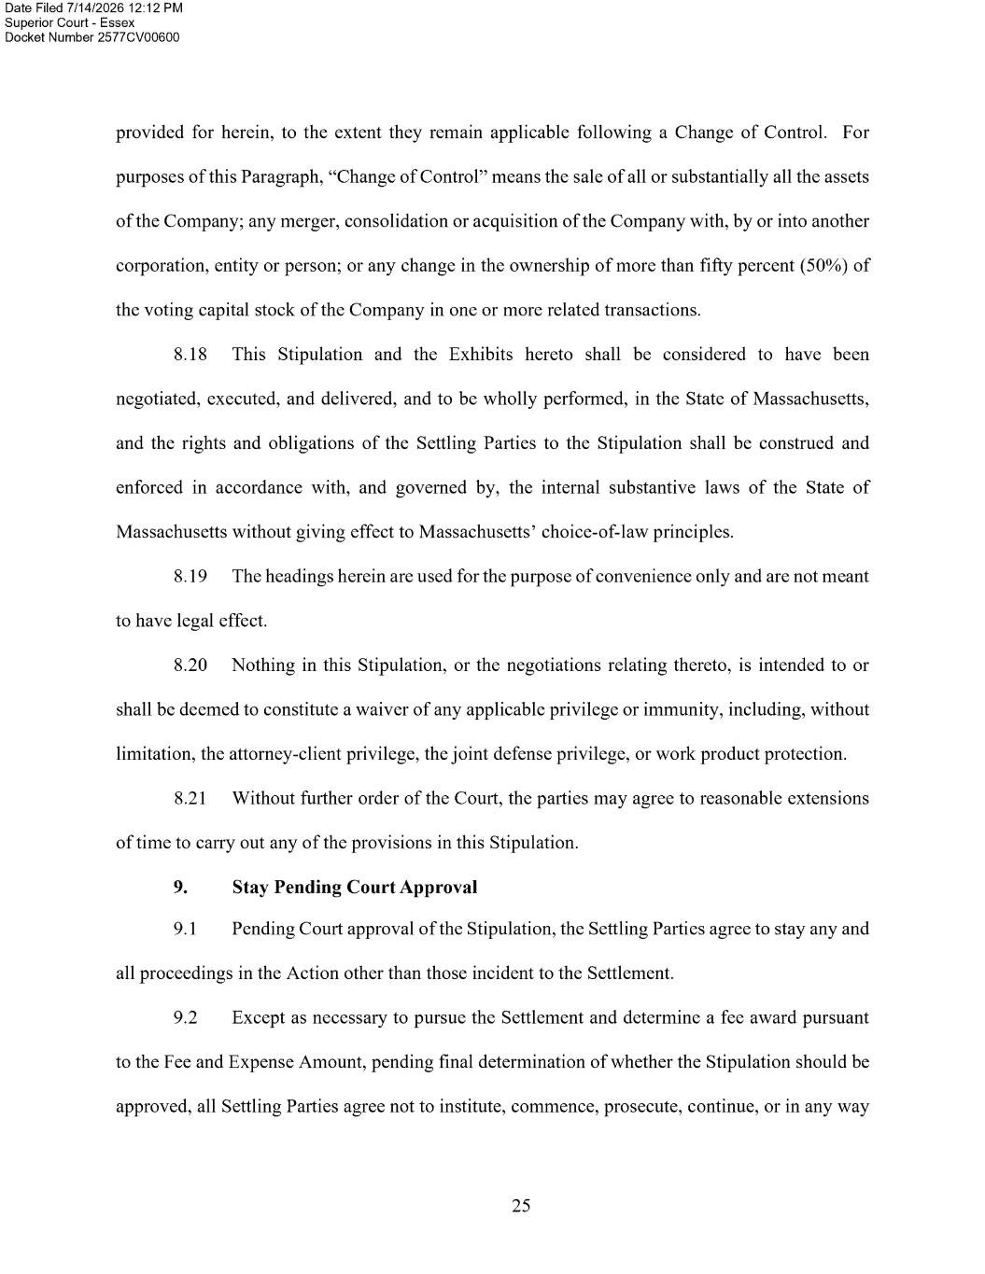

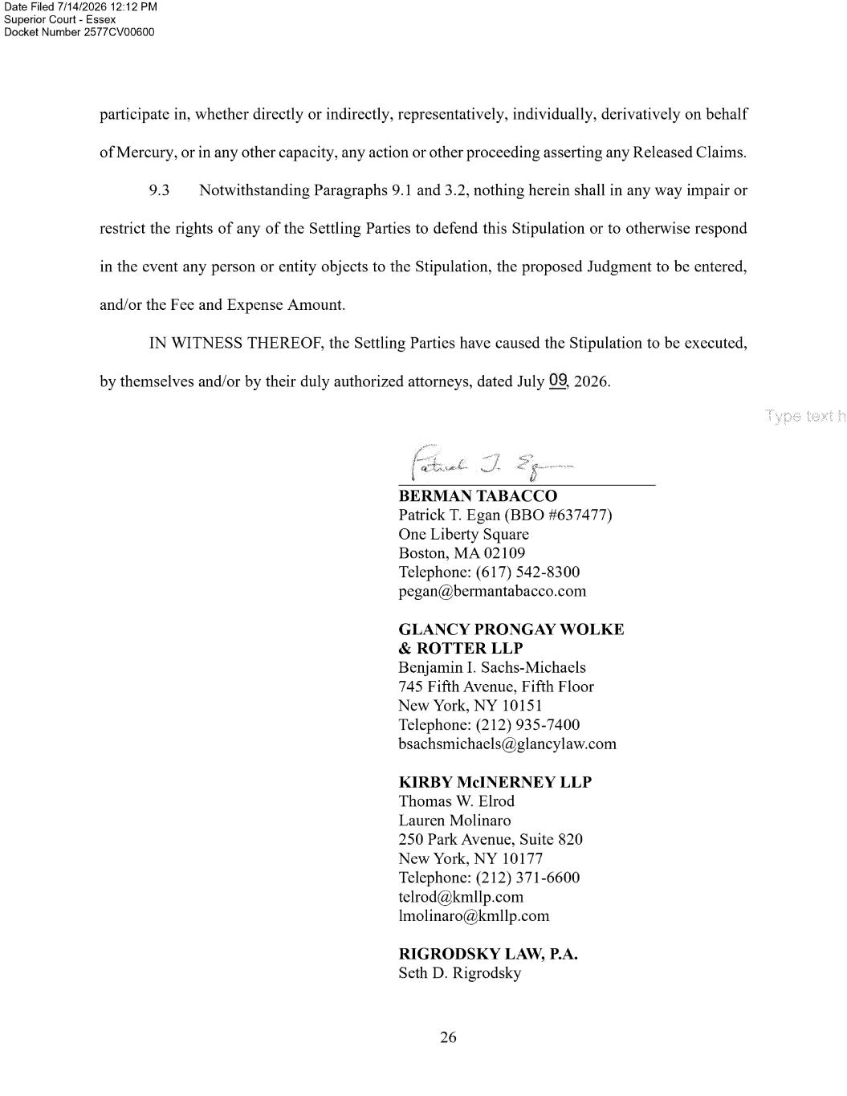

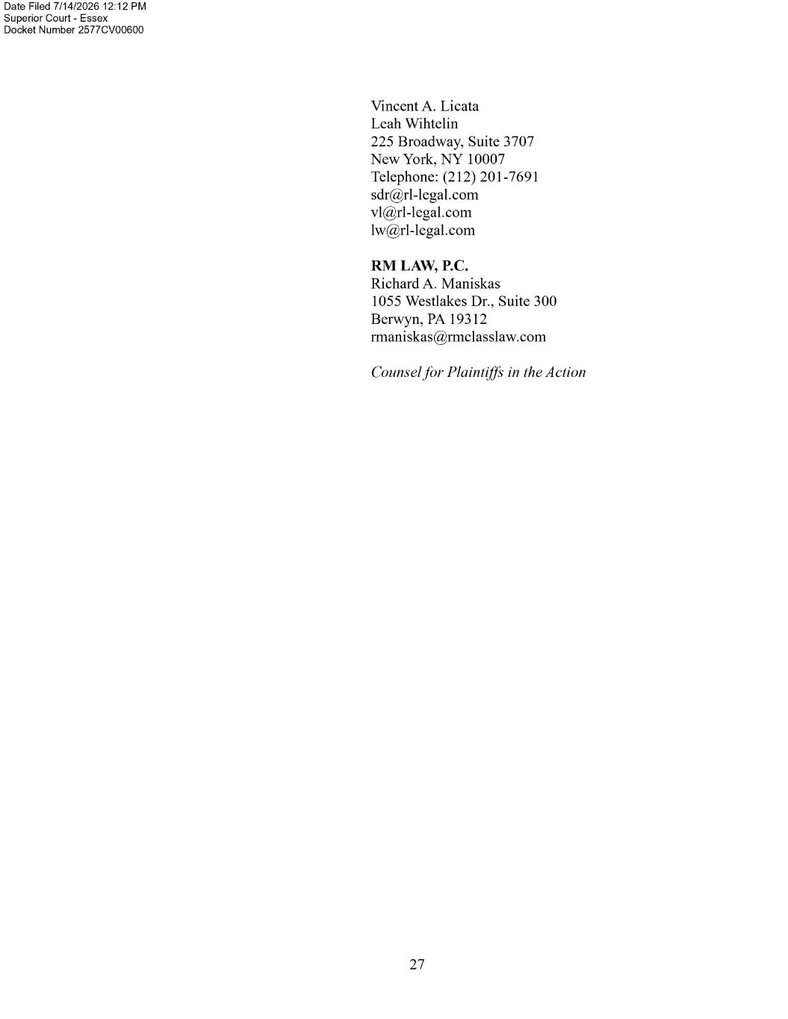

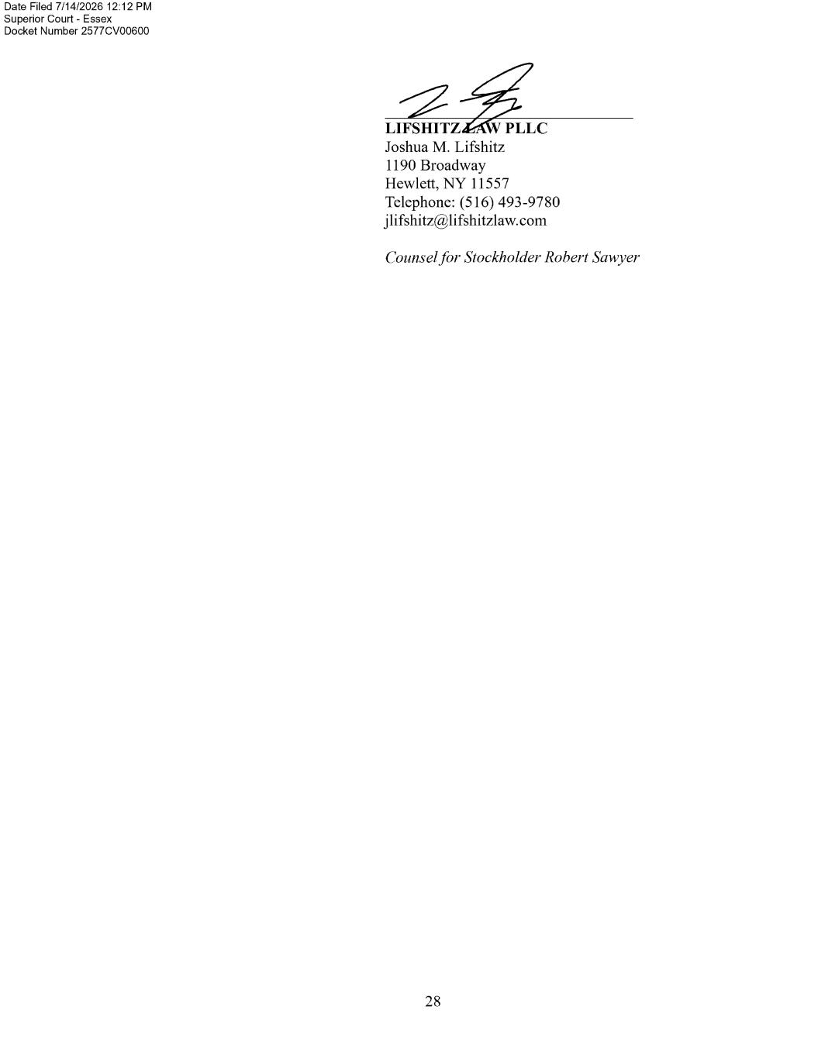

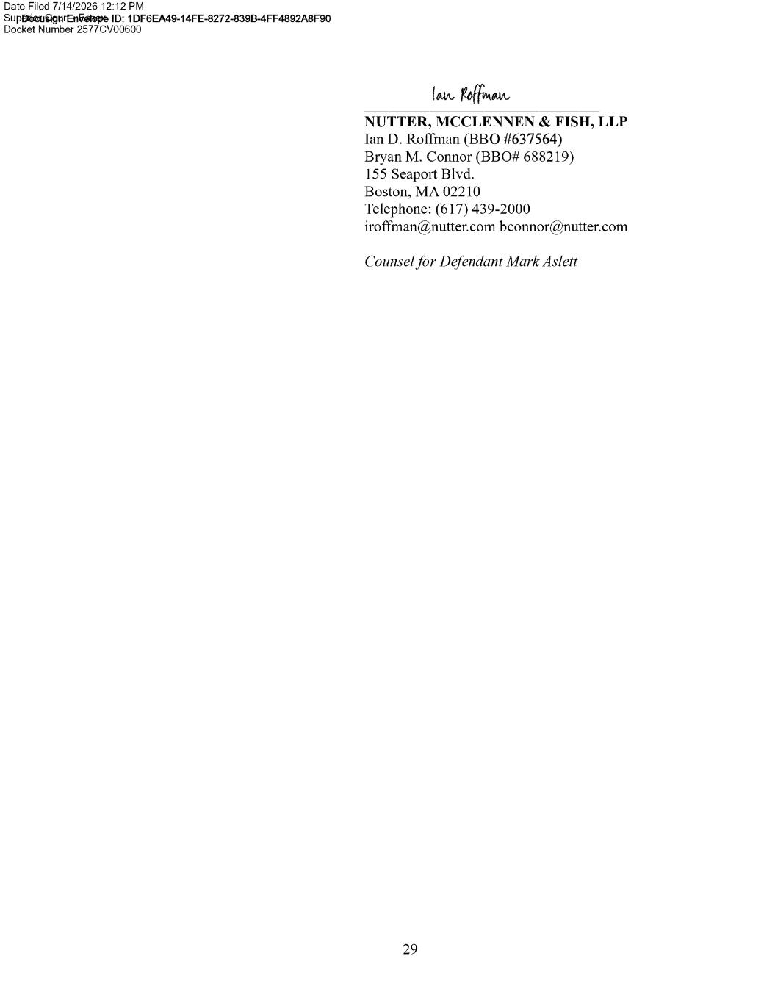

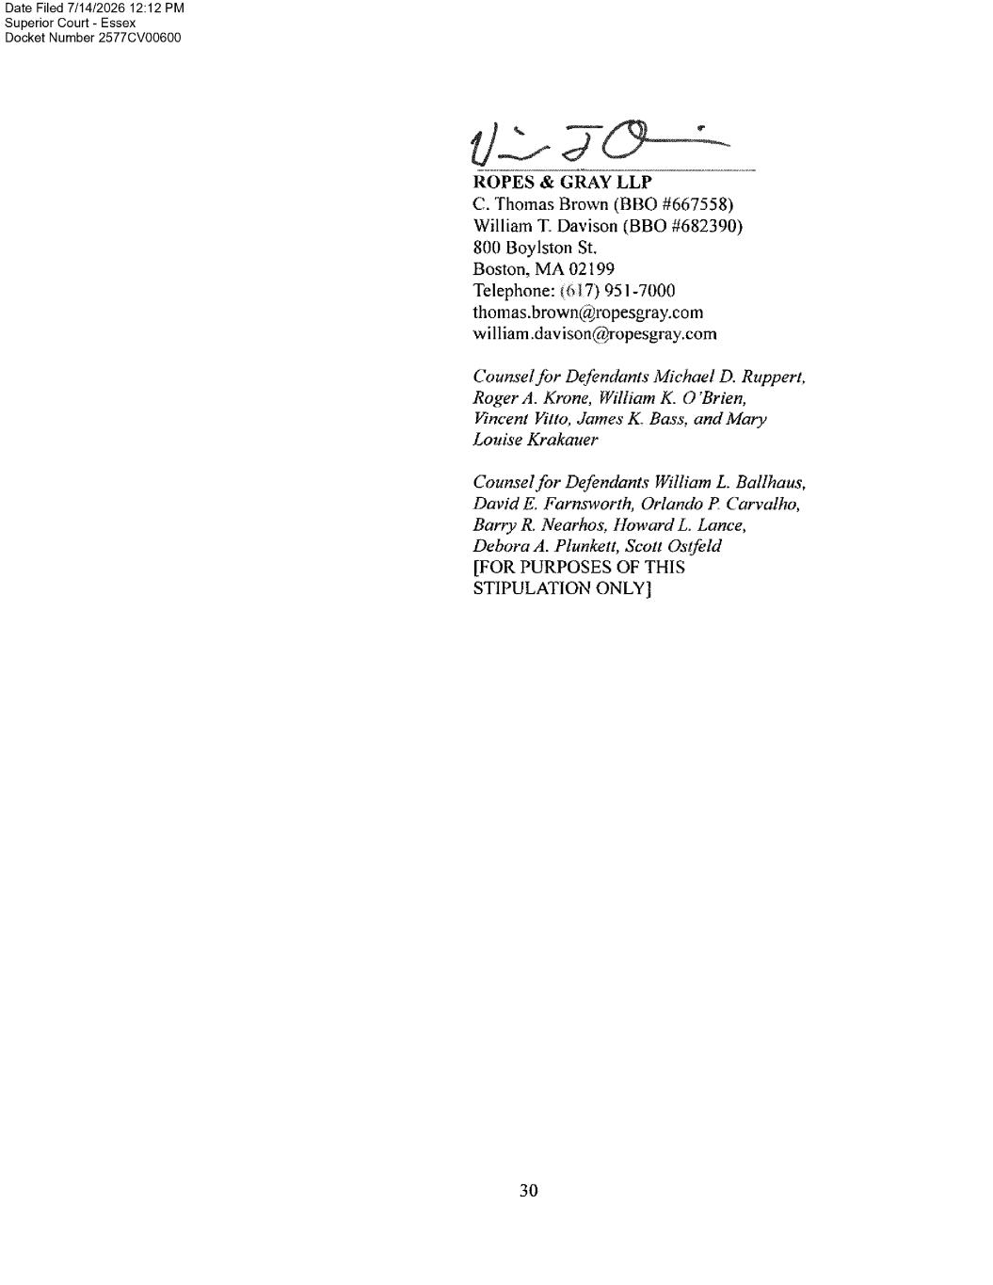

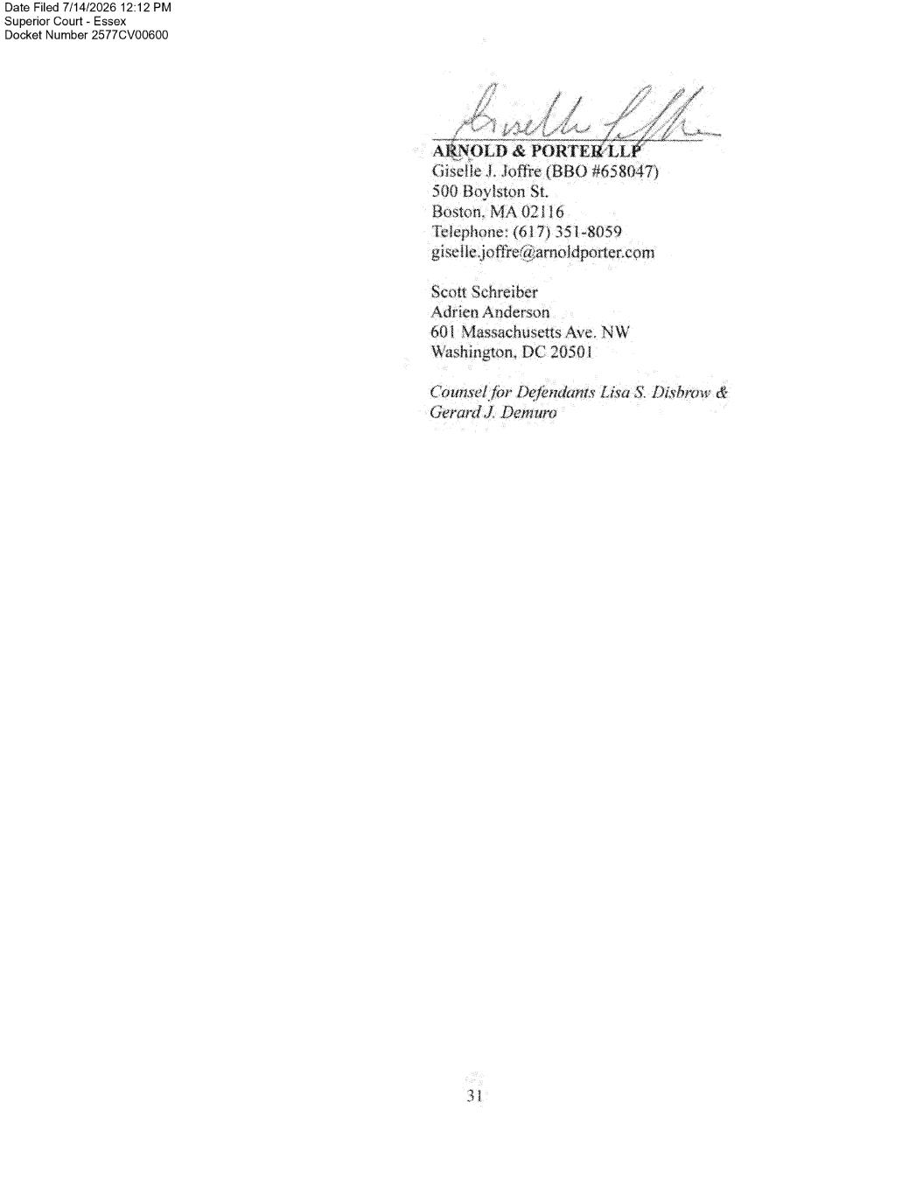



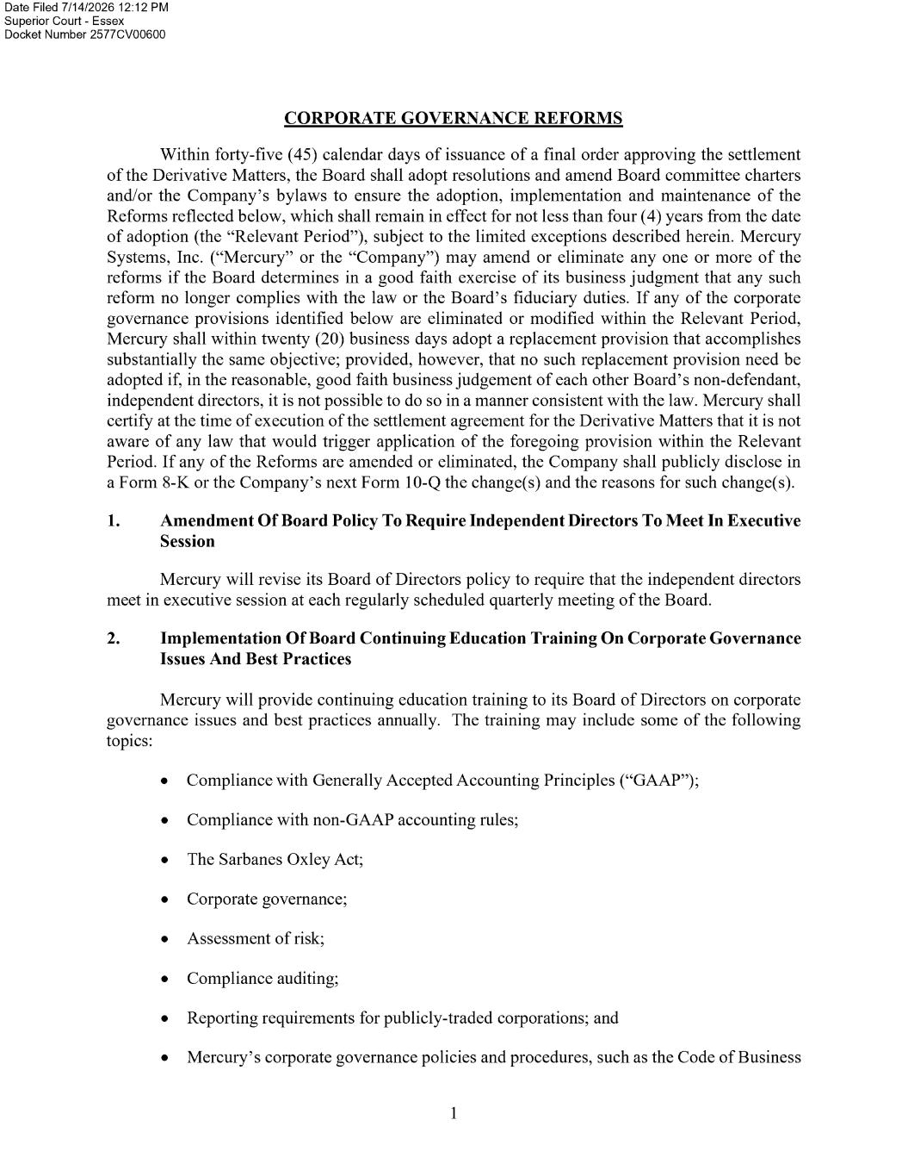

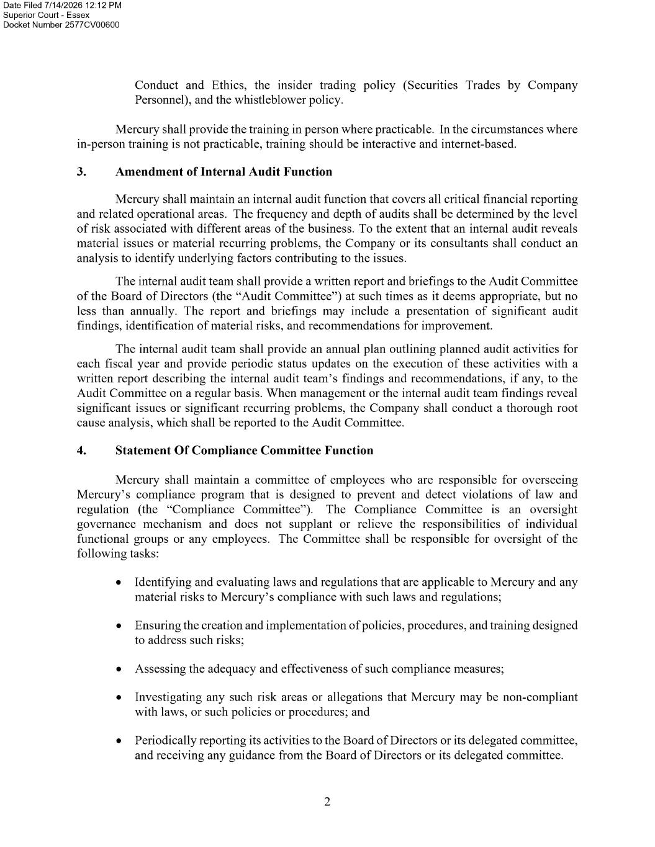

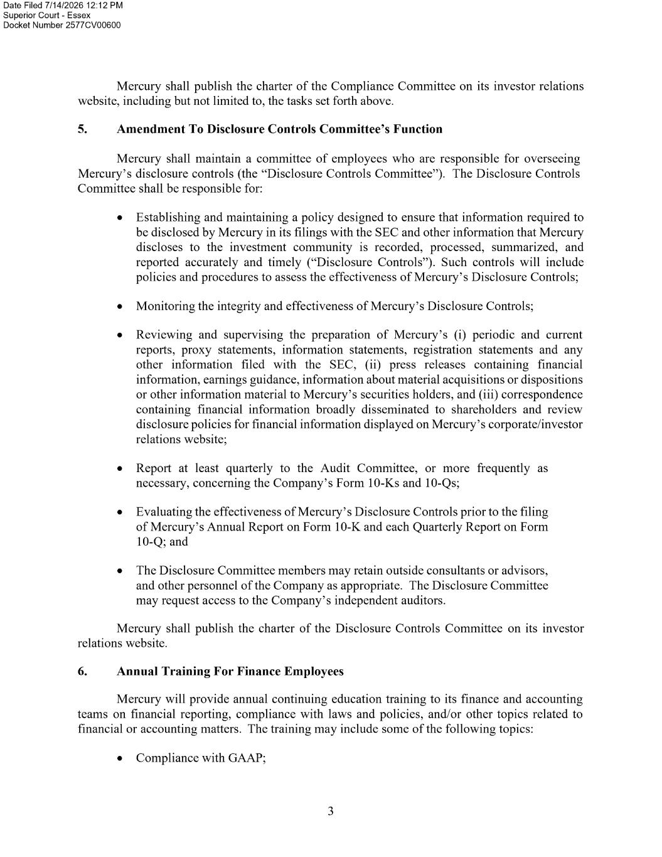

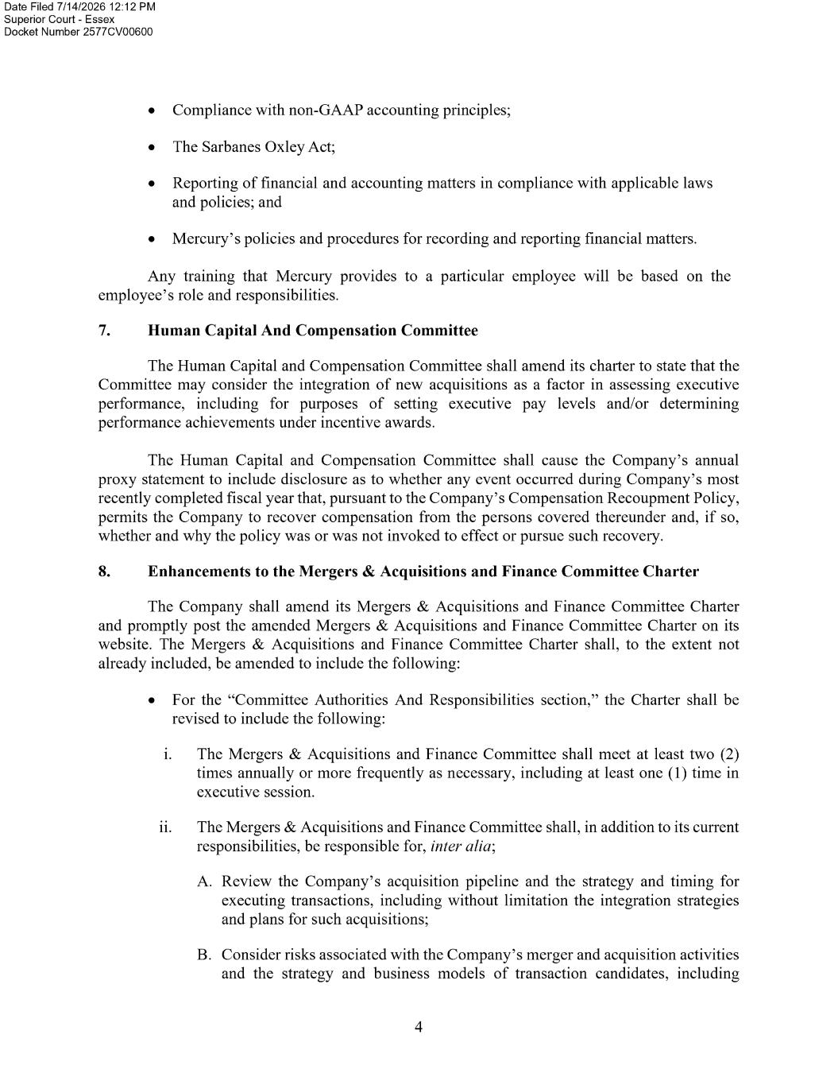

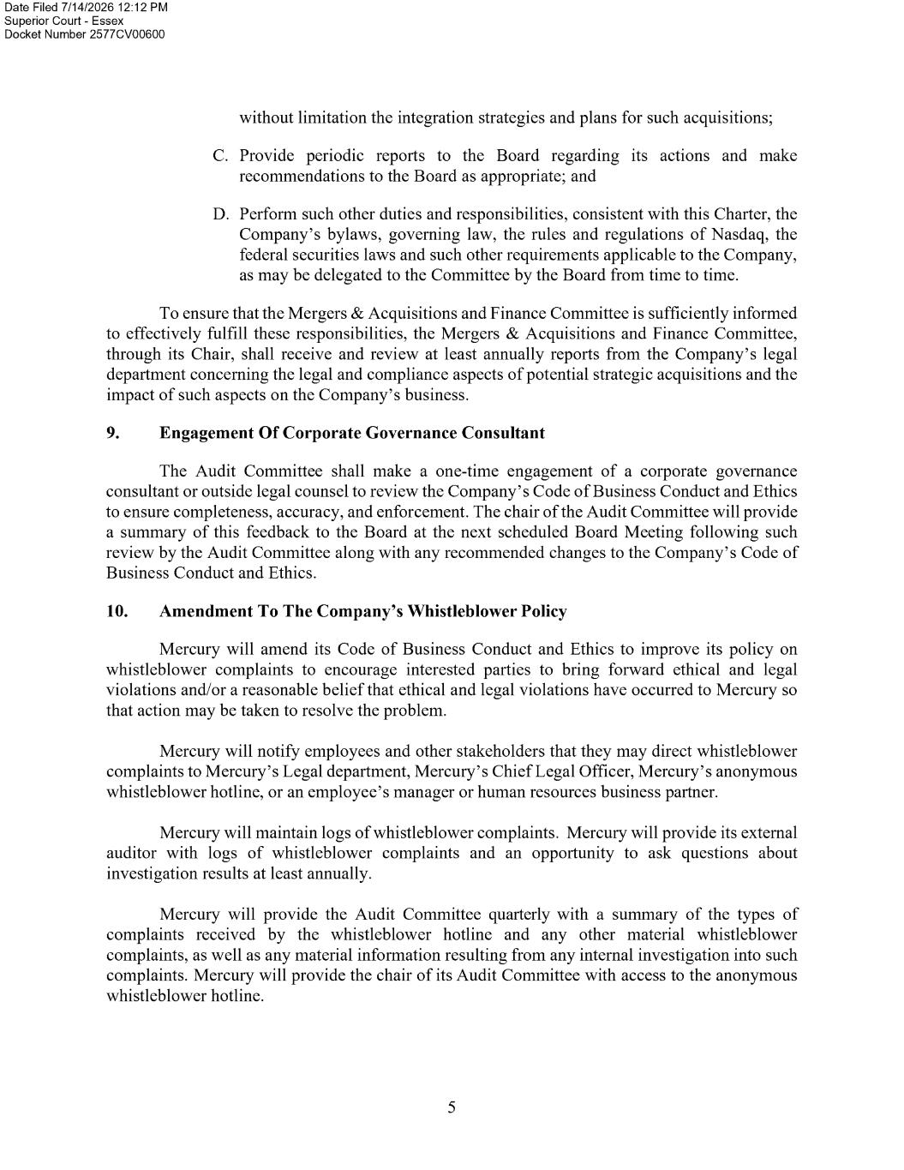



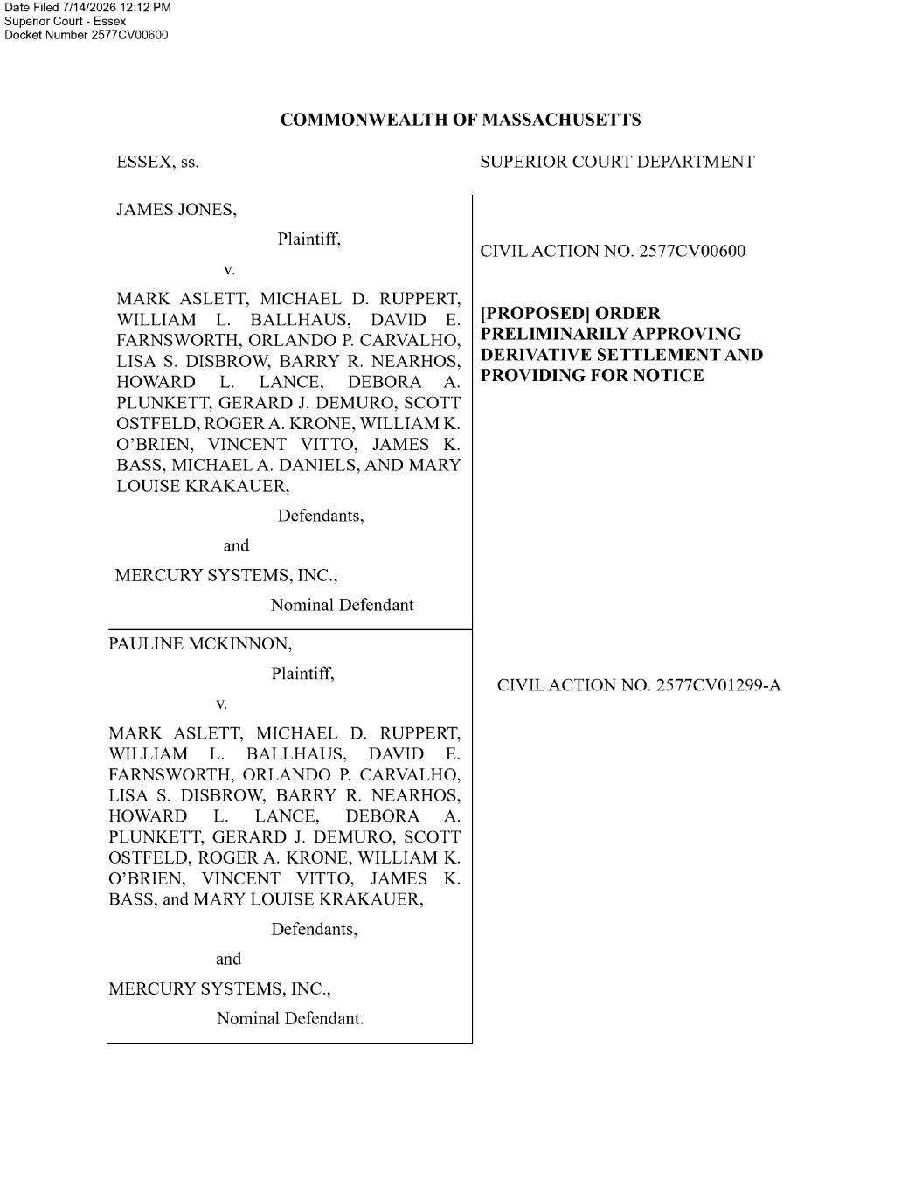

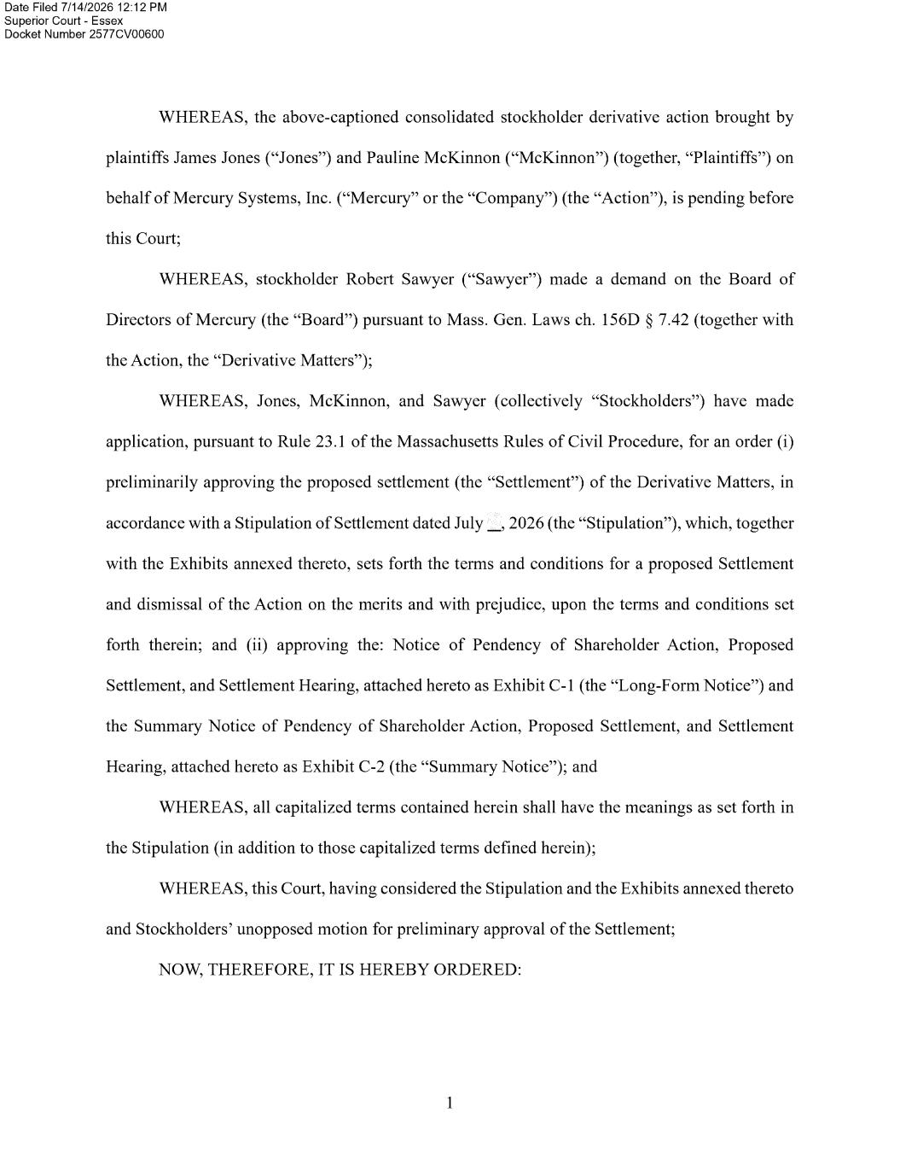

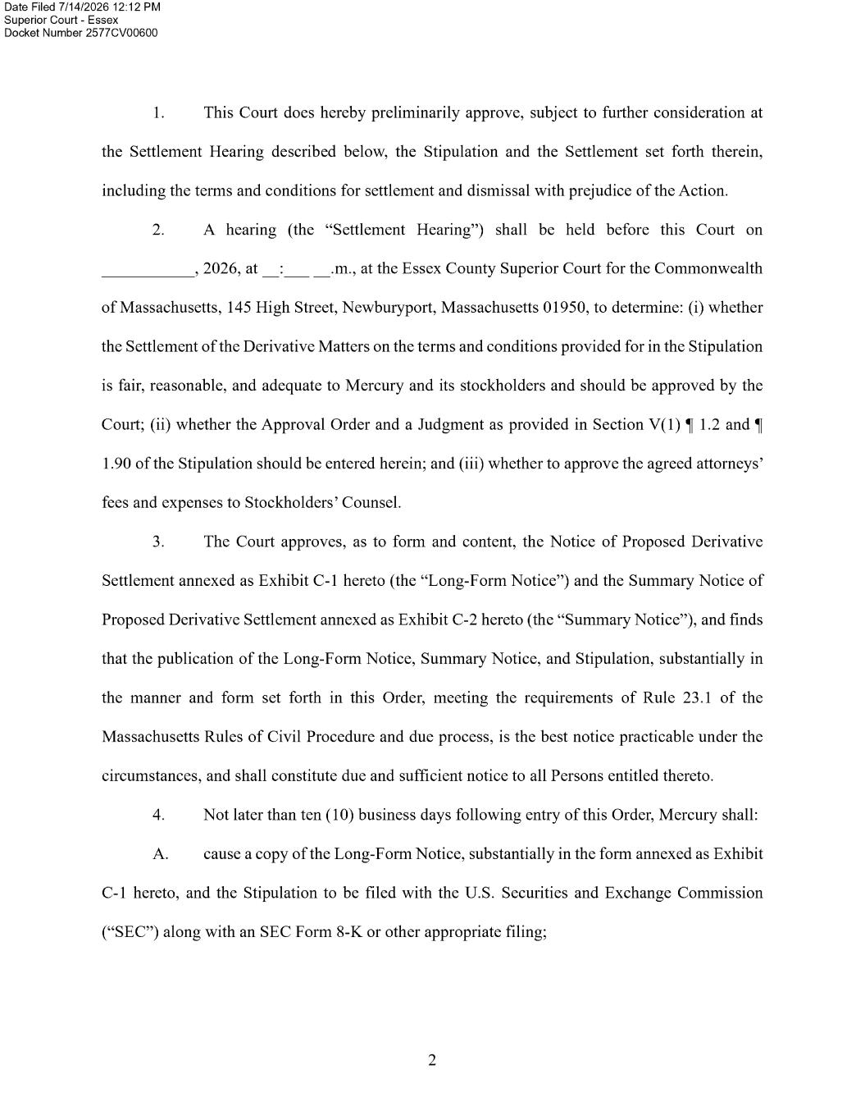

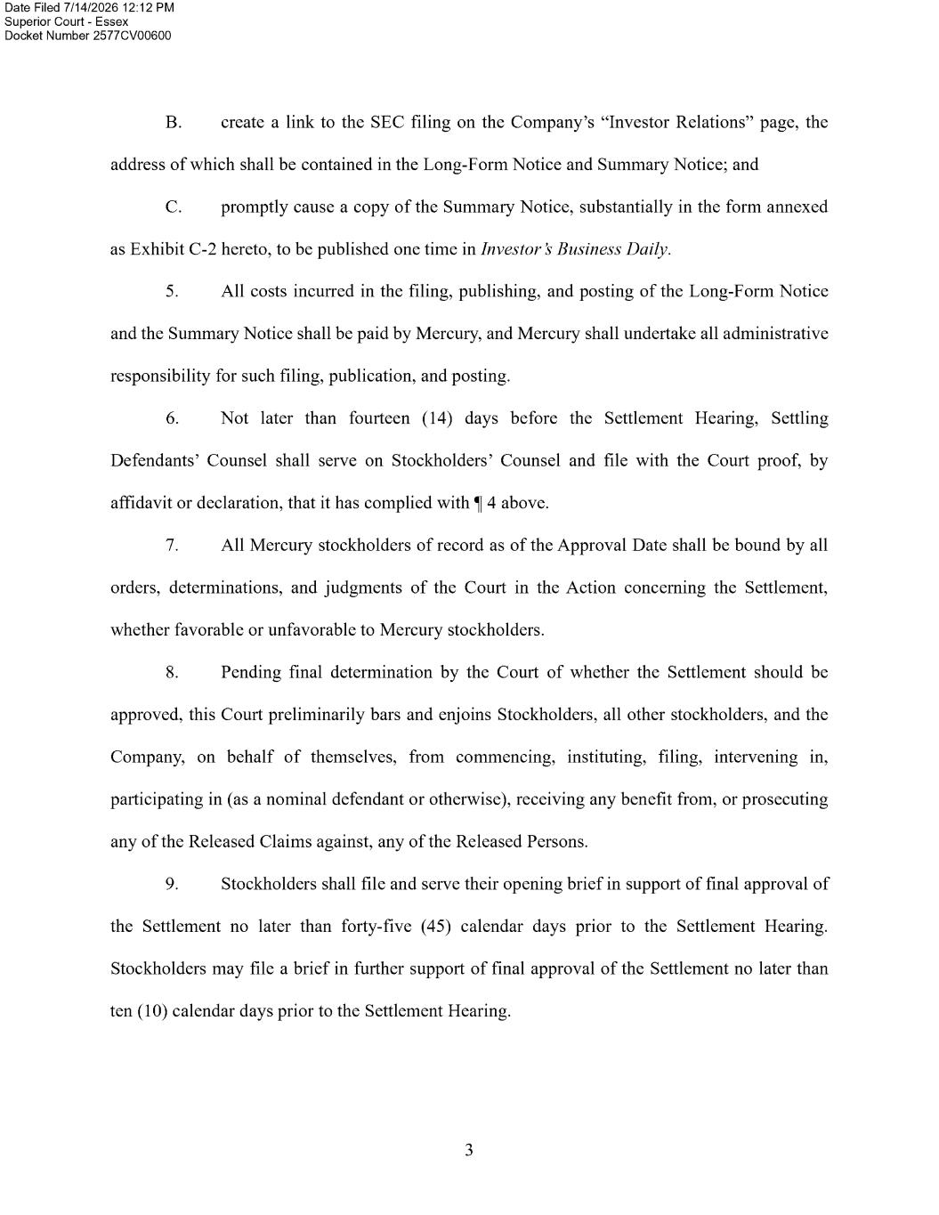

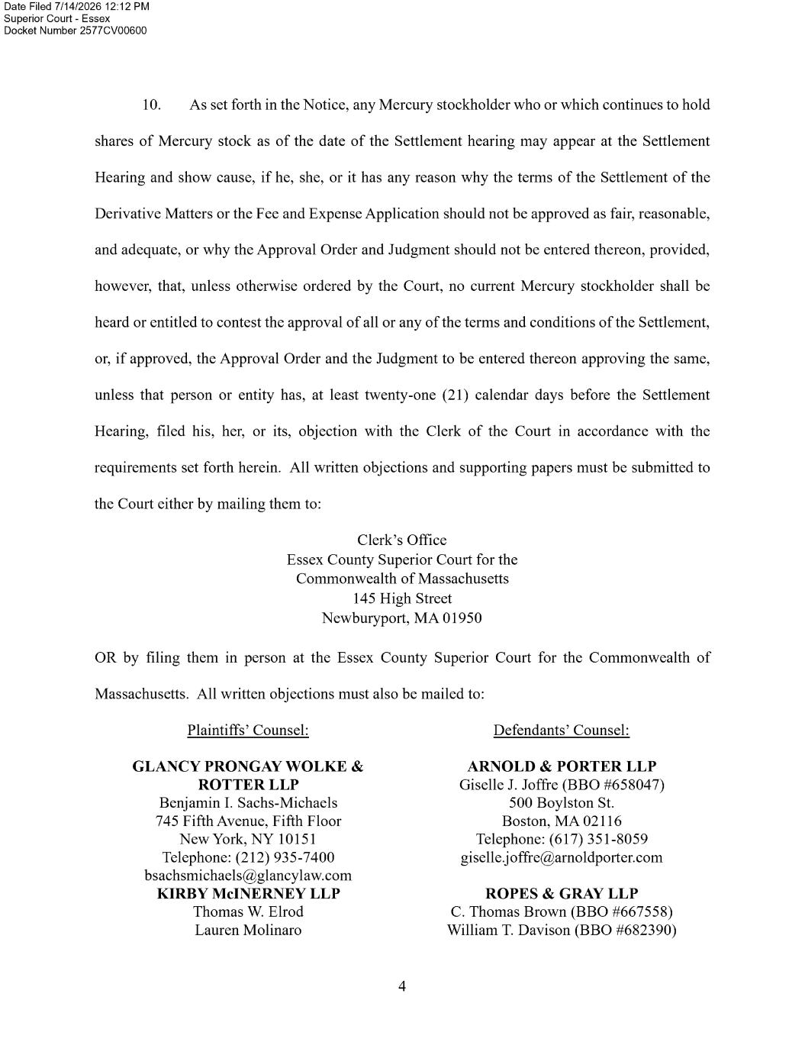

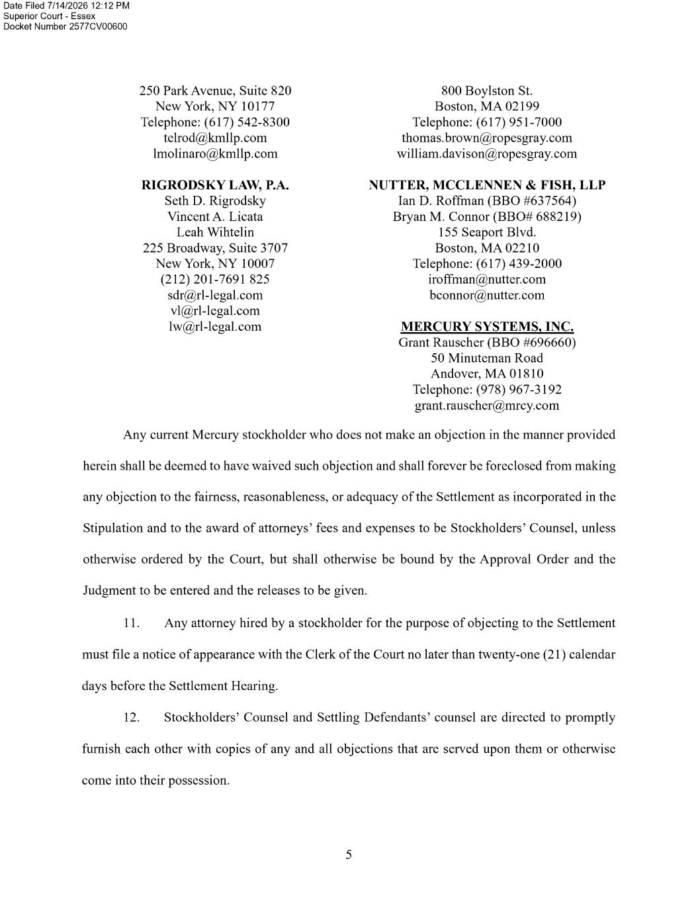

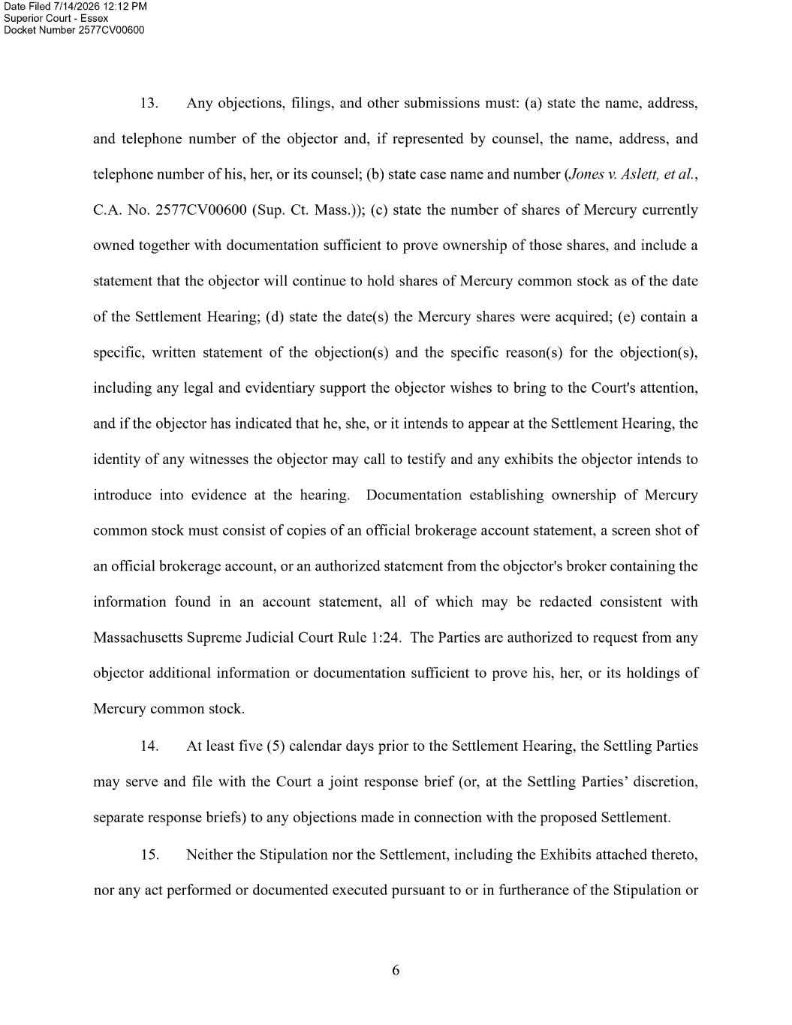

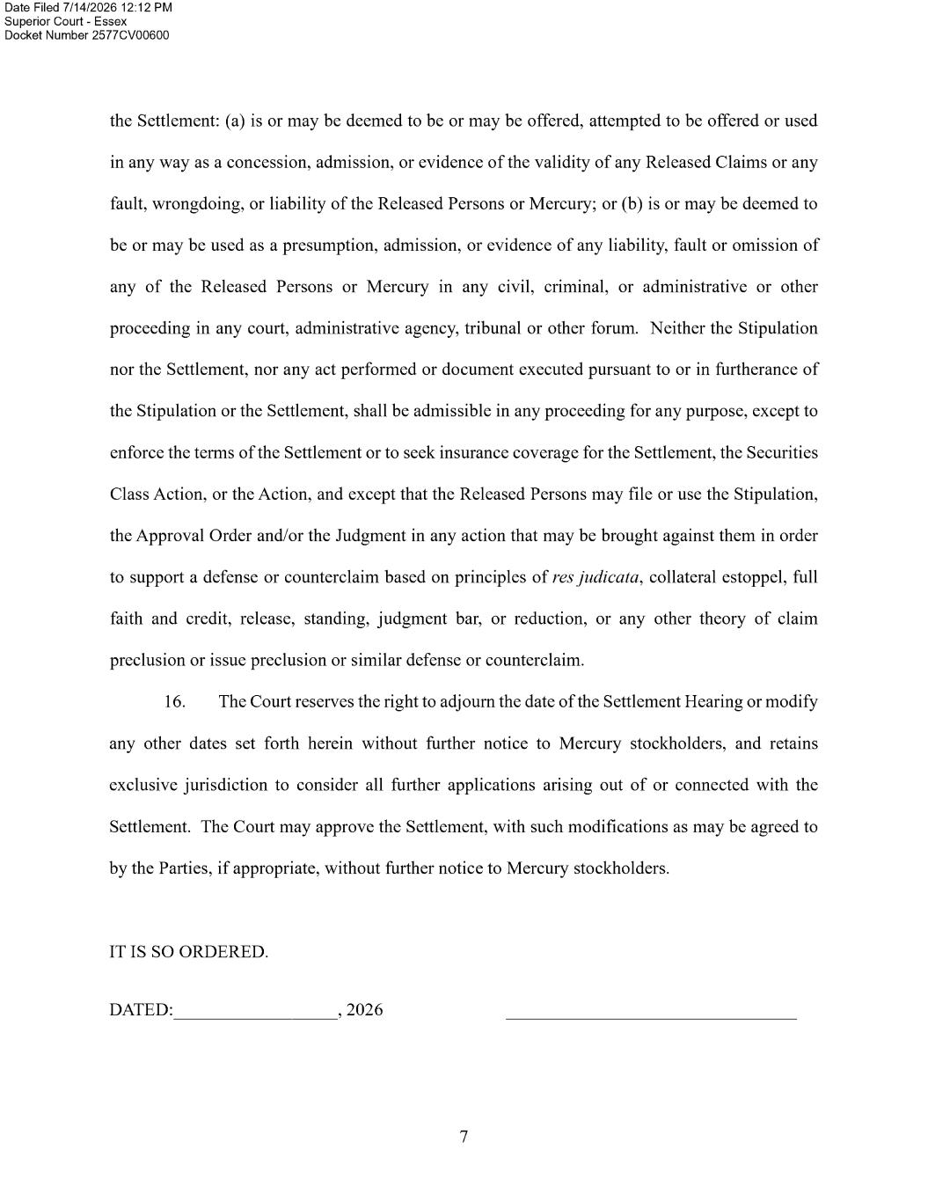



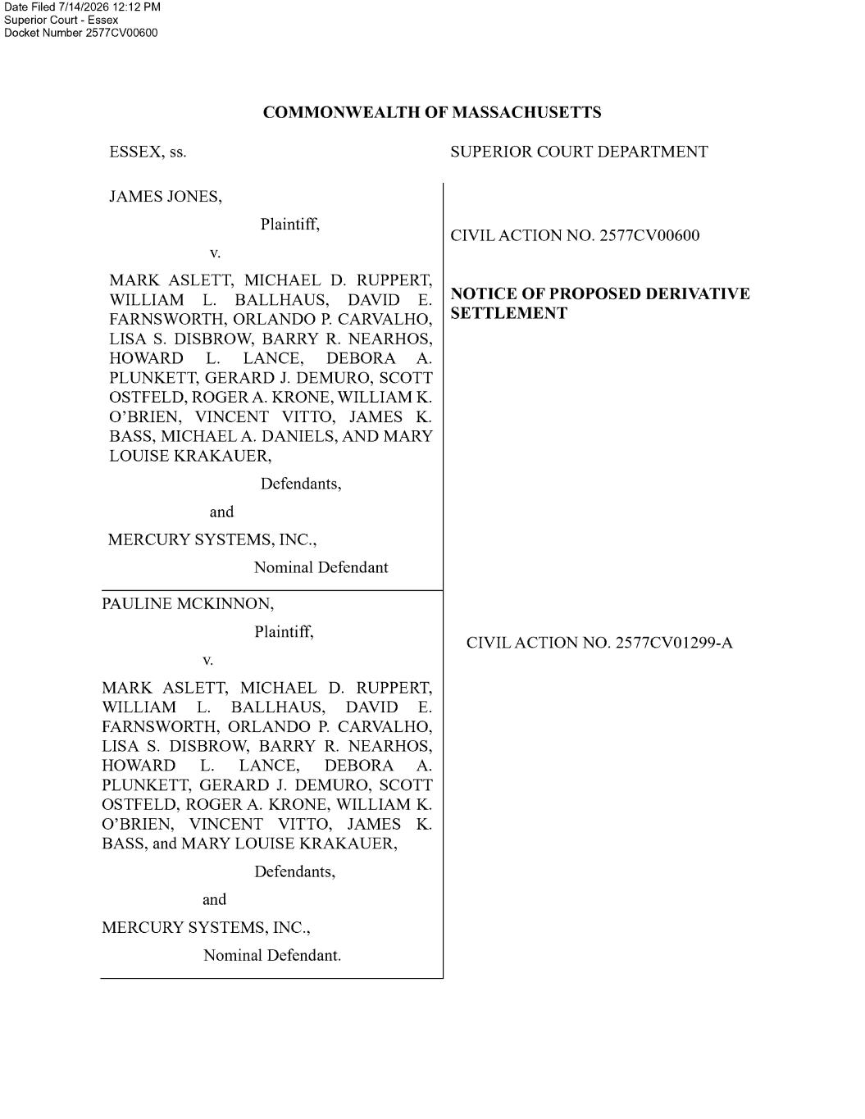



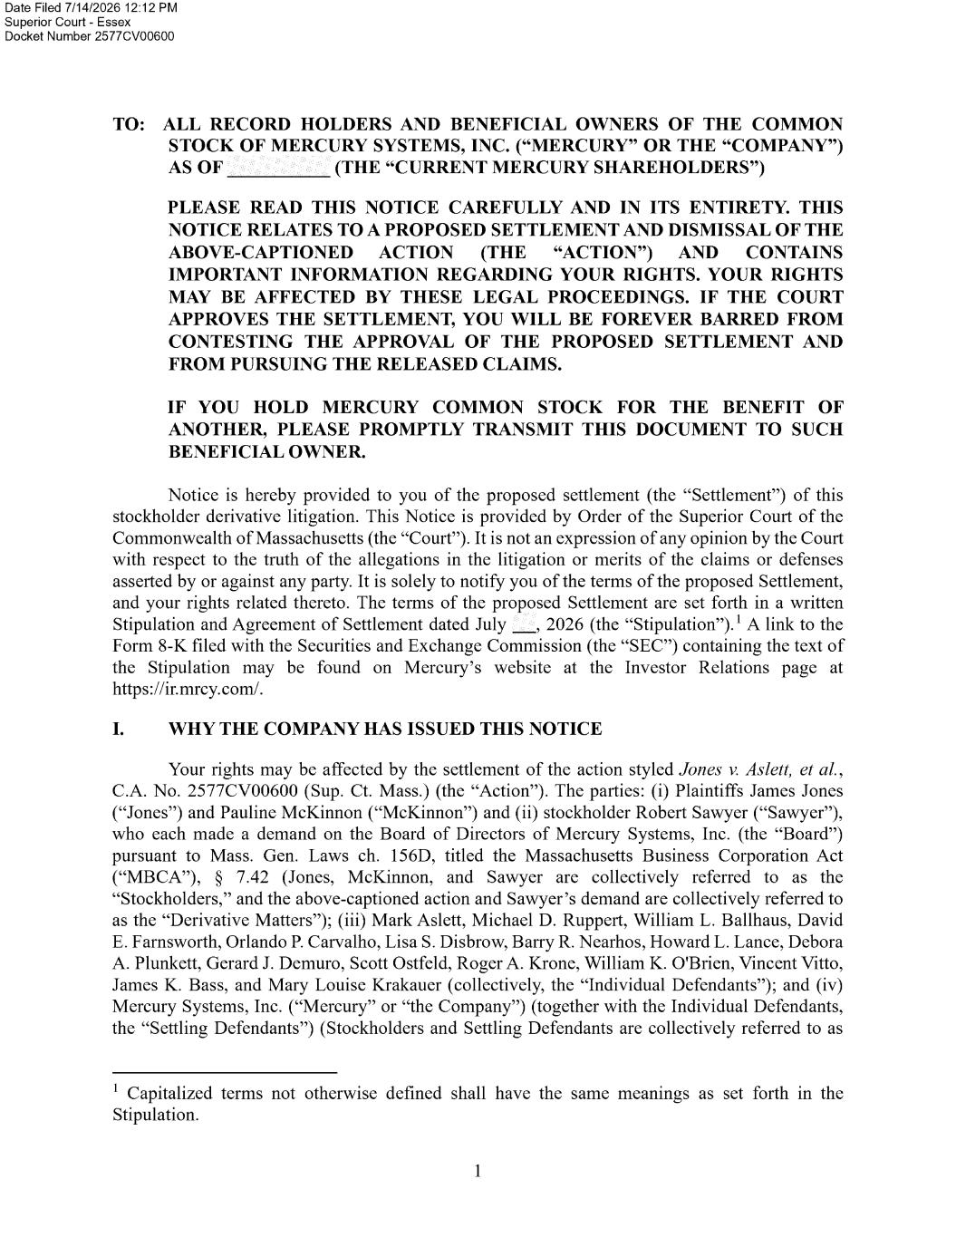

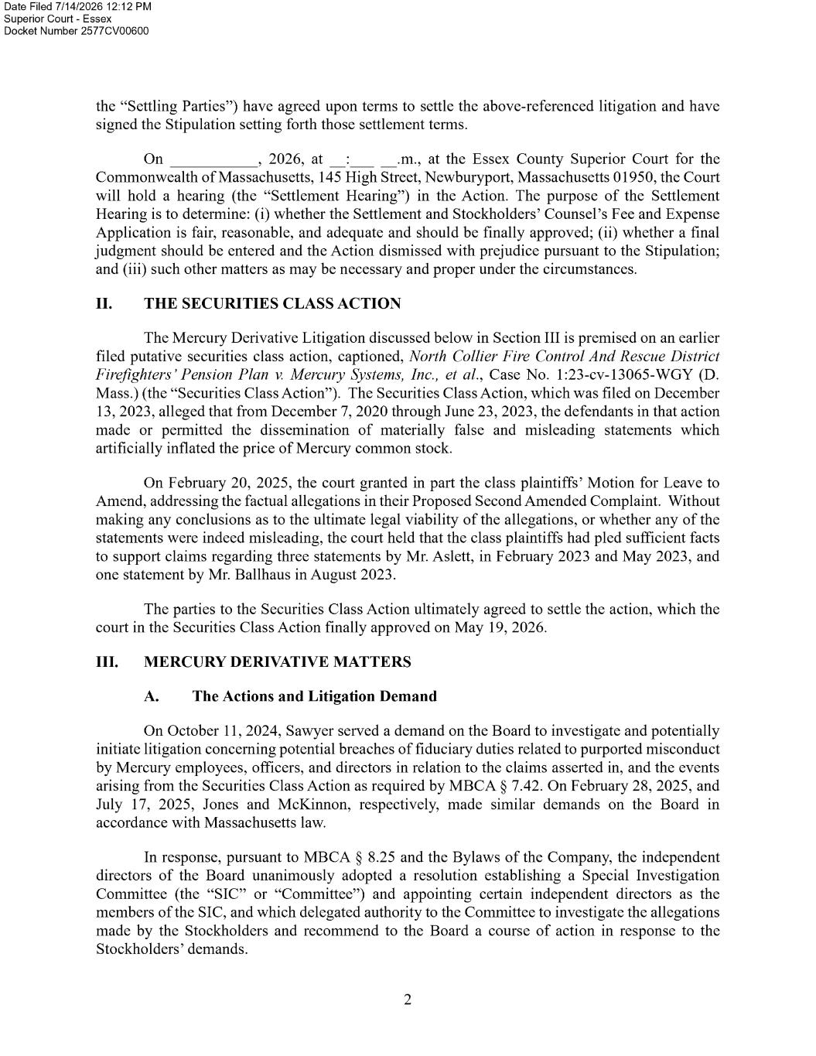

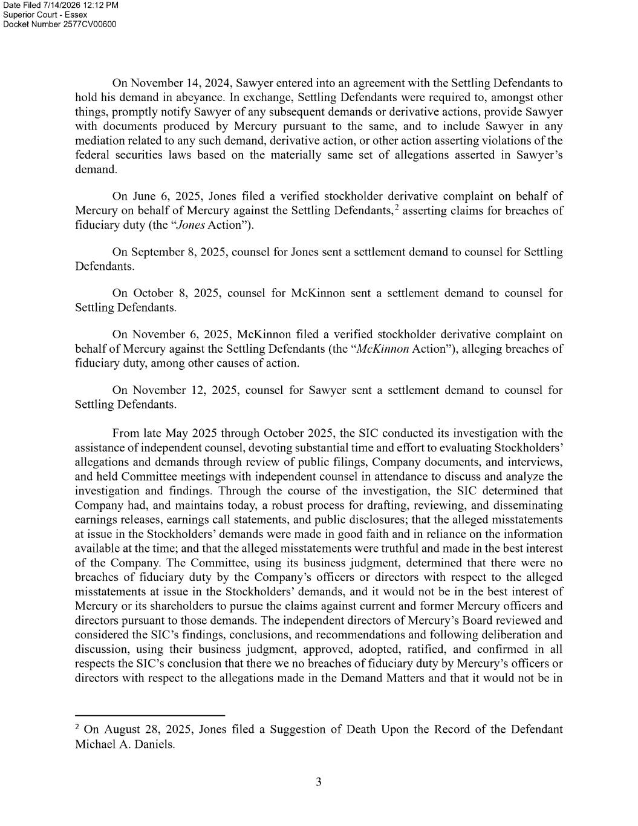

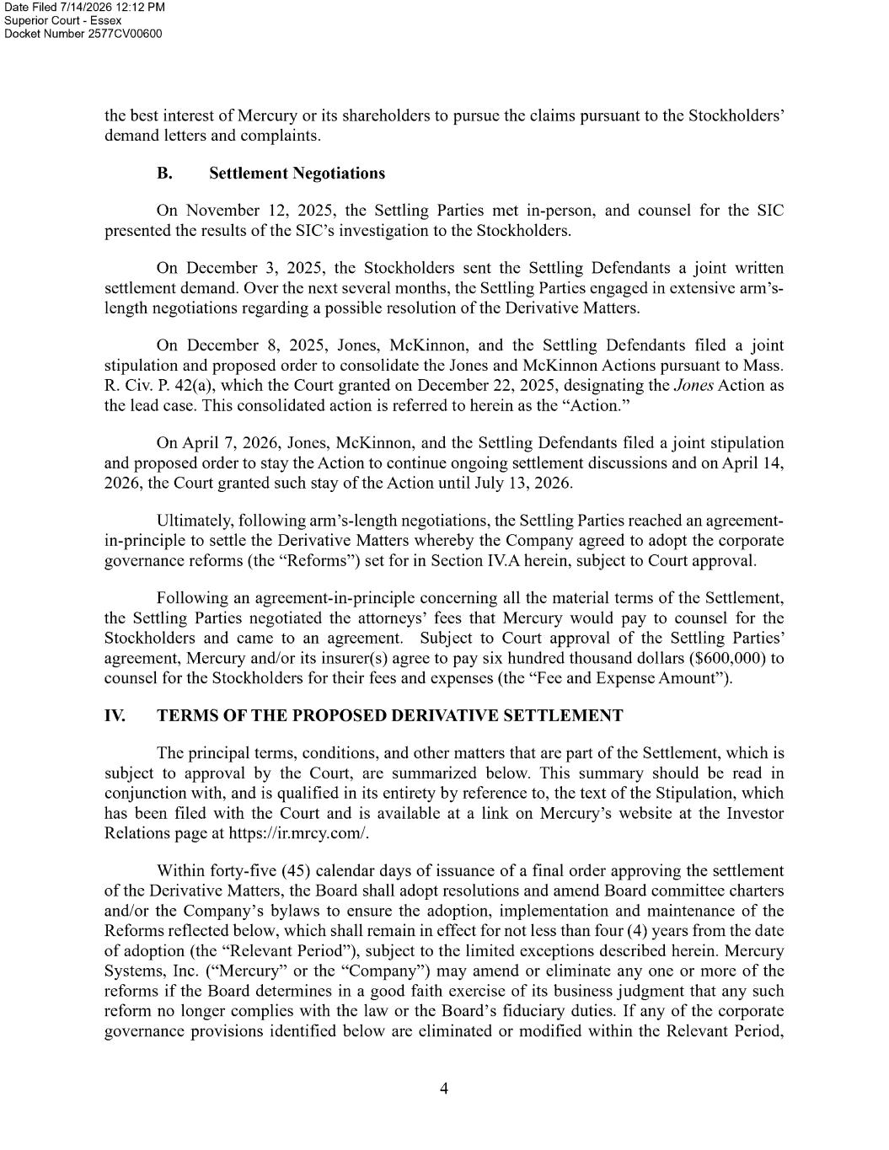

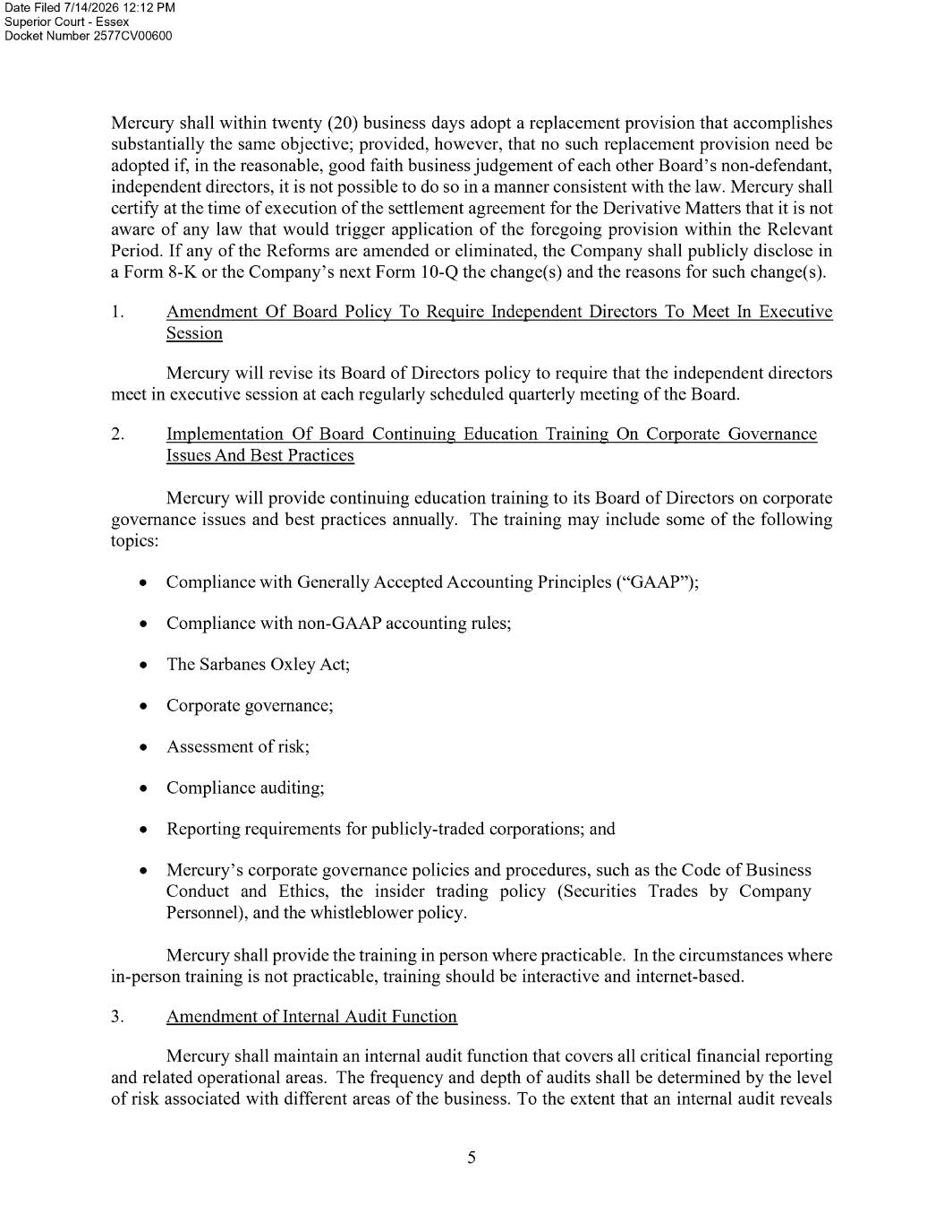

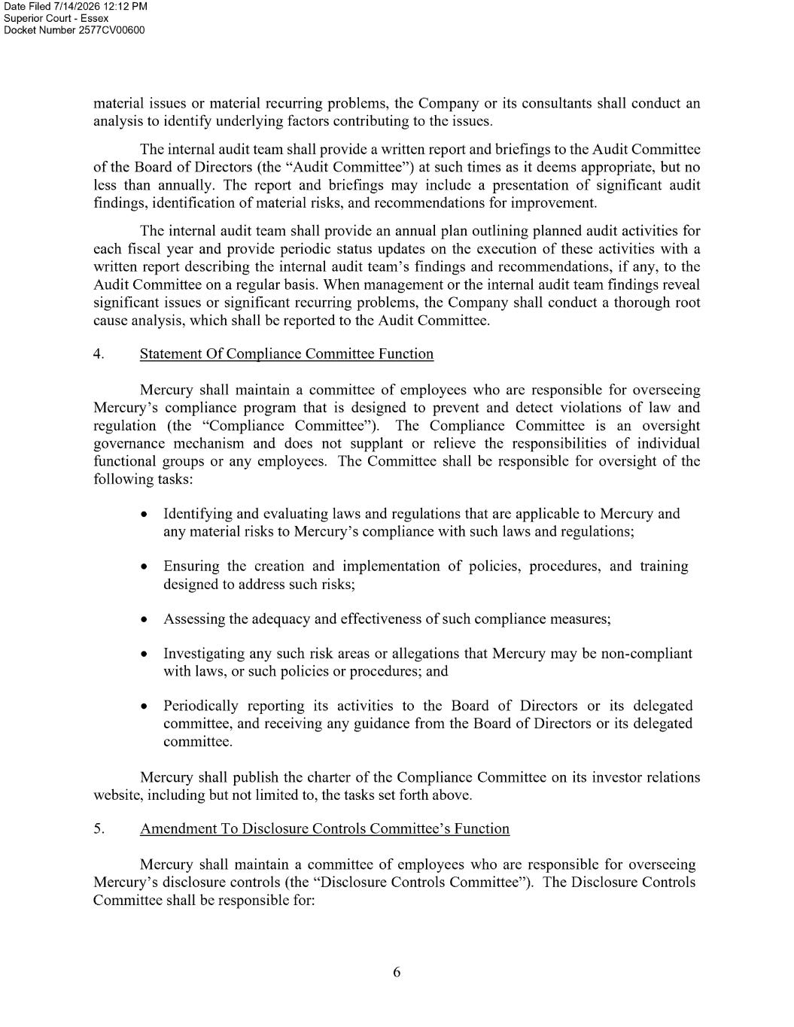

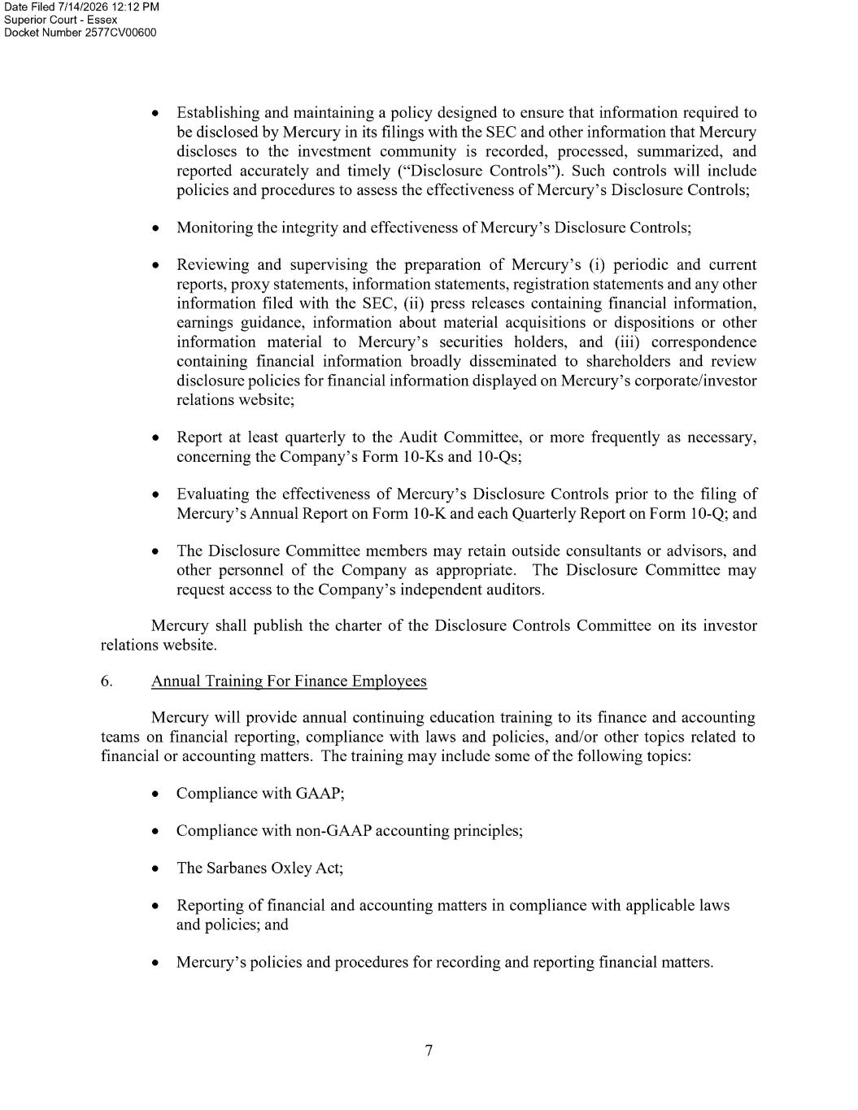

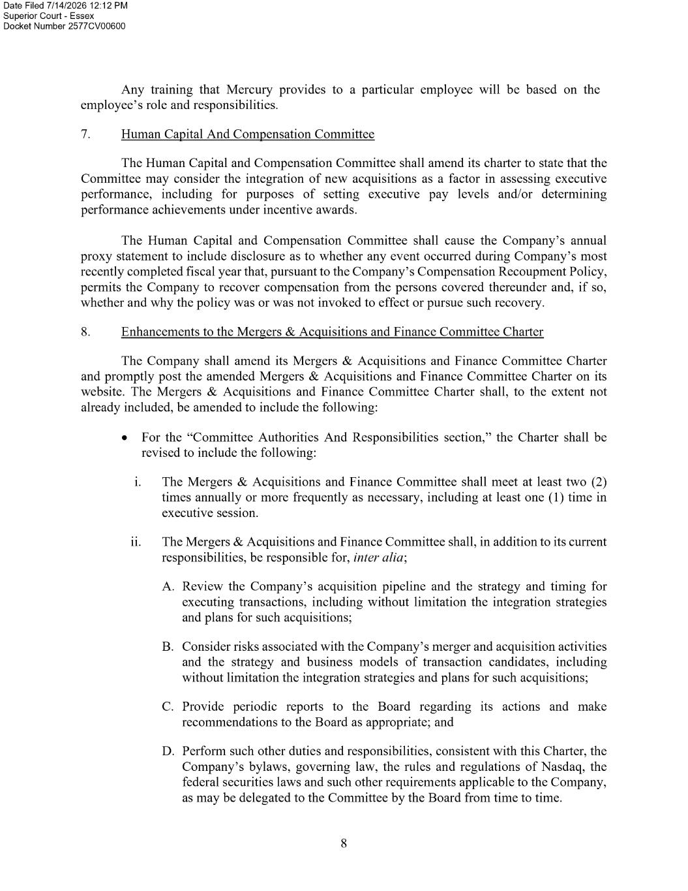

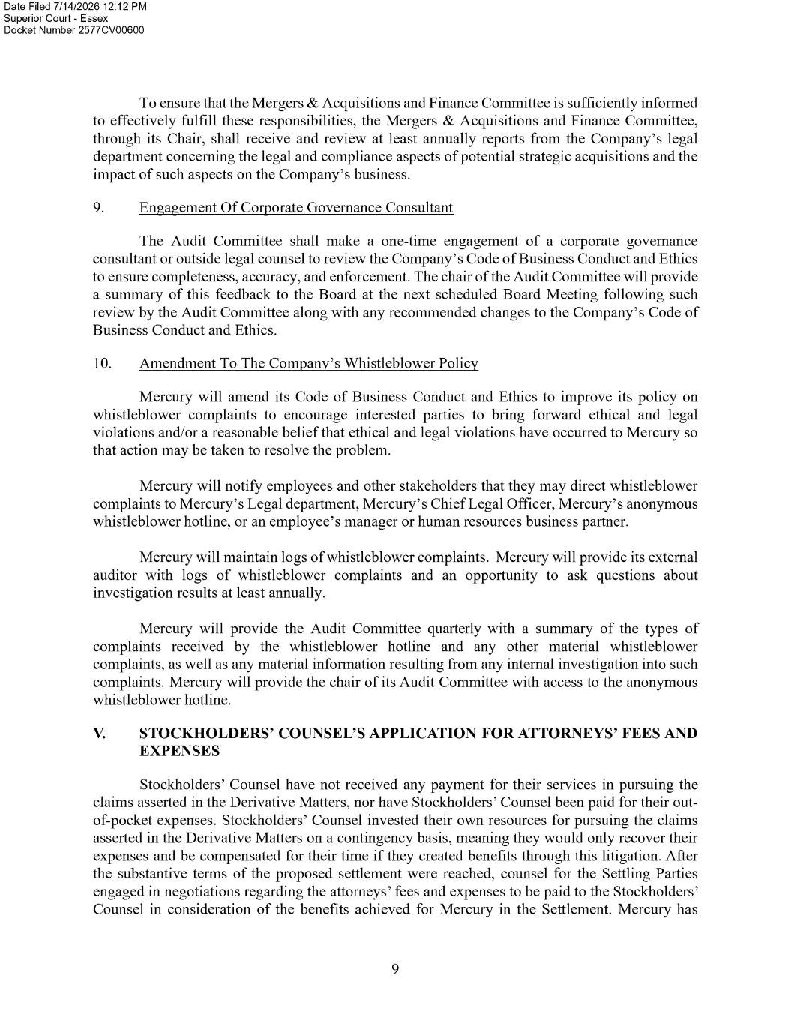

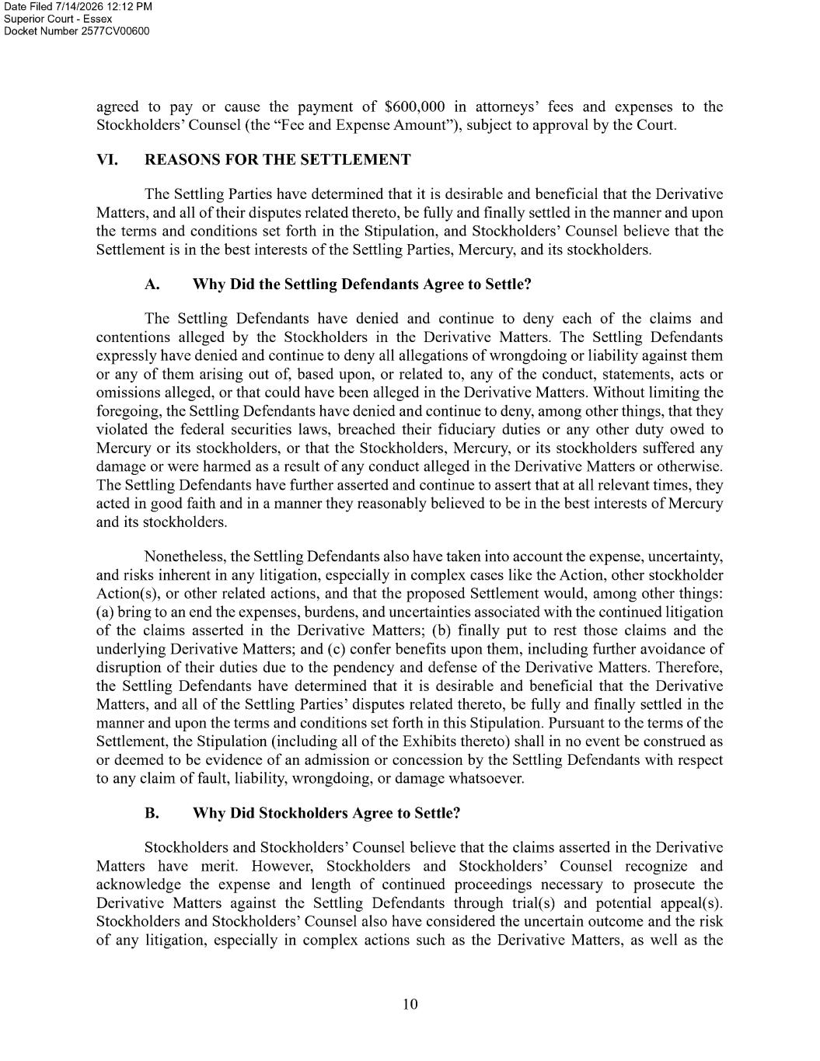

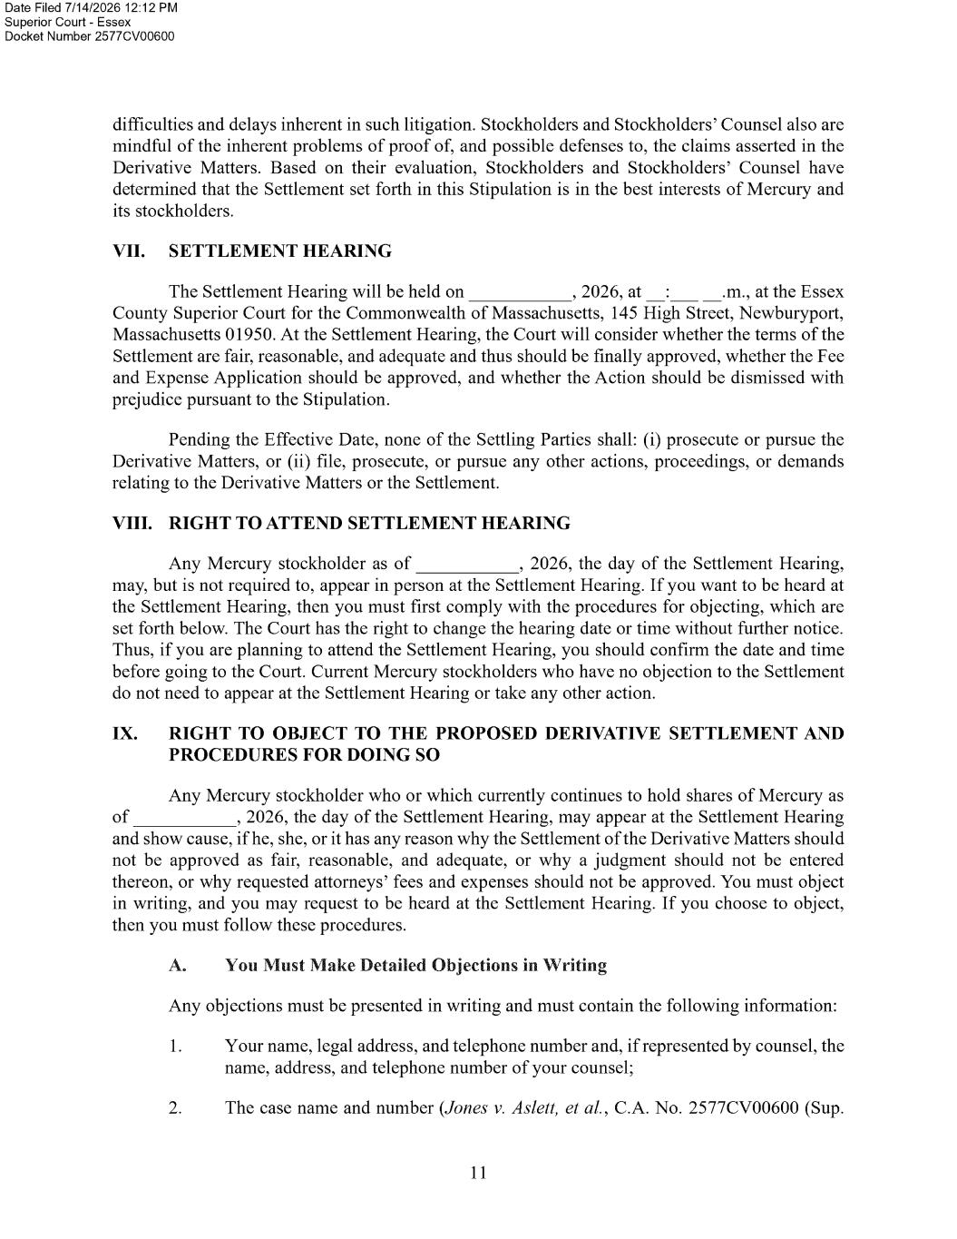

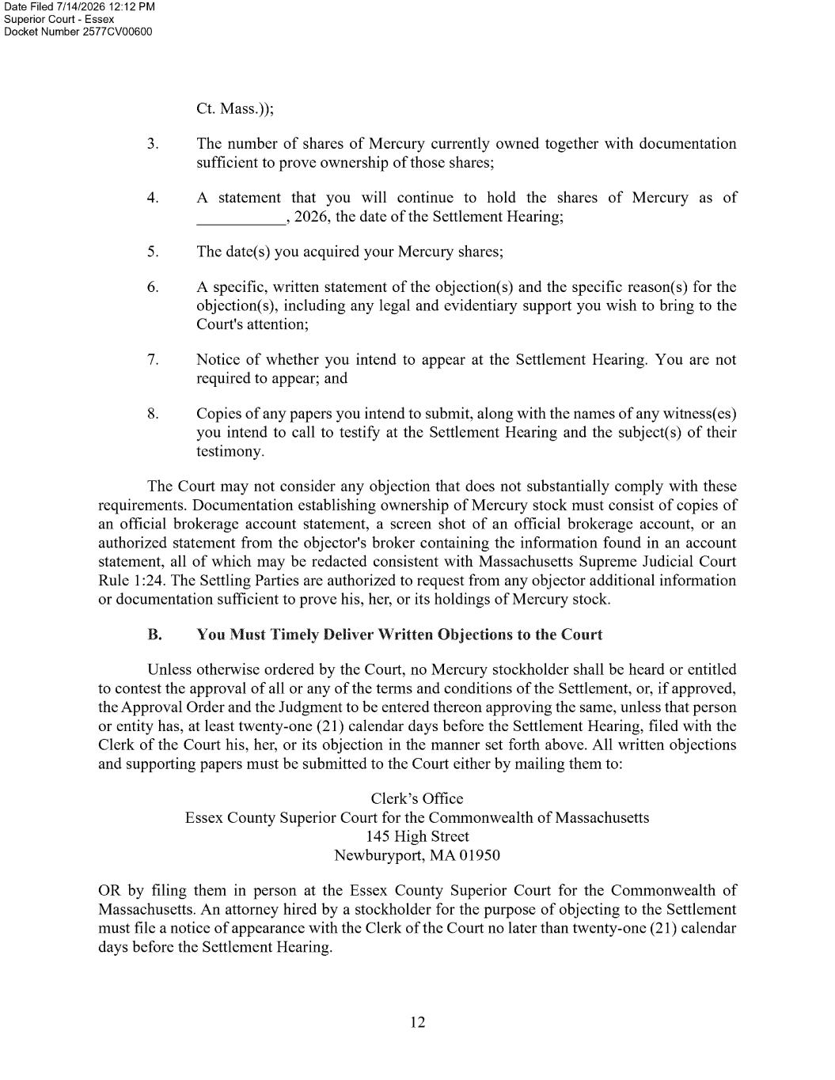

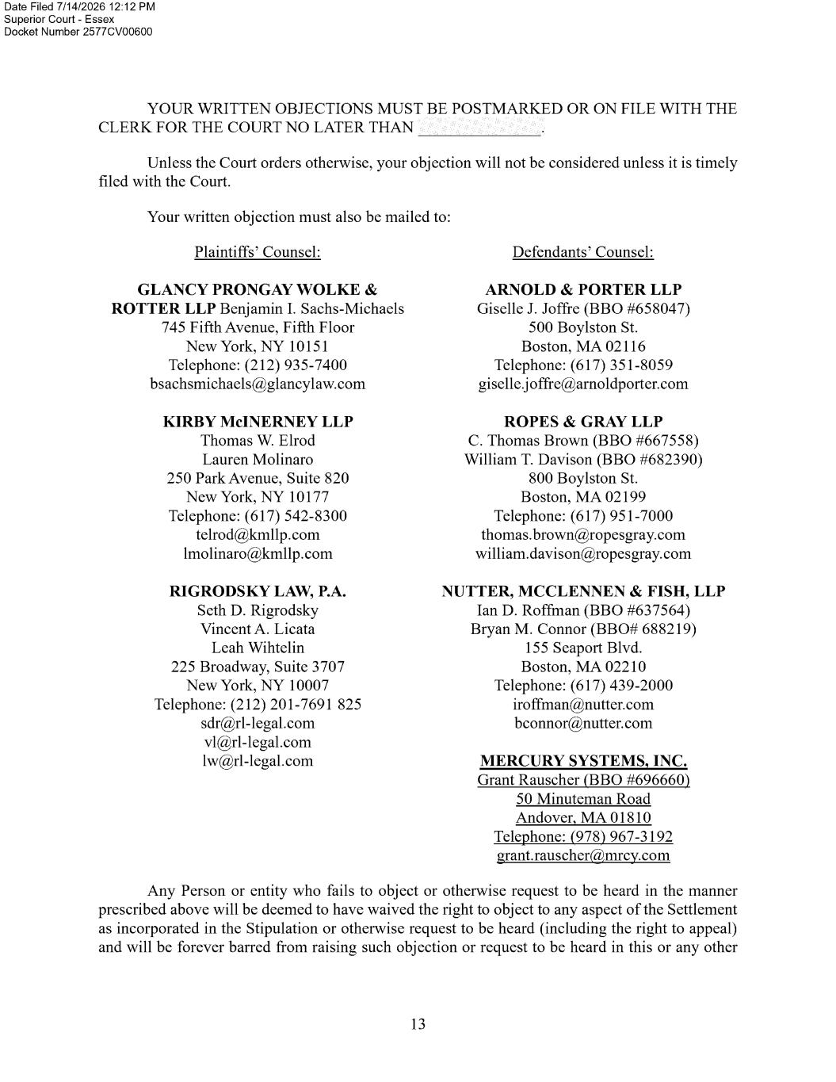

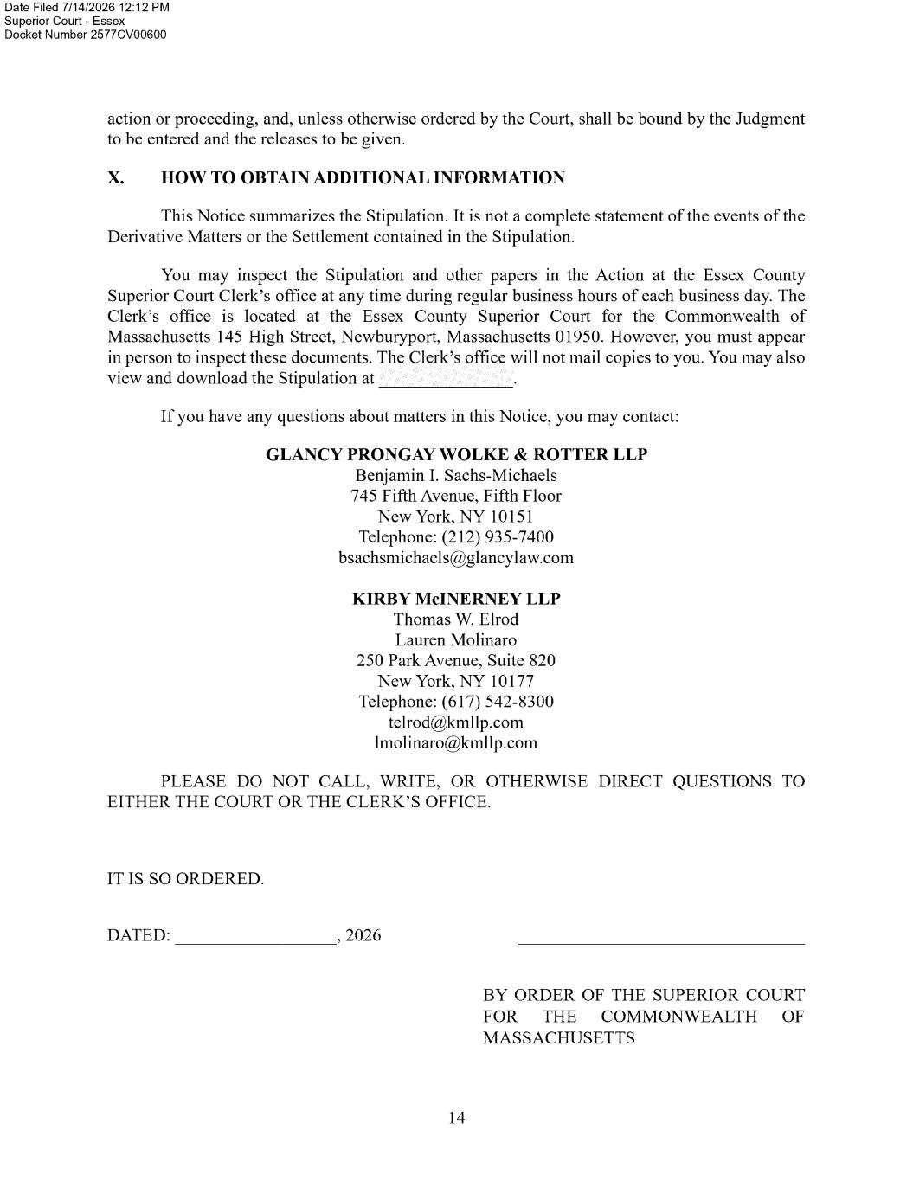



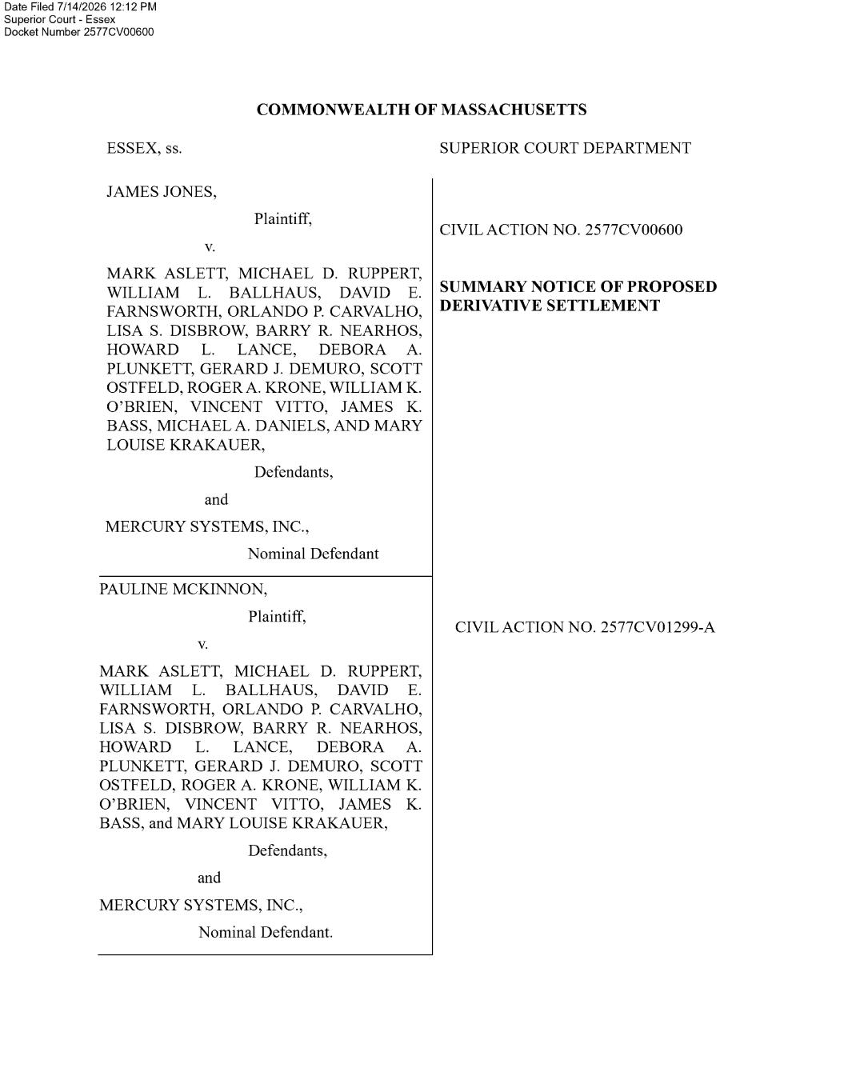

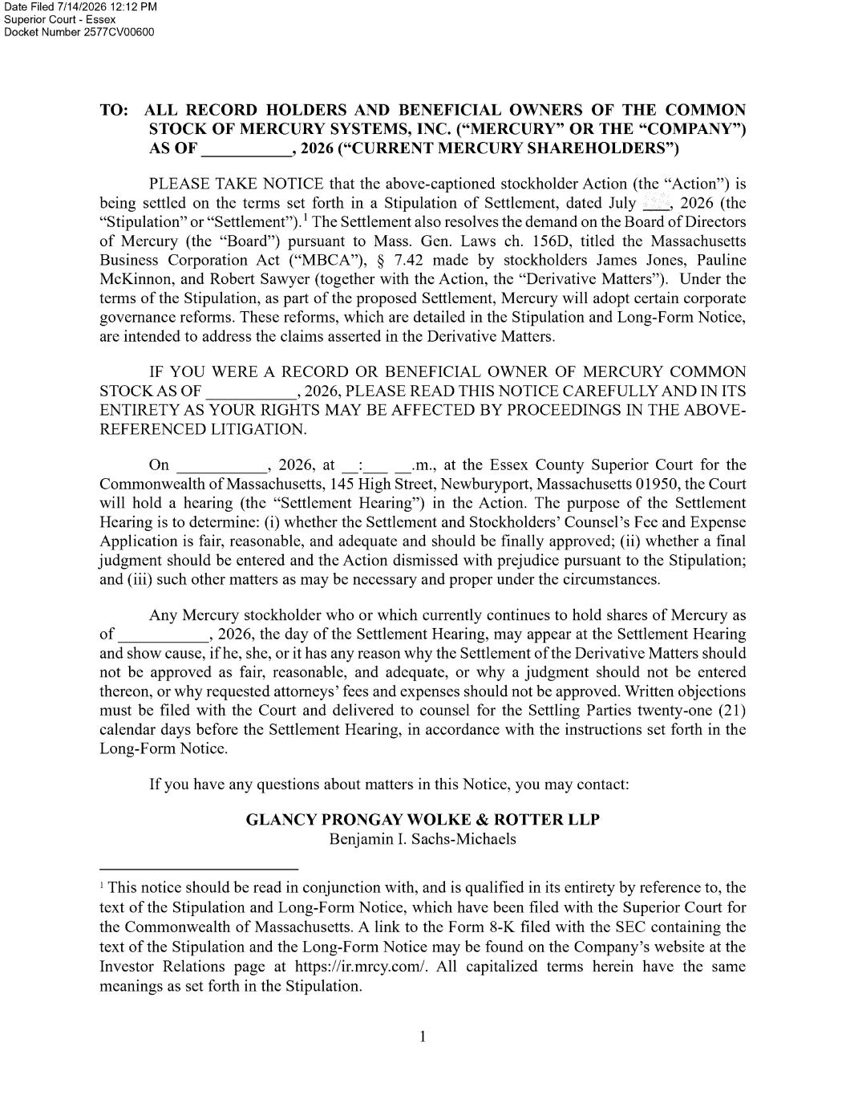

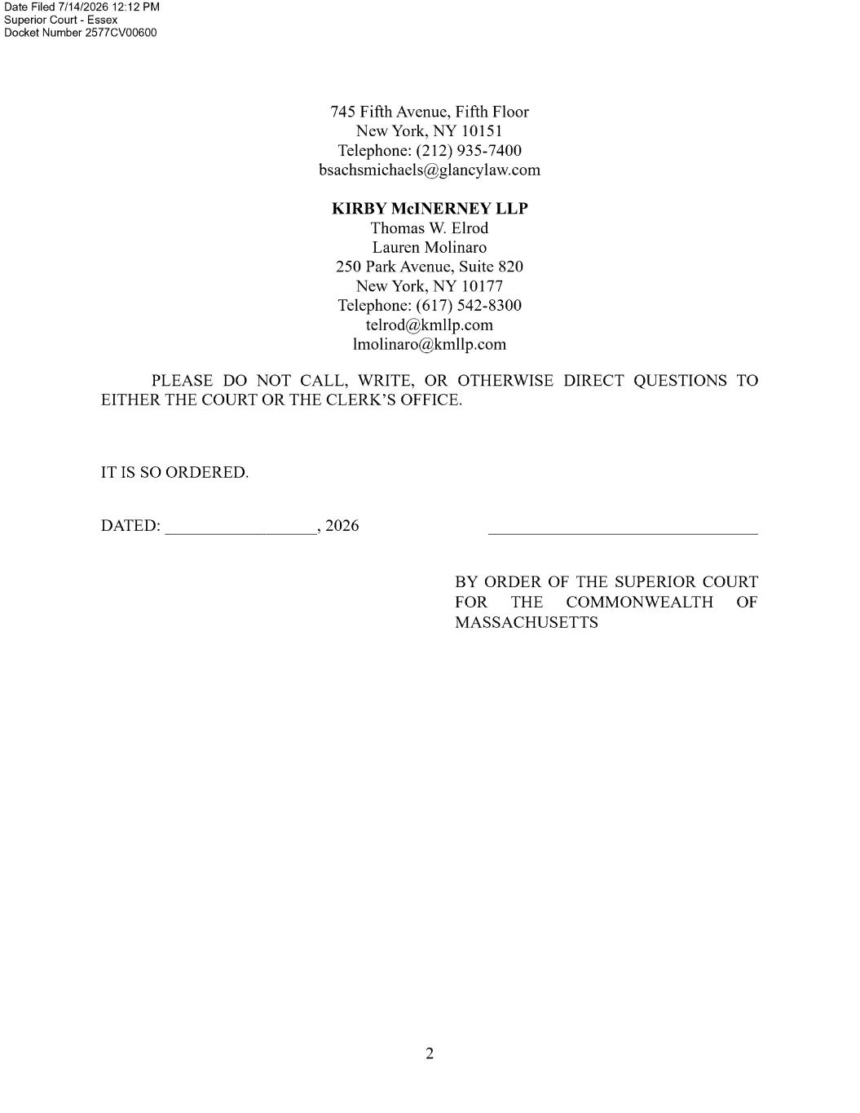



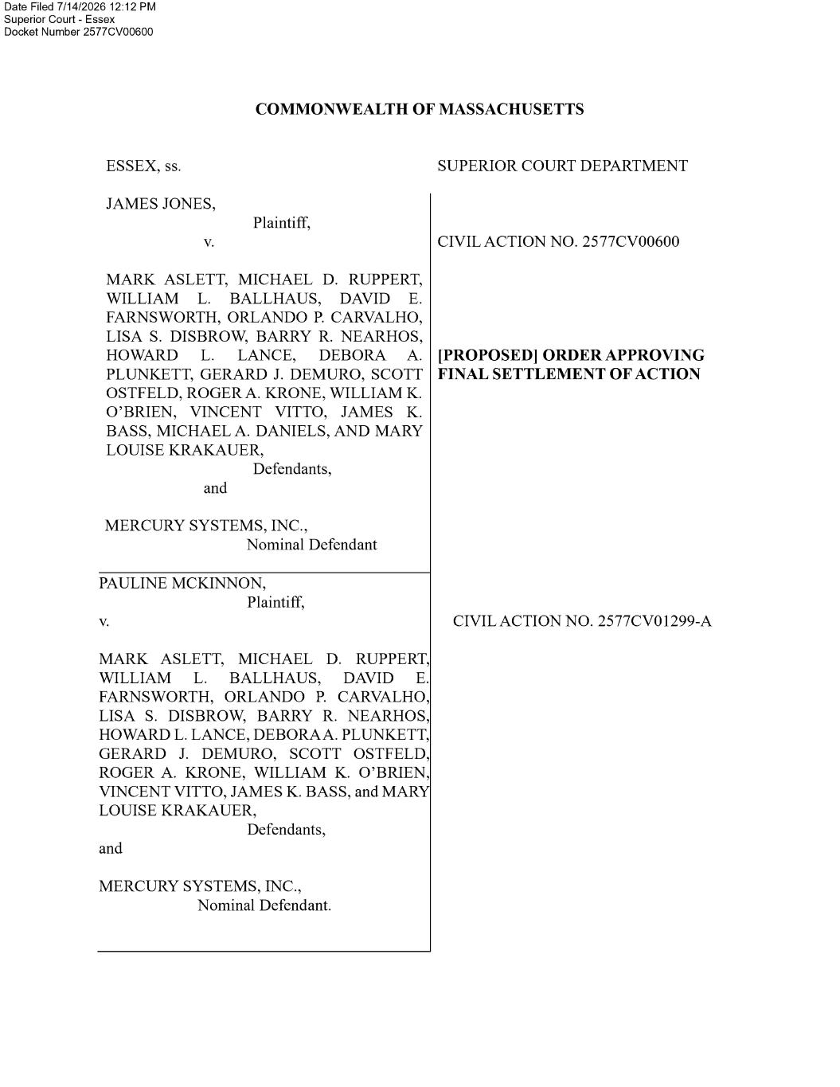

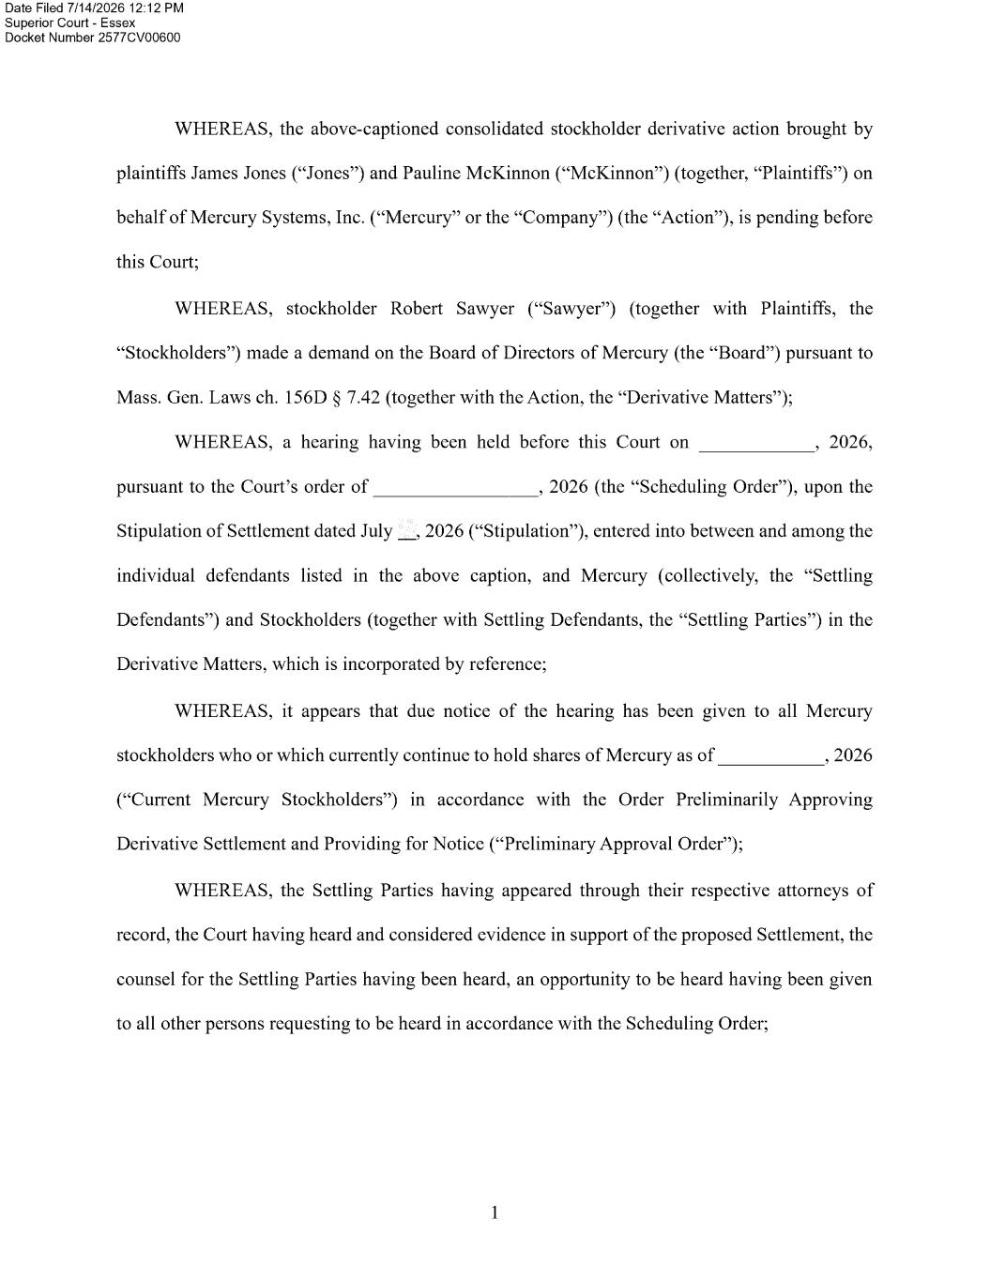

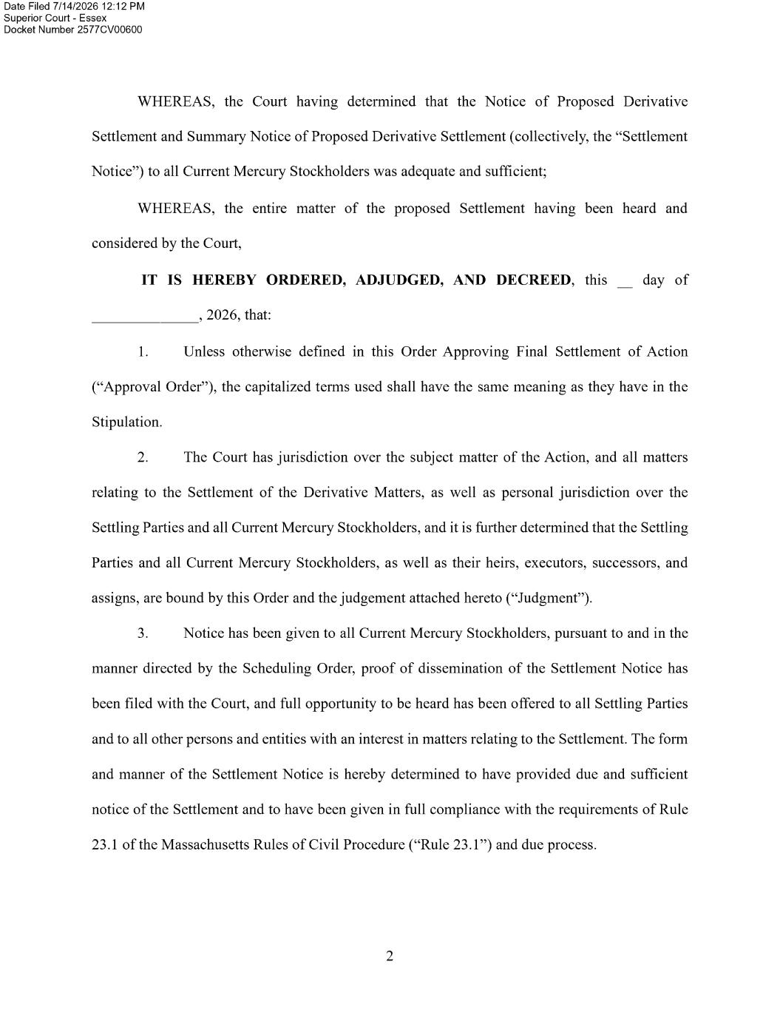

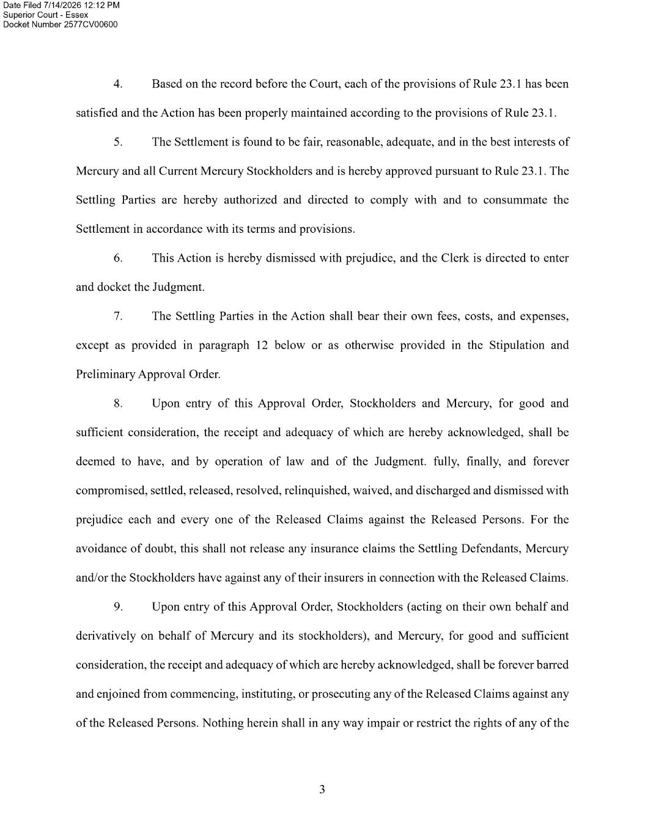

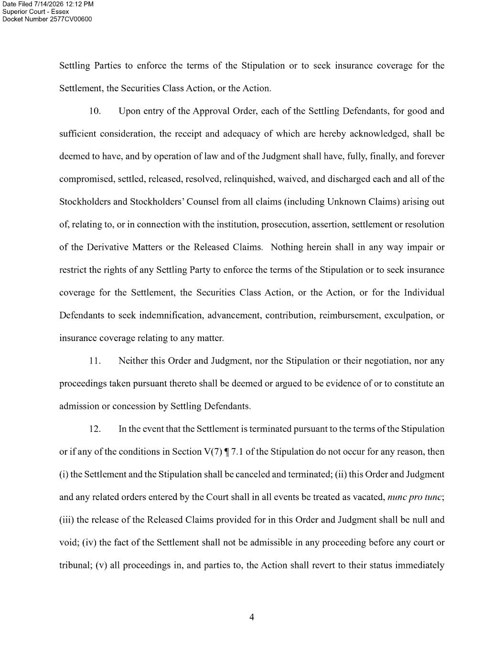

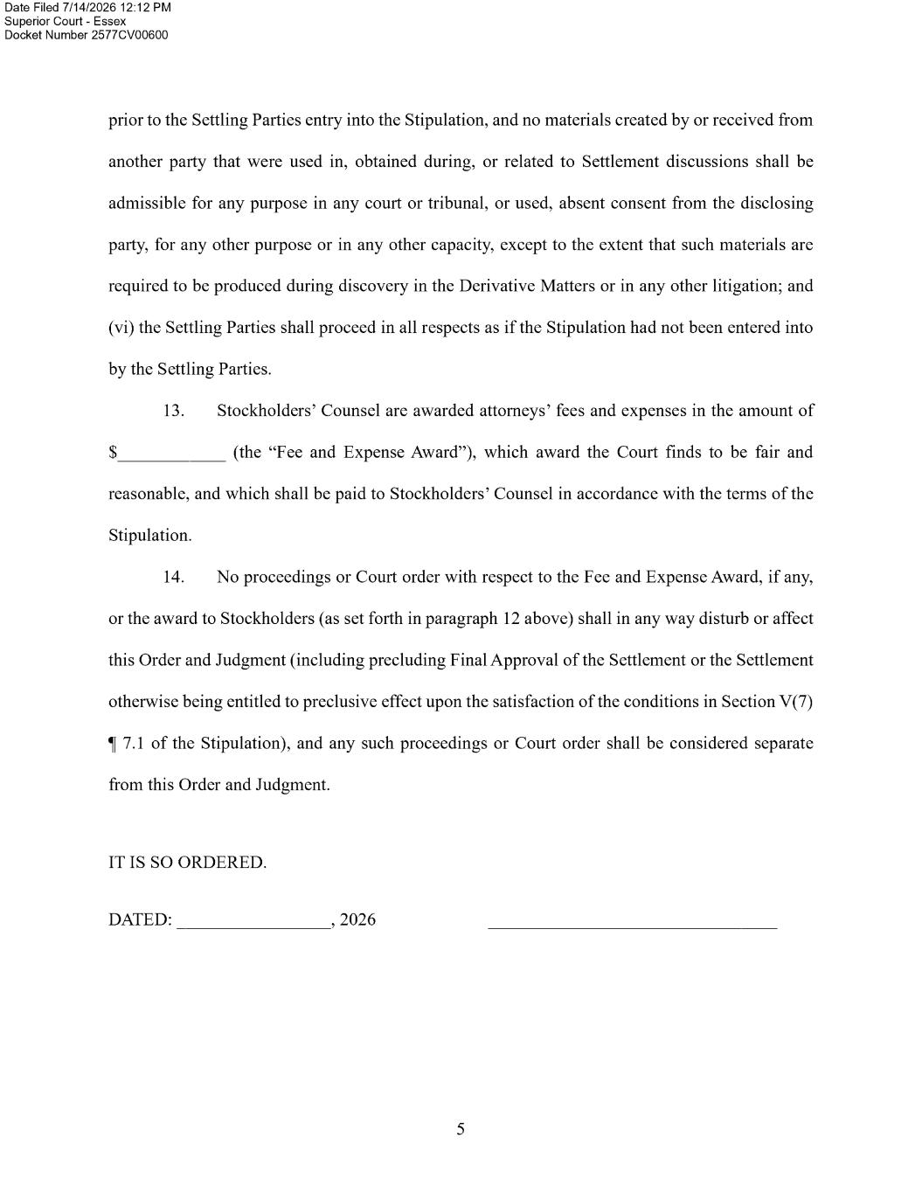



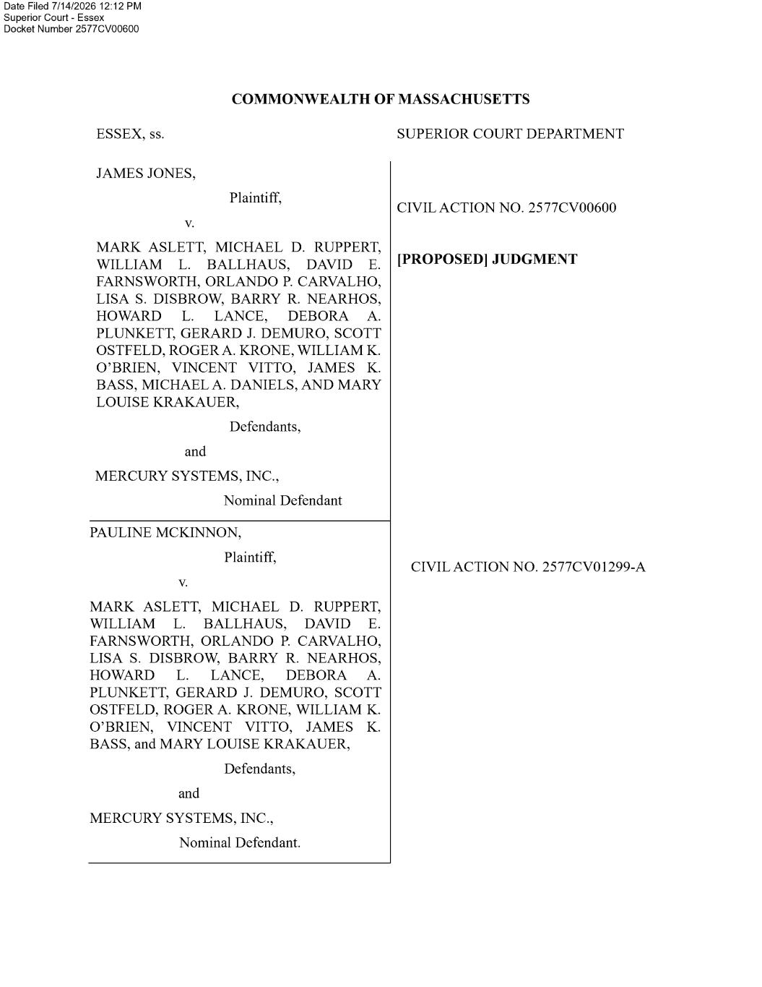

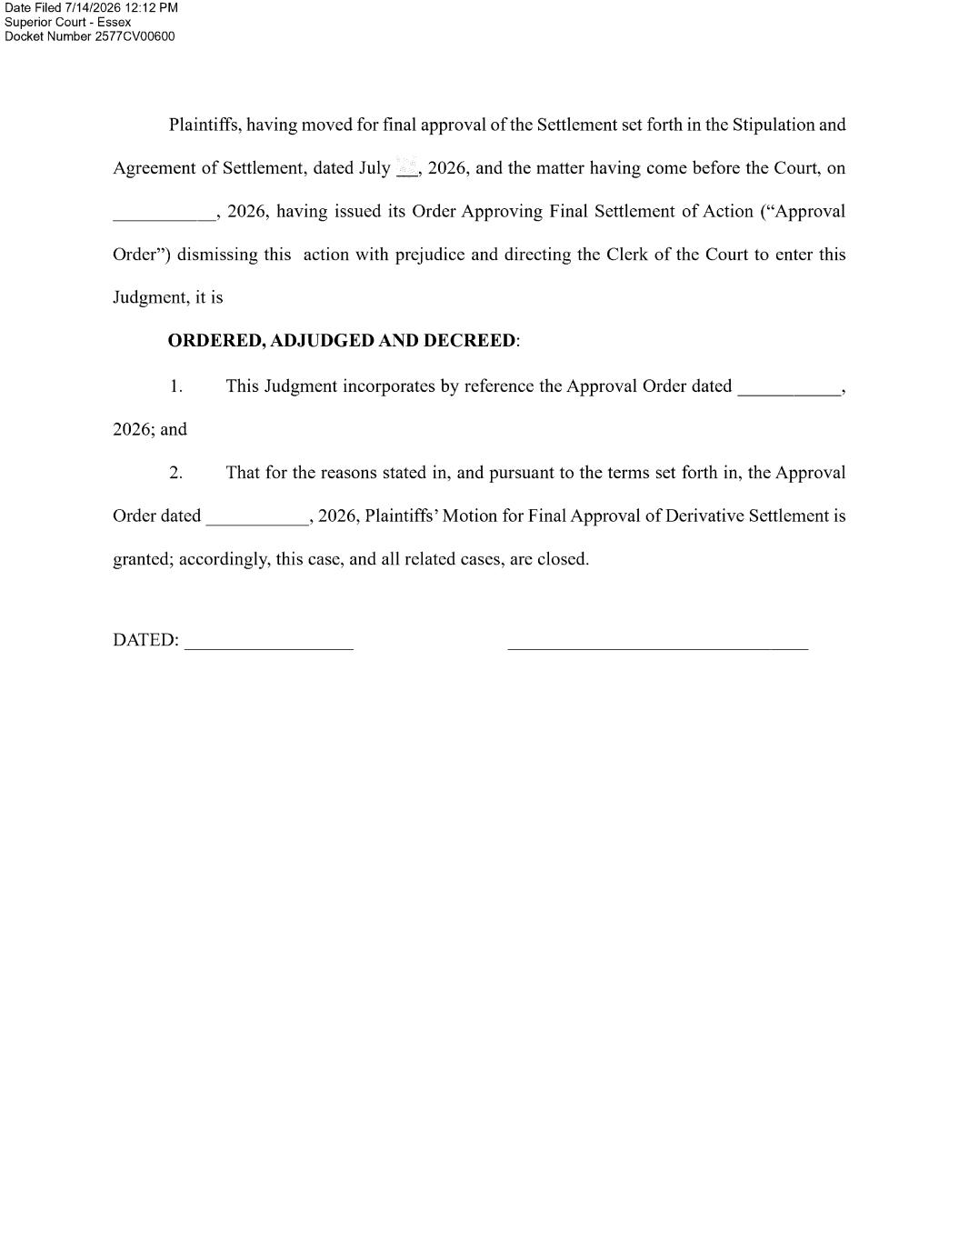

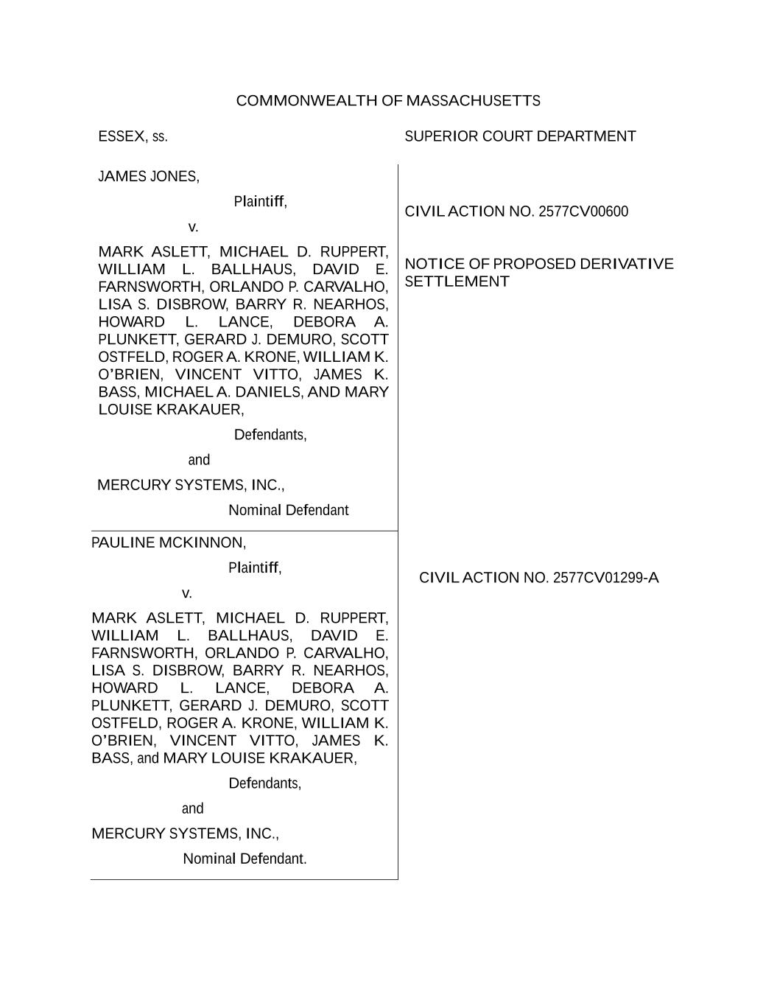
COMMONWEALTH OF MASSACHUSETTS ESSEX, ss. SUPERIOR COURT DEPARTMENT JAMES JONES, Plaintiff, v. MARK ASLETT, MICHAEL D. RUPPERT, WILLIAM L. BALLHAUS, DAVID E. FARNSWORTH, ORLANDO P. CARVALHO, LISA S. DISBROW, BARRY R. NEARHOS, HOWARD L. LANCE, DEBORA A. PLUNKETT, GERARD J. DEMURO, SCOTT OSTFELD, ROGER A. KRONE, WILLIAM K. O’BRIEN, VINCENT VITTO, JAMES K. BASS, MICHAEL A. DANIELS, AND MARY LOUISE KRAKAUER, Defendants, and MERCURY SYSTEMS, INC., Nominal Defendant CIVIL ACTION NO. 2577CV00600 NOTICE OF PROPOSED DERIVATIVE SETTLEMENT PAULINE MCKINNON, Plaintiff, v. MARK ASLETT, MICHAEL D. RUPPERT, WILLIAM L. BALLHAUS, DAVID E. FARNSWORTH, ORLANDO P. CARVALHO, LISA S. DISBROW, BARRY R. NEARHOS, HOWARD L. LANCE, DEBORA A. PLUNKETT, GERARD J. DEMURO, SCOTT OSTFELD, ROGER A. KRONE, WILLIAM K. O’BRIEN, VINCENT VITTO, JAMES K. BASS, and MARY LOUISE KRAKAUER, Defendants, and MERCURY SYSTEMS, INC., Nominal Defendant. CIVIL ACTION NO. 2577CV01299-A

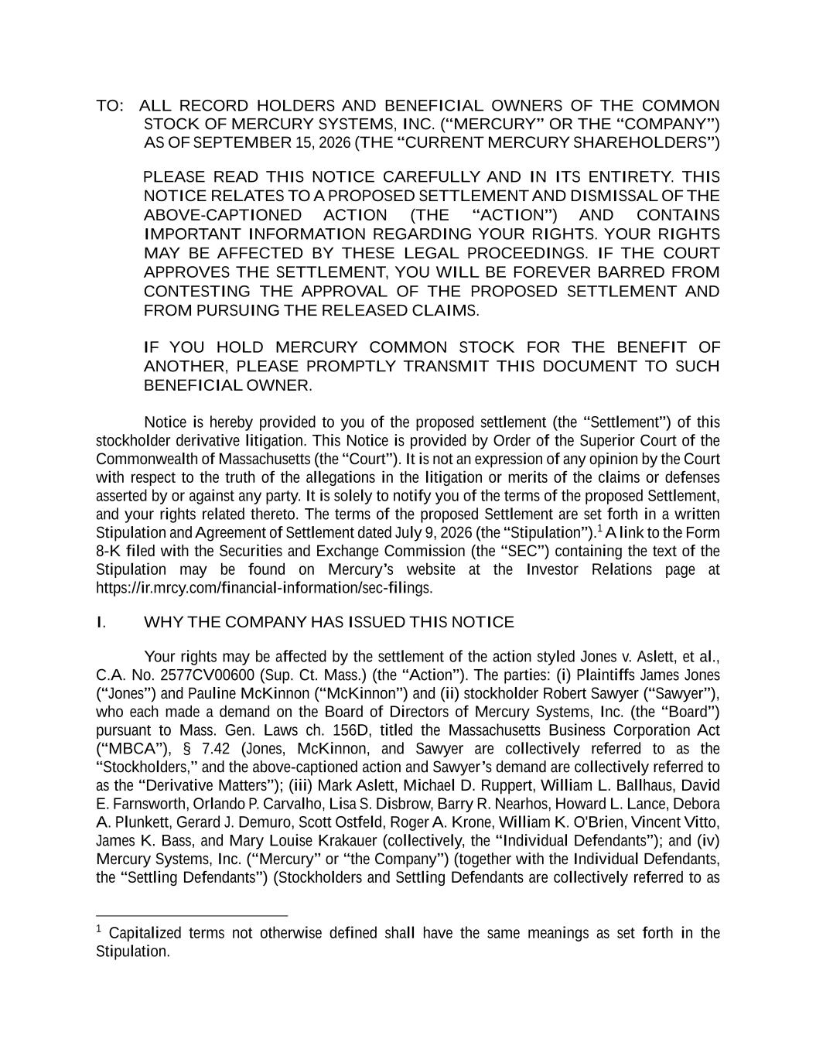
TO: ALL RECORD HOLDERS AND BENEFICIAL OWNERS OF THE COMMON STOCK OF MERCURY SYSTEMS, INC. (“MERCURY” OR THE “COMPANY”) AS OF SEPTEMBER 15, 2026 (THE “CURRENT MERCURY SHAREHOLDERS”) PLEASE READ THIS NOTICE CAREFULLY AND IN ITS ENTIRETY. THIS NOTICE RELATES TO A PROPOSED SETTLEMENT AND DISMISSAL OF THE ABOVE-CAPTIONED ACTION (THE “ACTION”) AND CONTAINS IMPORTANT INFORMATION REGARDING YOUR RIGHTS. YOUR RIGHTS MAY BE AFFECTED BY THESE LEGAL PROCEEDINGS. IF THE COURT APPROVES THE SETTLEMENT, YOU WILL BE FOREVER BARRED FROM CONTESTING THE APPROVAL OF THE PROPOSED SETTLEMENT AND FROM PURSUING THE RELEASED CLAIMS. IF YOU HOLD MERCURY COMMON STOCK FOR THE BENEFIT OF ANOTHER, PLEASE PROMPTLY TRANSMIT THIS DOCUMENT TO SUCH BENEFICIAL OWNER. Notice is hereby provided to you of the proposed settlement (the “Settlement”) of this stockholder derivative litigation. This Notice is provided by Order of the Superior Court of the Commonwealth of Massachusetts (the “Court”). It is not an expression of any opinion by the Court with respect to the truth of the allegations in the litigation or merits of the claims or defenses asserted by or against any party. It is solely to notify you of the terms of the proposed Settlement, and your rights related thereto. The terms of the proposed Settlement are set forth in a written Stipulation and Agreement of Settlement dated July 9, 2026 (the “Stipulation”).1 A link to the Form 8-K filed with the Securities and Exchange Commission (the “SEC”) containing the text of the Stipulation may be found on Mercury’s website at the Investor Relations page at https://ir.mrcy.com/financial-information/sec-filings. I. WHY THE COMPANY HAS ISSUED THIS NOTICE Your rights may be affected by the settlement of the action styled Jones v. Aslett, et al., C.A. No. 2577CV00600 (Sup. Ct. Mass.) (the “Action”). The parties: (i) Plaintiffs James Jones (“Jones”) and Pauline McKinnon (“McKinnon”) and (ii) stockholder Robert Sawyer (“Sawyer”), who each made a demand on the Board of Directors of Mercury Systems, Inc. (the “Board”) pursuant to Mass. Gen. Laws ch. 156D, titled the Massachusetts Business Corporation Act (“MBCA”), § 7.42 (Jones, McKinnon, and Sawyer are collectively referred to as the “Stockholders,” and the above-captioned action and Sawyer’s demand are collectively referred to as the “Derivative Matters”); (iii) Mark Aslett, Michael D. Ruppert, William L. Ballhaus, David E. Farnsworth, Orlando P. Carvalho, Lisa S. Disbrow, Barry R. Nearhos, Howard L. Lance, Debora A. Plunkett, Gerard J. Demuro, Scott Ostfeld, Roger A. Krone, William K. O'Brien, Vincent Vitto, James K. Bass, and Mary Louise Krakauer (collectively, the “Individual Defendants”); and (iv) Mercury Systems, Inc. (“Mercury” or “the Company”) (together with the Individual Defendants, the “Settling Defendants”) (Stockholders and Settling Defendants are collectively referred to as 1 Capitalized terms not otherwise defined shall have the same meanings as set forth in the Stipulation.

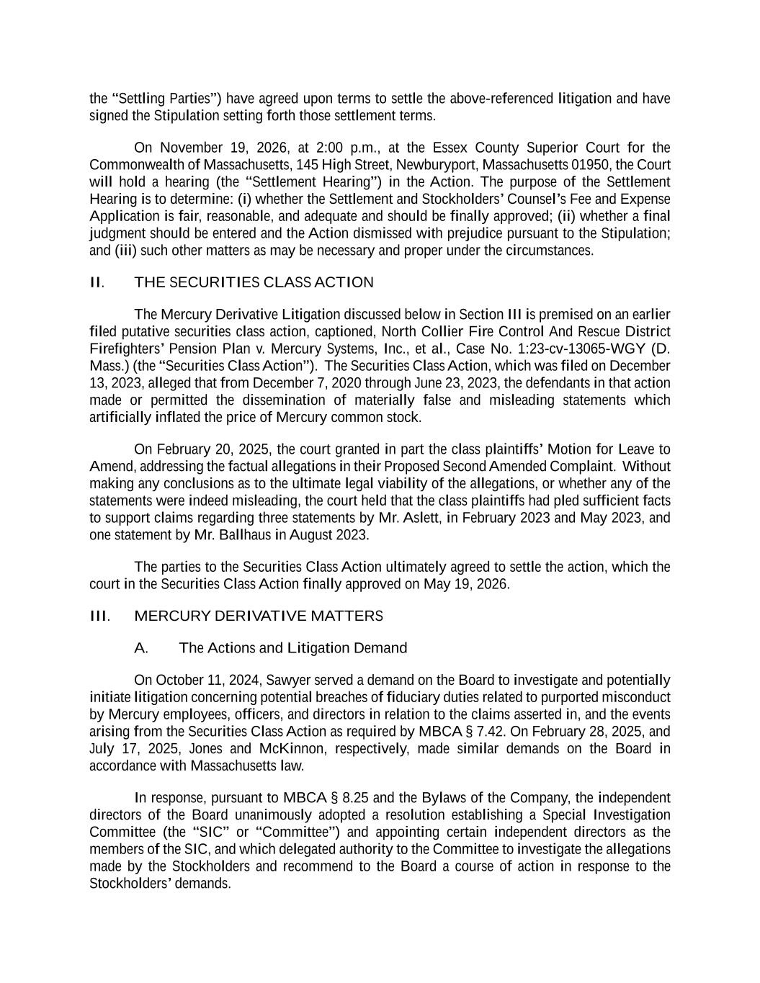
the “Settling Parties”) have agreed upon terms to settle the above-referenced litigation and have signed the Stipulation setting forth those settlement terms. On November 19, 2026, at 2:00 p.m., at the Essex County Superior Court for the Commonwealth of Massachusetts, 145 High Street, Newburyport, Massachusetts 01950, the Court will hold a hearing (the “Settlement Hearing”) in the Action. The purpose of the Settlement Hearing is to determine: (i) whether the Settlement and Stockholders’ Counsel’s Fee and Expense Application is fair, reasonable, and adequate and should be finally approved; (ii) whether a final judgment should be entered and the Action dismissed with prejudice pursuant to the Stipulation; and (iii) such other matters as may be necessary and proper under the circumstances. II. THE SECURITIES CLASS ACTION The Mercury Derivative Litigation discussed below in Section III is premised on an earlier filed putative securities class action, captioned, North Collier Fire Control And Rescue District Firefighters’ Pension Plan v. Mercury Systems, Inc., et al., Case No. 1:23-cv-13065-WGY (D. Mass.) (the “Securities Class Action”). The Securities Class Action, which was filed on December 13, 2023, alleged that from December 7, 2020 through June 23, 2023, the defendants in that action made or permitted the dissemination of materially false and misleading statements which artificially inflated the price of Mercury common stock. On February 20, 2025, the court granted in part the class plaintiffs’ Motion for Leave to Amend, addressing the factual allegations in their Proposed Second Amended Complaint. Without making any conclusions as to the ultimate legal viability of the allegations, or whether any of the statements were indeed misleading, the court held that the class plaintiffs had pled sufficient facts to support claims regarding three statements by Mr. Aslett, in February 2023 and May 2023, and one statement by Mr. Ballhaus in August 2023. The parties to the Securities Class Action ultimately agreed to settle the action, which the court in the Securities Class Action finally approved on May 19, 2026. III. MERCURY DERIVATIVE MATTERS A. The Actions and Litigation Demand On October 11, 2024, Sawyer served a demand on the Board to investigate and potentially initiate litigation concerning potential breaches of fiduciary duties related to purported misconduct by Mercury employees, officers, and directors in relation to the claims asserted in, and the events arising from the Securities Class Action as required by MBCA § 7.42. On February 28, 2025, and July 17, 2025, Jones and McKinnon, respectively, made similar demands on the Board in accordance with Massachusetts law. In response, pursuant to MBCA § 8.25 and the Bylaws of the Company, the independent directors of the Board unanimously adopted a resolution establishing a Special Investigation Committee (the “SIC” or “Committee”) and appointing certain independent directors as the members of the SIC, and which delegated authority to the Committee to investigate the allegations made by the Stockholders and recommend to the Board a course of action in response to the Stockholders’ demands.

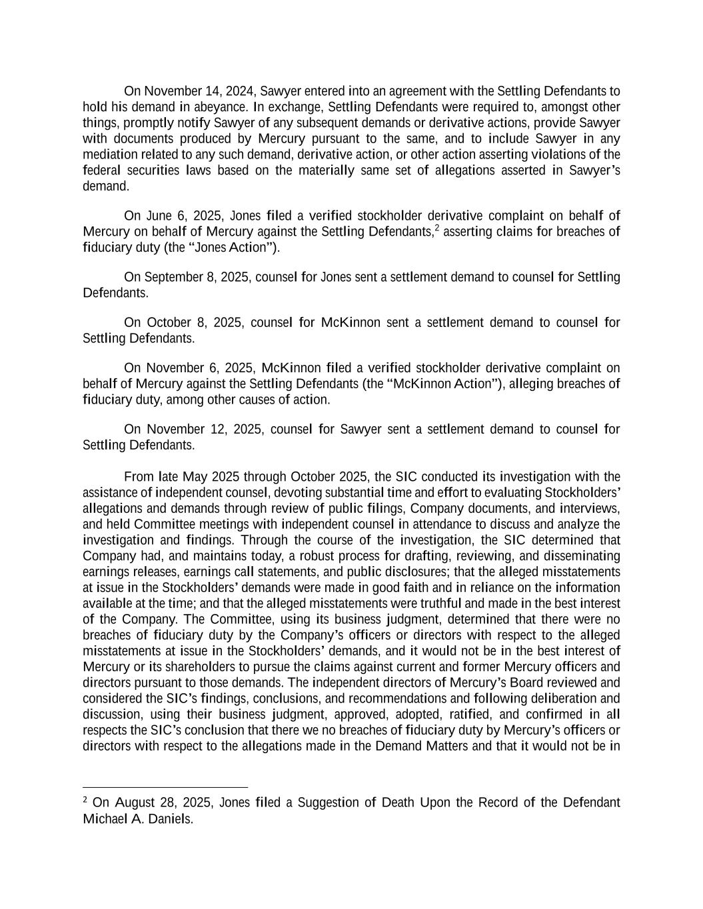
On November 14, 2024, Sawyer entered into an agreement with the Settling Defendants to hold his demand in abeyance. In exchange, Settling Defendants were required to, amongst other things, promptly notify Sawyer of any subsequent demands or derivative actions, provide Sawyer with documents produced by Mercury pursuant to the same, and to include Sawyer in any mediation related to any such demand, derivative action, or other action asserting violations of the federal securities laws based on the materially same set of allegations asserted in Sawyer’s demand. On June 6, 2025, Jones filed a verified stockholder derivative complaint on behalf of Mercury on behalf of Mercury against the Settling Defendants,2 asserting claims for breaches of fiduciary duty (the “Jones Action”). On September 8, 2025, counsel for Jones sent a settlement demand to counsel for Settling Defendants. On October 8, 2025, counsel for McKinnon sent a settlement demand to counsel for Settling Defendants. On November 6, 2025, McKinnon filed a verified stockholder derivative complaint on behalf of Mercury against the Settling Defendants (the “McKinnon Action”), alleging breaches of fiduciary duty, among other causes of action. On November 12, 2025, counsel for Sawyer sent a settlement demand to counsel for Settling Defendants. From late May 2025 through October 2025, the SIC conducted its investigation with the assistance of independent counsel, devoting substantial time and effort to evaluating Stockholders’ allegations and demands through review of public filings, Company documents, and interviews, and held Committee meetings with independent counsel in attendance to discuss and analyze the investigation and findings. Through the course of the investigation, the SIC determined that Company had, and maintains today, a robust process for drafting, reviewing, and disseminating earnings releases, earnings call statements, and public disclosures; that the alleged misstatements at issue in the Stockholders’ demands were made in good faith and in reliance on the information available at the time; and that the alleged misstatements were truthful and made in the best interest of the Company. The Committee, using its business judgment, determined that there were no breaches of fiduciary duty by the Company’s officers or directors with respect to the alleged misstatements at issue in the Stockholders’ demands, and it would not be in the best interest of Mercury or its shareholders to pursue the claims against current and former Mercury officers and directors pursuant to those demands. The independent directors of Mercury’s Board reviewed and considered the SIC’s findings, conclusions, and recommendations and following deliberation and discussion, using their business judgment, approved, adopted, ratified, and confirmed in all respects the SIC’s conclusion that there we no breaches of fiduciary duty by Mercury’s officers or directors with respect to the allegations made in the Demand Matters and that it would not be in 2 On August 28, 2025, Jones filed a Suggestion of Death Upon the Record of the Defendant Michael A. Daniels.

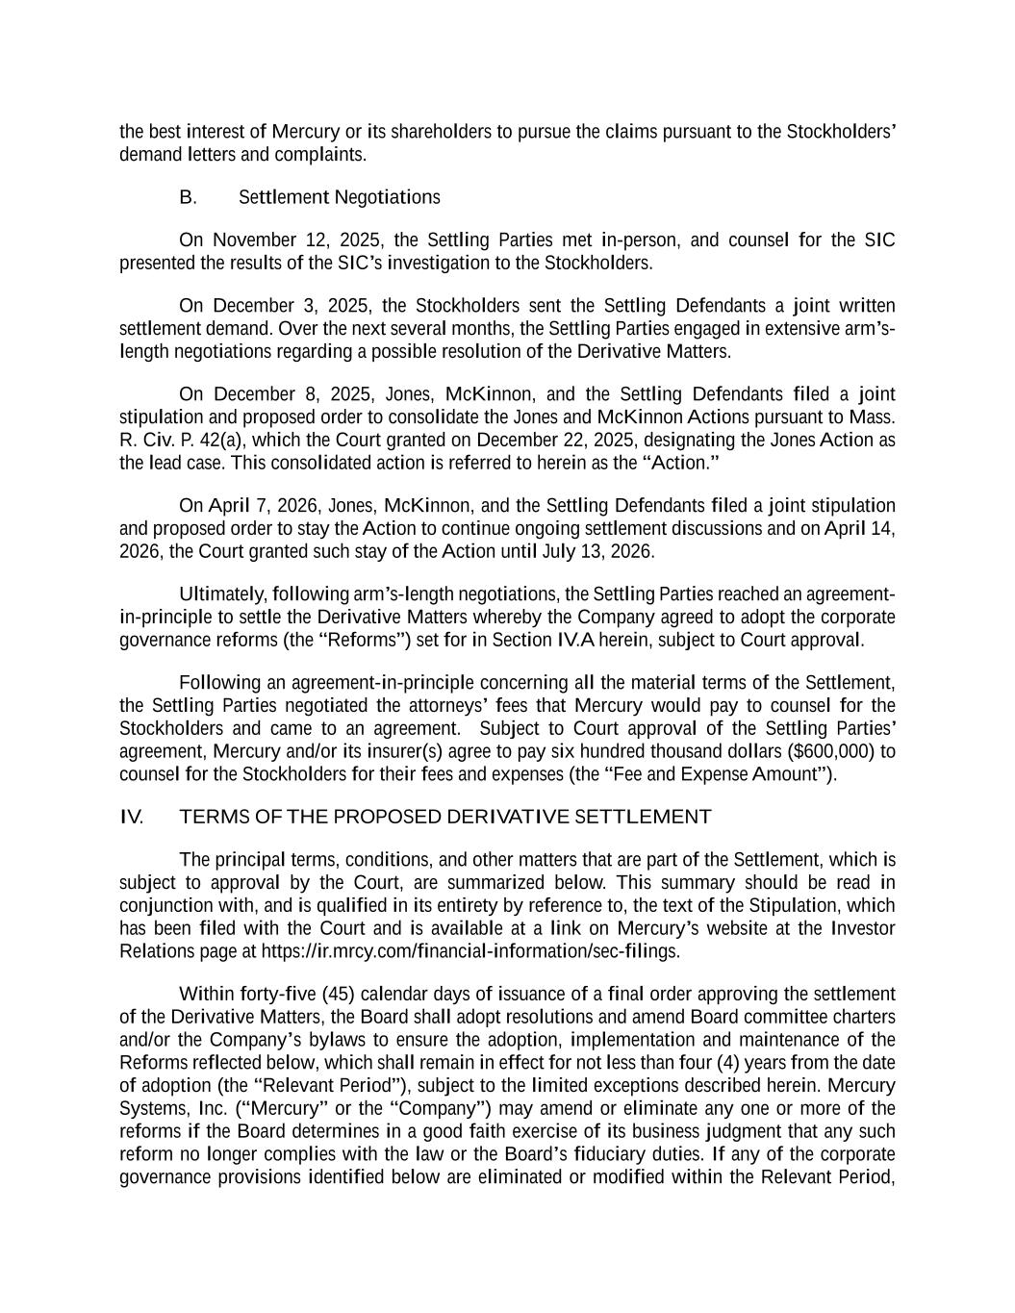
the best interest of Mercury or its shareholders to pursue the claims pursuant to the Stockholders’ demand letters and complaints. B. Settlement Negotiations On November 12, 2025, the Settling Parties met in-person, and counsel for the SIC presented the results of the SIC’s investigation to the Stockholders. On December 3, 2025, the Stockholders sent the Settling Defendants a joint written settlement demand. Over the next several months, the Settling Parties engaged in extensive arm’s- length negotiations regarding a possible resolution of the Derivative Matters. On December 8, 2025, Jones, McKinnon, and the Settling Defendants filed a joint stipulation and proposed order to consolidate the Jones and McKinnon Actions pursuant to Mass. R. Civ. P. 42(a), which the Court granted on December 22, 2025, designating the Jones Action as the lead case. This consolidated action is referred to herein as the “Action.” On April 7, 2026, Jones, McKinnon, and the Settling Defendants filed a joint stipulation and proposed order to stay the Action to continue ongoing settlement discussions and on April 14, 2026, the Court granted such stay of the Action until July 13, 2026. Ultimately, following arm’s-length negotiations, the Settling Parties reached an agreement- in-principle to settle the Derivative Matters whereby the Company agreed to adopt the corporate governance reforms (the “Reforms”) set for in Section IV.A herein, subject to Court approval. Following an agreement-in-principle concerning all the material terms of the Settlement, the Settling Parties negotiated the attorneys’ fees that Mercury would pay to counsel for the Stockholders and came to an agreement. Subject to Court approval of the Settling Parties’ agreement, Mercury and/or its insurer(s) agree to pay six hundred thousand dollars ($600,000) to counsel for the Stockholders for their fees and expenses (the “Fee and Expense Amount”). IV. TERMS OF THE PROPOSED DERIVATIVE SETTLEMENT The principal terms, conditions, and other matters that are part of the Settlement, which is subject to approval by the Court, are summarized below. This summary should be read in conjunction with, and is qualified in its entirety by reference to, the text of the Stipulation, which has been filed with the Court and is available at a link on Mercury’s website at the Investor Relations page at https://ir.mrcy.com/financial-information/sec-filings. Within forty-five (45) calendar days of issuance of a final order approving the settlement of the Derivative Matters, the Board shall adopt resolutions and amend Board committee charters and/or the Company’s bylaws to ensure the adoption, implementation and maintenance of the Reforms reflected below, which shall remain in effect for not less than four (4) years from the date of adoption (the “Relevant Period”), subject to the limited exceptions described herein. Mercury Systems, Inc. (“Mercury” or the “Company”) may amend or eliminate any one or more of the reforms if the Board determines in a good faith exercise of its business judgment that any such reform no longer complies with the law or the Board’s fiduciary duties. If any of the corporate governance provisions identified below are eliminated or modified within the Relevant Period,

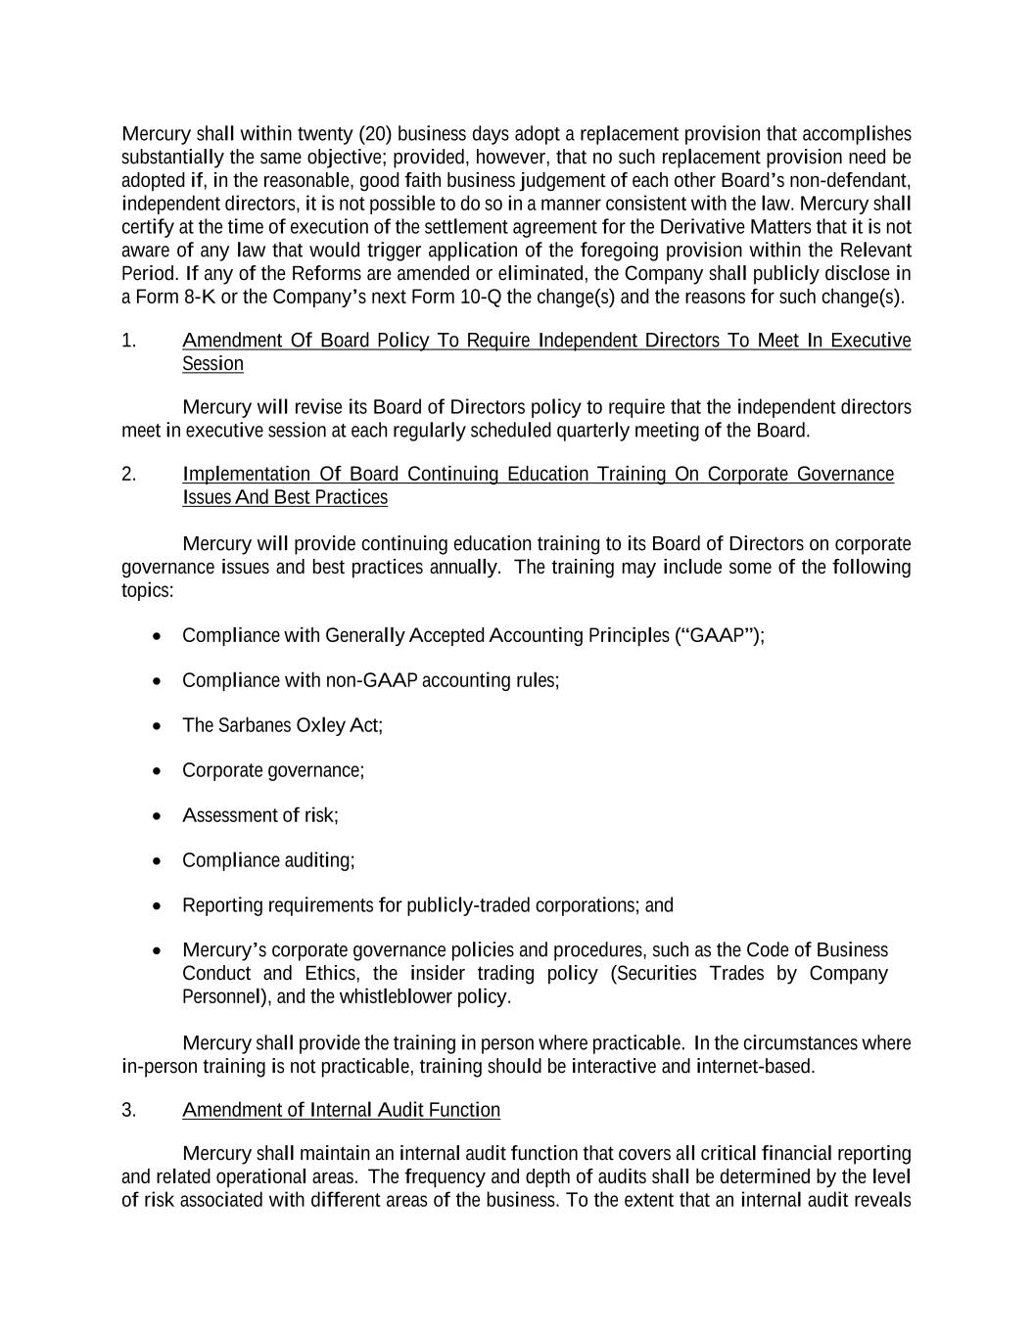
Mercury shall within twenty (20) business days adopt a replacement provision that accomplishes substantially the same objective; provided, however, that no such replacement provision need be adopted if, in the reasonable, good faith business judgement of each other Board’s non-defendant, independent directors, it is not possible to do so in a manner consistent with the law. Mercury shall certify at the time of execution of the settlement agreement for the Derivative Matters that it is not aware of any law that would trigger application of the foregoing provision within the Relevant Period. If any of the Reforms are amended or eliminated, the Company shall publicly disclose in a Form 8-K or the Company’s next Form 10-Q the change(s) and the reasons for such change(s). 1. Amendment Of Board Policy To Require Independent Directors To Meet In Executive Session Mercury will revise its Board of Directors policy to require that the independent directors meet in executive session at each regularly scheduled quarterly meeting of the Board. 2. Implementation Of Board Continuing Education Training On Corporate Governance Issues And Best Practices Mercury will provide continuing education training to its Board of Directors on corporate governance issues and best practices annually. The training may include some of the following topics: • Compliance with Generally Accepted Accounting Principles (“GAAP”); • Compliance with non-GAAP accounting rules; • The Sarbanes Oxley Act; • Corporate governance; • Assessment of risk; • Compliance auditing; • Reporting requirements for publicly-traded corporations; and • Mercury’s corporate governance policies and procedures, such as the Code of Business Conduct and Ethics, the insider trading policy (Securities Trades by Company Personnel), and the whistleblower policy. Mercury shall provide the training in person where practicable. In the circumstances where in-person training is not practicable, training should be interactive and internet-based. 3. Amendment of Internal Audit Function Mercury shall maintain an internal audit function that covers all critical financial reporting and related operational areas. The frequency and depth of audits shall be determined by the level of risk associated with different areas of the business. To the extent that an internal audit reveals

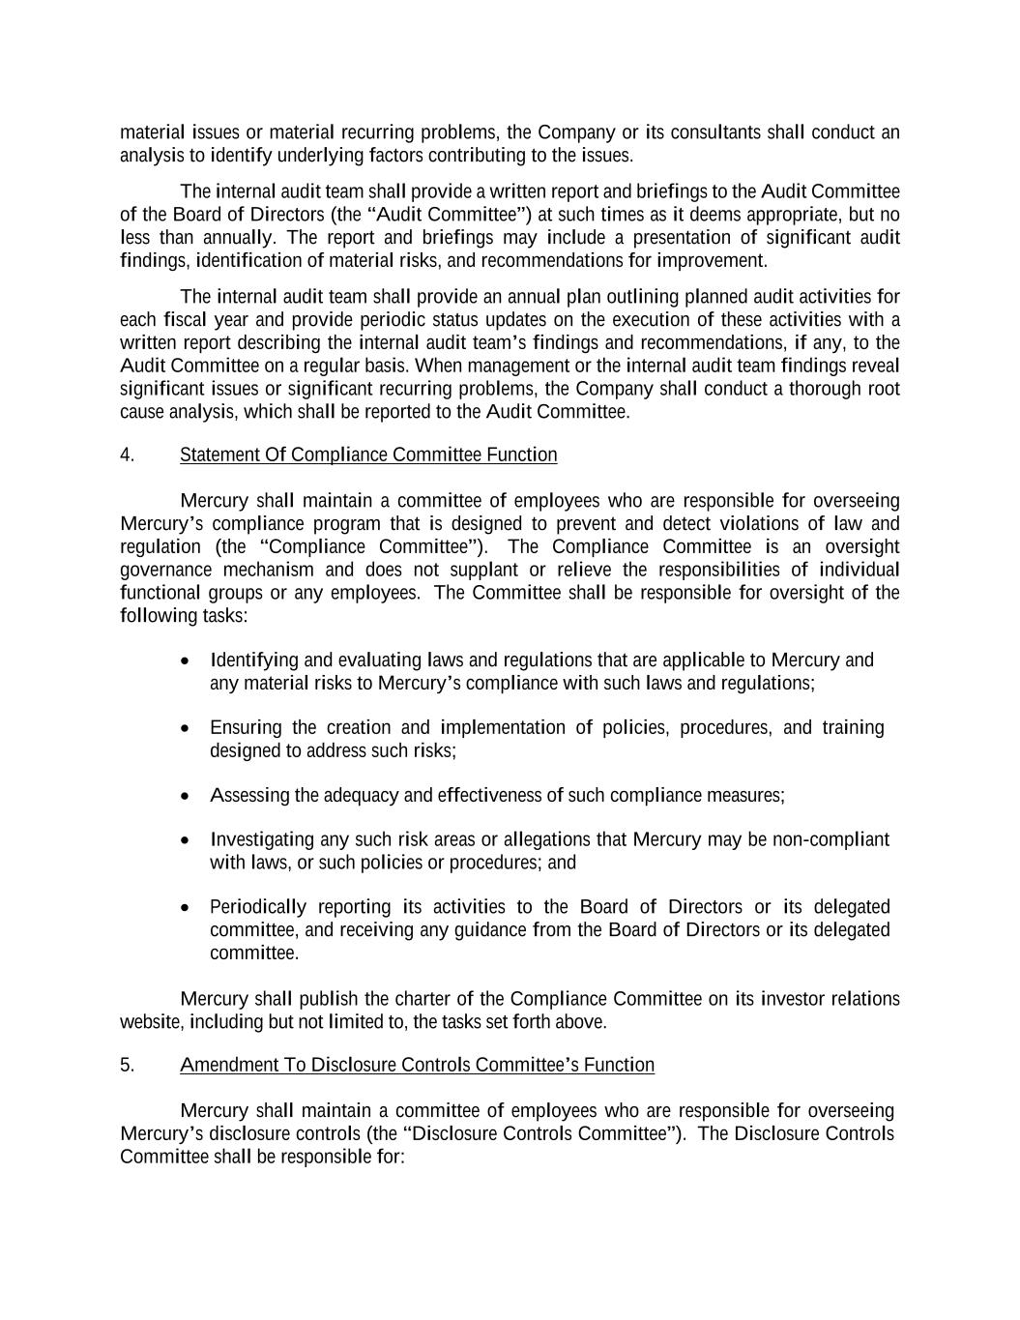
material issues or material recurring problems, the Company or its consultants shall conduct an analysis to identify underlying factors contributing to the issues. The internal audit team shall provide a written report and briefings to the Audit Committee of the Board of Directors (the “Audit Committee”) at such times as it deems appropriate, but no less than annually. The report and briefings may include a presentation of significant audit findings, identification of material risks, and recommendations for improvement. The internal audit team shall provide an annual plan outlining planned audit activities for each fiscal year and provide periodic status updates on the execution of these activities with a written report describing the internal audit team’s findings and recommendations, if any, to the Audit Committee on a regular basis. When management or the internal audit team findings reveal significant issues or significant recurring problems, the Company shall conduct a thorough root cause analysis, which shall be reported to the Audit Committee. 4. Statement Of Compliance Committee Function Mercury shall maintain a committee of employees who are responsible for overseeing Mercury’s compliance program that is designed to prevent and detect violations of law and regulation (the “Compliance Committee”). The Compliance Committee is an oversight governance mechanism and does not supplant or relieve the responsibilities of individual functional groups or any employees. The Committee shall be responsible for oversight of the following tasks: • Identifying and evaluating laws and regulations that are applicable to Mercury and any material risks to Mercury’s compliance with such laws and regulations; • Ensuring the creation and implementation of policies, procedures, and training designed to address such risks; • Assessing the adequacy and effectiveness of such compliance measures; • Investigating any such risk areas or allegations that Mercury may be non-compliant with laws, or such policies or procedures; and • Periodically reporting its activities to the Board of Directors or its delegated committee, and receiving any guidance from the Board of Directors or its delegated committee. Mercury shall publish the charter of the Compliance Committee on its investor relations website, including but not limited to, the tasks set forth above. 5. Amendment To Disclosure Controls Committee’s Function Mercury shall maintain a committee of employees who are responsible for overseeing Mercury’s disclosure controls (the “Disclosure Controls Committee”). The Disclosure Controls Committee shall be responsible for:

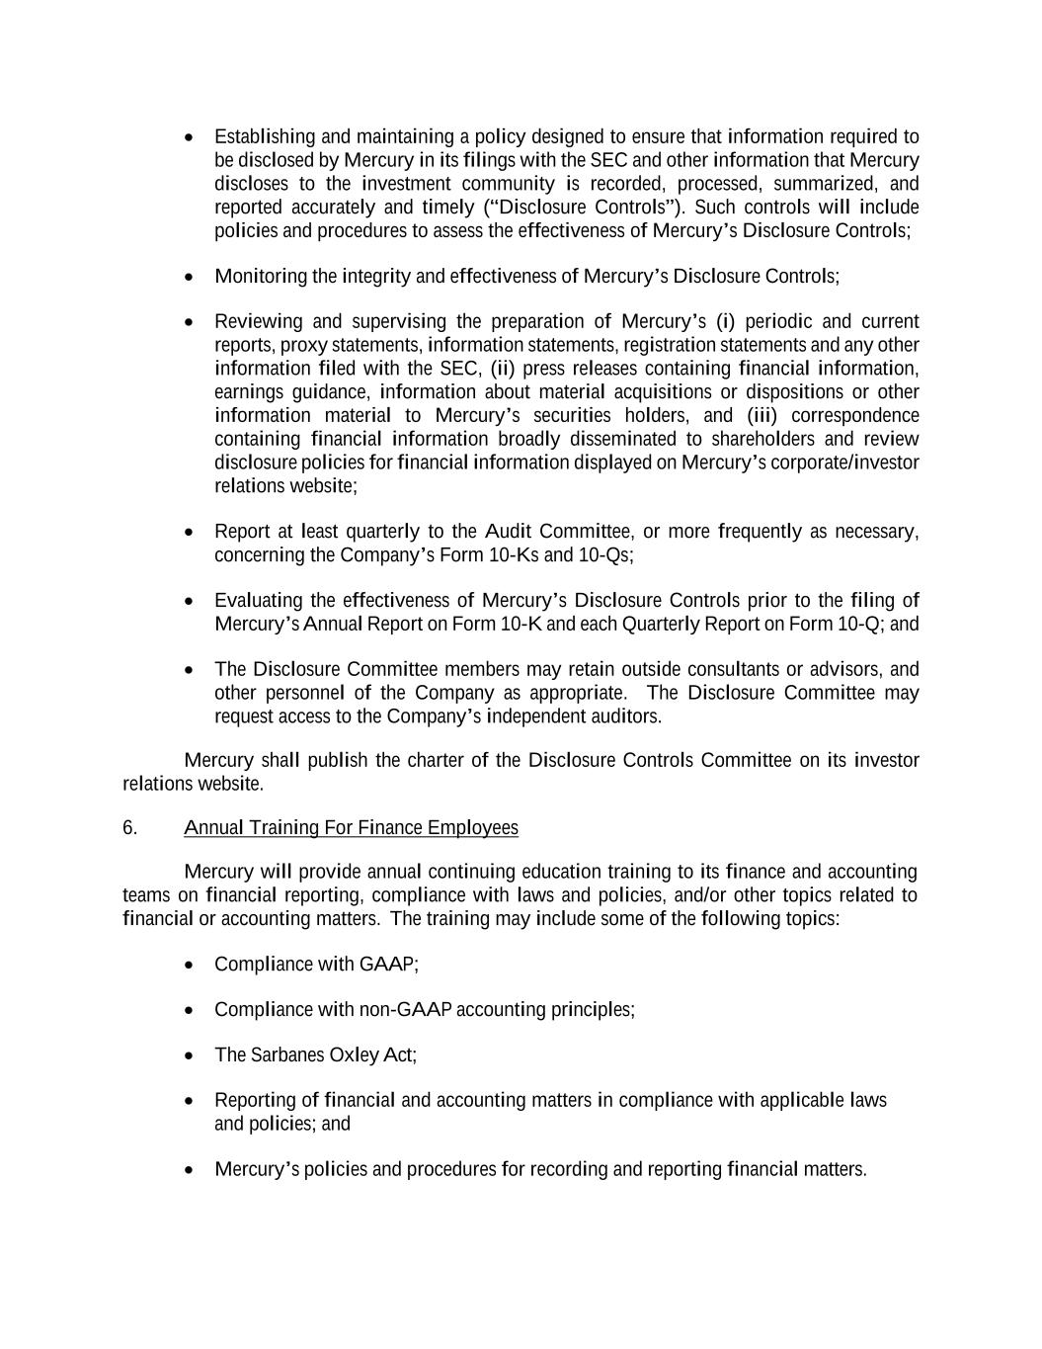
• Establishing and maintaining a policy designed to ensure that information required to be disclosed by Mercury in its filings with the SEC and other information that Mercury discloses to the investment community is recorded, processed, summarized, and reported accurately and timely (“Disclosure Controls”). Such controls will include policies and procedures to assess the effectiveness of Mercury’s Disclosure Controls; • Monitoring the integrity and effectiveness of Mercury’s Disclosure Controls; • Reviewing and supervising the preparation of Mercury’s (i) periodic and current reports, proxy statements, information statements, registration statements and any other information filed with the SEC, (ii) press releases containing financial information, earnings guidance, information about material acquisitions or dispositions or other information material to Mercury’s securities holders, and (iii) correspondence containing financial information broadly disseminated to shareholders and review disclosure policies for financial information displayed on Mercury’s corporate/investor relations website; • Report at least quarterly to the Audit Committee, or more frequently as necessary, concerning the Company’s Form 10-Ks and 10-Qs; • Evaluating the effectiveness of Mercury’s Disclosure Controls prior to the filing of Mercury’s Annual Report on Form 10-K and each Quarterly Report on Form 10-Q; and • The Disclosure Committee members may retain outside consultants or advisors, and other personnel of the Company as appropriate. The Disclosure Committee may request access to the Company’s independent auditors. Mercury shall publish the charter of the Disclosure Controls Committee on its investor relations website. 6. Annual Training For Finance Employees Mercury will provide annual continuing education training to its finance and accounting teams on financial reporting, compliance with laws and policies, and/or other topics related to financial or accounting matters. The training may include some of the following topics: • Compliance with GAAP; • Compliance with non-GAAP accounting principles; • The Sarbanes Oxley Act; • Reporting of financial and accounting matters in compliance with applicable laws and policies; and • Mercury’s policies and procedures for recording and reporting financial matters.

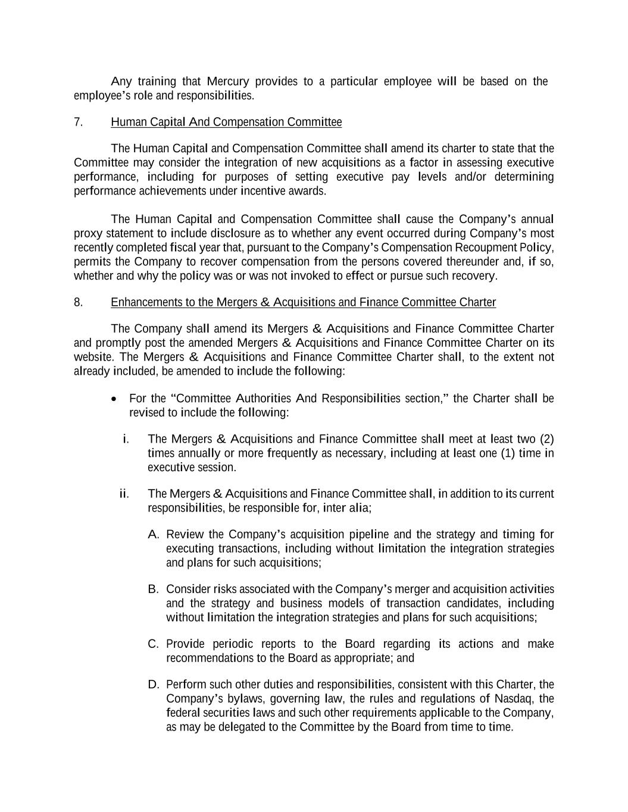
Any training that Mercury provides to a particular employee will be based on the employee’s role and responsibilities. 7. Human Capital And Compensation Committee The Human Capital and Compensation Committee shall amend its charter to state that the Committee may consider the integration of new acquisitions as a factor in assessing executive performance, including for purposes of setting executive pay levels and/or determining performance achievements under incentive awards. The Human Capital and Compensation Committee shall cause the Company’s annual proxy statement to include disclosure as to whether any event occurred during Company’s most recently completed fiscal year that, pursuant to the Company’s Compensation Recoupment Policy, permits the Company to recover compensation from the persons covered thereunder and, if so, whether and why the policy was or was not invoked to effect or pursue such recovery. 8. Enhancements to the Mergers & Acquisitions and Finance Committee Charter The Company shall amend its Mergers & Acquisitions and Finance Committee Charter and promptly post the amended Mergers & Acquisitions and Finance Committee Charter on its website. The Mergers & Acquisitions and Finance Committee Charter shall, to the extent not already included, be amended to include the following: • For the “Committee Authorities And Responsibilities section,” the Charter shall be revised to include the following: i. The Mergers & Acquisitions and Finance Committee shall meet at least two (2) times annually or more frequently as necessary, including at least one (1) time in executive session. ii. The Mergers & Acquisitions and Finance Committee shall, in addition to its current responsibilities, be responsible for, inter alia; A. Review the Company’s acquisition pipeline and the strategy and timing for executing transactions, including without limitation the integration strategies and plans for such acquisitions; B. Consider risks associated with the Company’s merger and acquisition activities and the strategy and business models of transaction candidates, including without limitation the integration strategies and plans for such acquisitions; C. Provide periodic reports to the Board regarding its actions and make recommendations to the Board as appropriate; and D. Perform such other duties and responsibilities, consistent with this Charter, the Company’s bylaws, governing law, the rules and regulations of Nasdaq, the federal securities laws and such other requirements applicable to the Company, as may be delegated to the Committee by the Board from time to time.

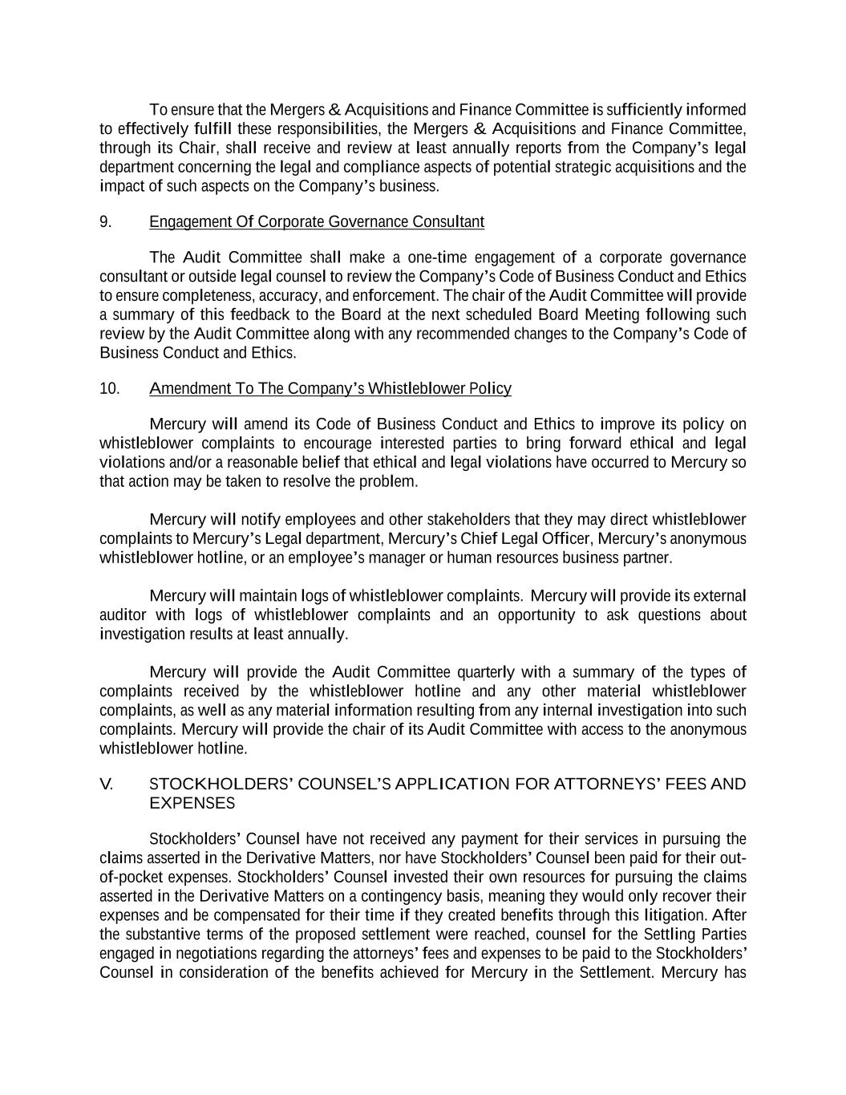
To ensure that the Mergers & Acquisitions and Finance Committee is sufficiently informed to effectively fulfill these responsibilities, the Mergers & Acquisitions and Finance Committee, through its Chair, shall receive and review at least annually reports from the Company’s legal department concerning the legal and compliance aspects of potential strategic acquisitions and the impact of such aspects on the Company’s business. 9. Engagement Of Corporate Governance Consultant The Audit Committee shall make a one-time engagement of a corporate governance consultant or outside legal counsel to review the Company’s Code of Business Conduct and Ethics to ensure completeness, accuracy, and enforcement. The chair of the Audit Committee will provide a summary of this feedback to the Board at the next scheduled Board Meeting following such review by the Audit Committee along with any recommended changes to the Company’s Code of Business Conduct and Ethics. 10. Amendment To The Company’s Whistleblower Policy Mercury will amend its Code of Business Conduct and Ethics to improve its policy on whistleblower complaints to encourage interested parties to bring forward ethical and legal violations and/or a reasonable belief that ethical and legal violations have occurred to Mercury so that action may be taken to resolve the problem. Mercury will notify employees and other stakeholders that they may direct whistleblower complaints to Mercury’s Legal department, Mercury’s Chief Legal Officer, Mercury’s anonymous whistleblower hotline, or an employee’s manager or human resources business partner. Mercury will maintain logs of whistleblower complaints. Mercury will provide its external auditor with logs of whistleblower complaints and an opportunity to ask questions about investigation results at least annually. Mercury will provide the Audit Committee quarterly with a summary of the types of complaints received by the whistleblower hotline and any other material whistleblower complaints, as well as any material information resulting from any internal investigation into such complaints. Mercury will provide the chair of its Audit Committee with access to the anonymous whistleblower hotline. V. STOCKHOLDERS’ COUNSEL’S APPLICATION FOR ATTORNEYS’ FEES AND EXPENSES Stockholders’ Counsel have not received any payment for their services in pursuing the claims asserted in the Derivative Matters, nor have Stockholders’ Counsel been paid for their out- of-pocket expenses. Stockholders’ Counsel invested their own resources for pursuing the claims asserted in the Derivative Matters on a contingency basis, meaning they would only recover their expenses and be compensated for their time if they created benefits through this litigation. After the substantive terms of the proposed settlement were reached, counsel for the Settling Parties engaged in negotiations regarding the attorneys’ fees and expenses to be paid to the Stockholders’ Counsel in consideration of the benefits achieved for Mercury in the Settlement. Mercury has

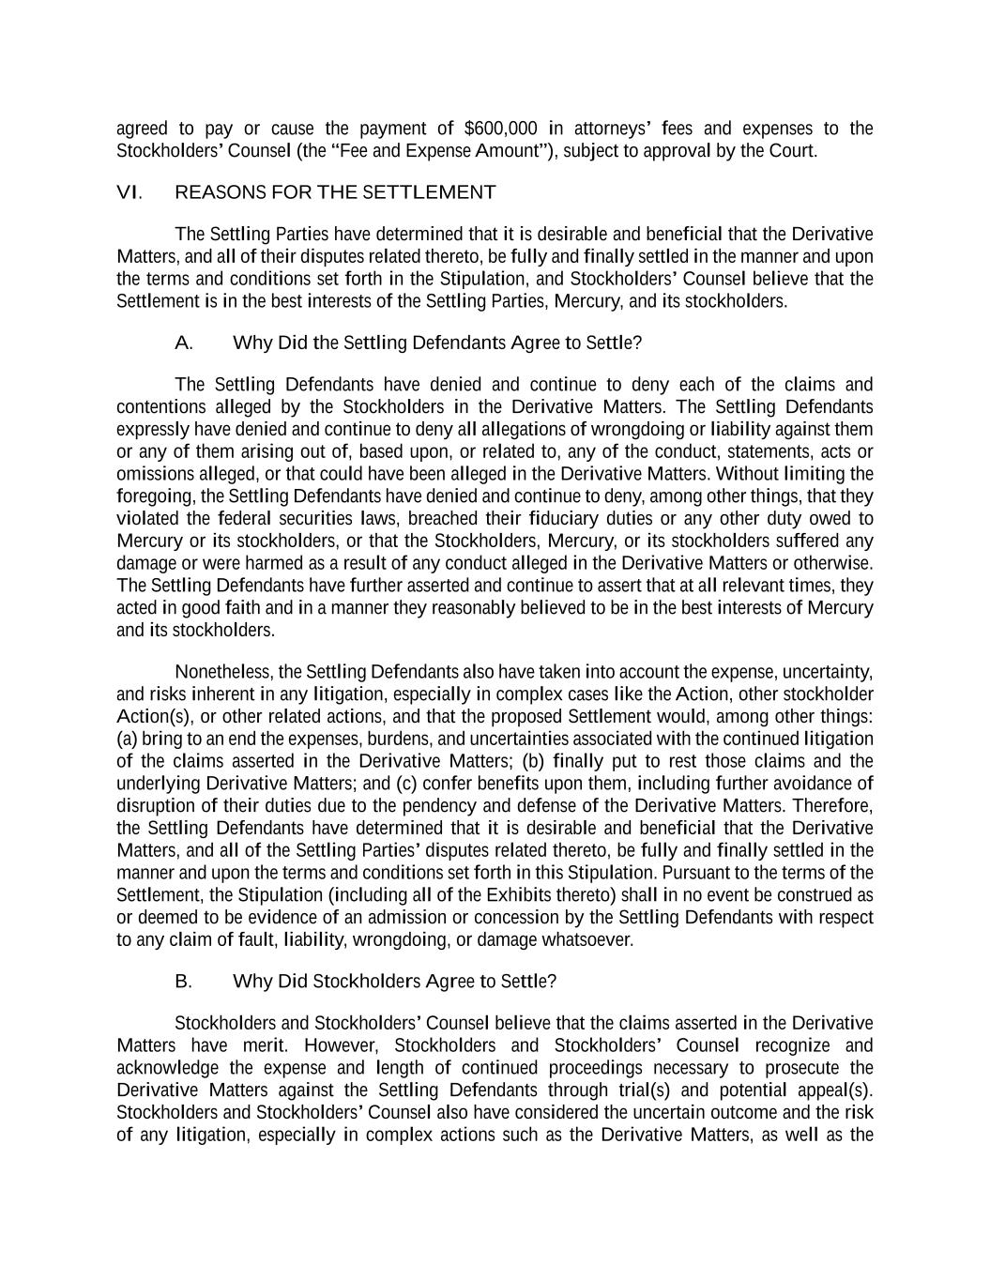
agreed to pay or cause the payment of $600,000 in attorneys’ fees and expenses to the Stockholders’ Counsel (the “Fee and Expense Amount”), subject to approval by the Court. VI. REASONS FOR THE SETTLEMENT The Settling Parties have determined that it is desirable and beneficial that the Derivative Matters, and all of their disputes related thereto, be fully and finally settled in the manner and upon the terms and conditions set forth in the Stipulation, and Stockholders’ Counsel believe that the Settlement is in the best interests of the Settling Parties, Mercury, and its stockholders. A. Why Did the Settling Defendants Agree to Settle? The Settling Defendants have denied and continue to deny each of the claims and contentions alleged by the Stockholders in the Derivative Matters. The Settling Defendants expressly have denied and continue to deny all allegations of wrongdoing or liability against them or any of them arising out of, based upon, or related to, any of the conduct, statements, acts or omissions alleged, or that could have been alleged in the Derivative Matters. Without limiting the foregoing, the Settling Defendants have denied and continue to deny, among other things, that they violated the federal securities laws, breached their fiduciary duties or any other duty owed to Mercury or its stockholders, or that the Stockholders, Mercury, or its stockholders suffered any damage or were harmed as a result of any conduct alleged in the Derivative Matters or otherwise. The Settling Defendants have further asserted and continue to assert that at all relevant times, they acted in good faith and in a manner they reasonably believed to be in the best interests of Mercury and its stockholders. Nonetheless, the Settling Defendants also have taken into account the expense, uncertainty, and risks inherent in any litigation, especially in complex cases like the Action, other stockholder Action(s), or other related actions, and that the proposed Settlement would, among other things: (a) bring to an end the expenses, burdens, and uncertainties associated with the continued litigation of the claims asserted in the Derivative Matters; (b) finally put to rest those claims and the underlying Derivative Matters; and (c) confer benefits upon them, including further avoidance of disruption of their duties due to the pendency and defense of the Derivative Matters. Therefore, the Settling Defendants have determined that it is desirable and beneficial that the Derivative Matters, and all of the Settling Parties’ disputes related thereto, be fully and finally settled in the manner and upon the terms and conditions set forth in this Stipulation. Pursuant to the terms of the Settlement, the Stipulation (including all of the Exhibits thereto) shall in no event be construed as or deemed to be evidence of an admission or concession by the Settling Defendants with respect to any claim of fault, liability, wrongdoing, or damage whatsoever. B. Why Did Stockholders Agree to Settle? Stockholders and Stockholders’ Counsel believe that the claims asserted in the Derivative Matters have merit. However, Stockholders and Stockholders’ Counsel recognize and acknowledge the expense and length of continued proceedings necessary to prosecute the Derivative Matters against the Settling Defendants through trial(s) and potential appeal(s). Stockholders and Stockholders’ Counsel also have considered the uncertain outcome and the risk of any litigation, especially in complex actions such as the Derivative Matters, as well as the

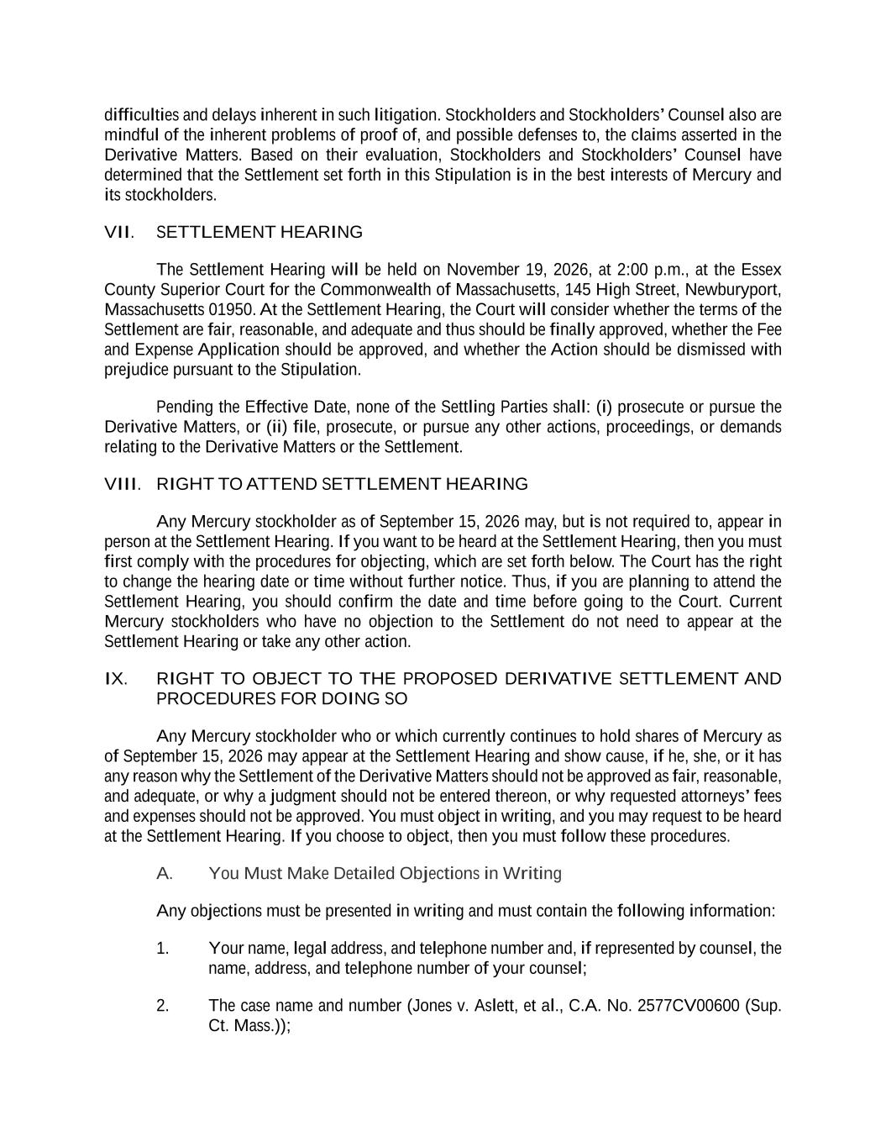
difficulties and delays inherent in such litigation. Stockholders and Stockholders’ Counsel also are mindful of the inherent problems of proof of, and possible defenses to, the claims asserted in the Derivative Matters. Based on their evaluation, Stockholders and Stockholders’ Counsel have determined that the Settlement set forth in this Stipulation is in the best interests of Mercury and its stockholders. VII. SETTLEMENT HEARING The Settlement Hearing will be held on November 19, 2026, at 2:00 p.m., at the Essex County Superior Court for the Commonwealth of Massachusetts, 145 High Street, Newburyport, Massachusetts 01950. At the Settlement Hearing, the Court will consider whether the terms of the Settlement are fair, reasonable, and adequate and thus should be finally approved, whether the Fee and Expense Application should be approved, and whether the Action should be dismissed with prejudice pursuant to the Stipulation. Pending the Effective Date, none of the Settling Parties shall: (i) prosecute or pursue the Derivative Matters, or (ii) file, prosecute, or pursue any other actions, proceedings, or demands relating to the Derivative Matters or the Settlement. VIII. RIGHT TO ATTEND SETTLEMENT HEARING Any Mercury stockholder as of September 15, 2026 may, but is not required to, appear in person at the Settlement Hearing. If you want to be heard at the Settlement Hearing, then you must first comply with the procedures for objecting, which are set forth below. The Court has the right to change the hearing date or time without further notice. Thus, if you are planning to attend the Settlement Hearing, you should confirm the date and time before going to the Court. Current Mercury stockholders who have no objection to the Settlement do not need to appear at the Settlement Hearing or take any other action. IX. RIGHT TO OBJECT TO THE PROPOSED DERIVATIVE SETTLEMENT AND PROCEDURES FOR DOING SO Any Mercury stockholder who or which currently continues to hold shares of Mercury as of September 15, 2026 may appear at the Settlement Hearing and show cause, if he, she, or it has any reason why the Settlement of the Derivative Matters should not be approved as fair, reasonable, and adequate, or why a judgment should not be entered thereon, or why requested attorneys’ fees and expenses should not be approved. You must object in writing, and you may request to be heard at the Settlement Hearing. If you choose to object, then you must follow these procedures. A. You Must Make Detailed Objections in Writing Any objections must be presented in writing and must contain the following information: 1. Your name, legal address, and telephone number and, if represented by counsel, the name, address, and telephone number of your counsel; 2. The case name and number (Jones v. Aslett, et al., C.A. No. 2577CV00600 (Sup. Ct. Mass.));

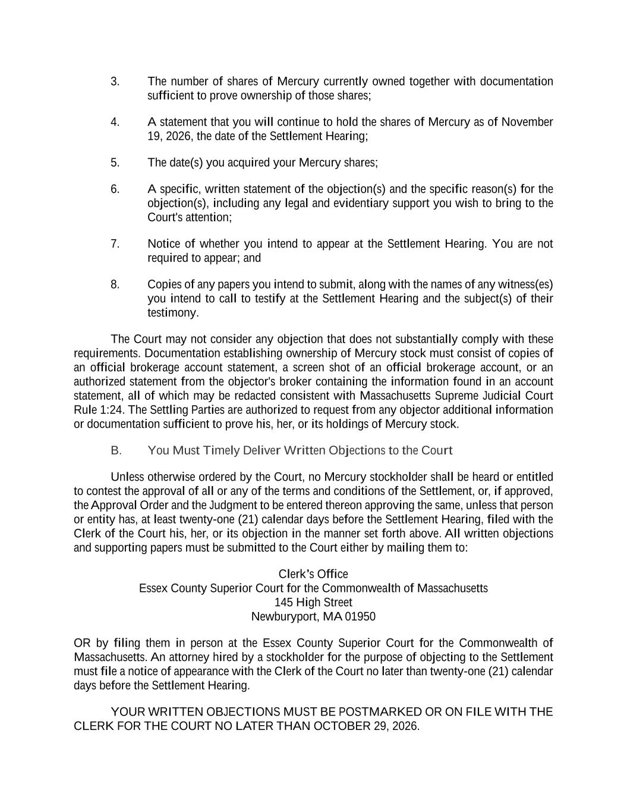
3. The number of shares of Mercury currently owned together with documentation sufficient to prove ownership of those shares; 4. A statement that you will continue to hold the shares of Mercury as of November 19, 2026, the date of the Settlement Hearing; 5. The date(s) you acquired your Mercury shares; 6. A specific, written statement of the objection(s) and the specific reason(s) for the objection(s), including any legal and evidentiary support you wish to bring to the Court's attention; 7. Notice of whether you intend to appear at the Settlement Hearing. You are not required to appear; and 8. Copies of any papers you intend to submit, along with the names of any witness(es) you intend to call to testify at the Settlement Hearing and the subject(s) of their testimony. The Court may not consider any objection that does not substantially comply with these requirements. Documentation establishing ownership of Mercury stock must consist of copies of an official brokerage account statement, a screen shot of an official brokerage account, or an authorized statement from the objector's broker containing the information found in an account statement, all of which may be redacted consistent with Massachusetts Supreme Judicial Court Rule 1:24. The Settling Parties are authorized to request from any objector additional information or documentation sufficient to prove his, her, or its holdings of Mercury stock. B. You Must Timely Deliver Written Objections to the Court Unless otherwise ordered by the Court, no Mercury stockholder shall be heard or entitled to contest the approval of all or any of the terms and conditions of the Settlement, or, if approved, the Approval Order and the Judgment to be entered thereon approving the same, unless that person or entity has, at least twenty-one (21) calendar days before the Settlement Hearing, filed with the Clerk of the Court his, her, or its objection in the manner set forth above. All written objections and supporting papers must be submitted to the Court either by mailing them to: Clerk’s Office Essex County Superior Court for the Commonwealth of Massachusetts 145 High Street Newburyport, MA 01950 OR by filing them in person at the Essex County Superior Court for the Commonwealth of Massachusetts. An attorney hired by a stockholder for the purpose of objecting to the Settlement must file a notice of appearance with the Clerk of the Court no later than twenty-one (21) calendar days before the Settlement Hearing. YOUR WRITTEN OBJECTIONS MUST BE POSTMARKED OR ON FILE WITH THE CLERK FOR THE COURT NO LATER THAN OCTOBER 29, 2026.

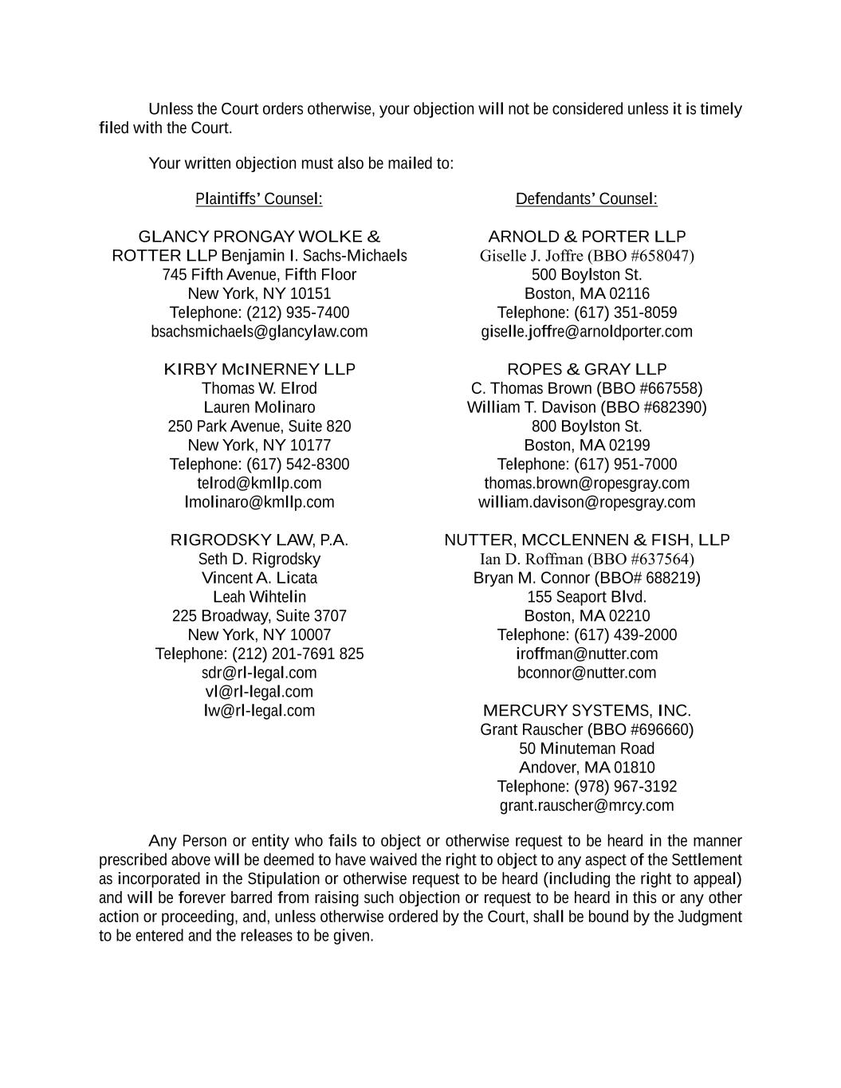
Unless the Court orders otherwise, your objection will not be considered unless it is timely filed with the Court. Your written objection must also be mailed to: Plaintiffs’ Counsel: Defendants’ Counsel: GLANCY PRONGAY WOLKE & ROTTER LLP Benjamin I. Sachs-Michaels 745 Fifth Avenue, Fifth Floor New York, NY 10151 Telephone: (212) 935-7400 bsachsmichaels@glancylaw.com ARNOLD & PORTER LLP Giselle J. Joffre (BBО #658047) 500 Boylston St. Boston, MA 02116 Telephone: (617) 351-8059 giselle.joffre@arnoldporter.com KIRBY McINERNEY LLP Thomas W. Elrod Lauren Molinaro 250 Park Avenue, Suite 820 New York, NY 10177 Telephone: (617) 542-8300 telrod@kmllp.com lmolinaro@kmllp.com ROPES & GRAY LLP C. Thomas Brown (BBO #667558) William T. Davison (BBO #682390) 800 Boylston St. Boston, MA 02199 Telephone: (617) 951-7000 thomas.brown@ropesgray.com william.davison@ropesgray.com RIGRODSKY LAW, P.A. Seth D. Rigrodsky Vincent A. Licata Leah Wihtelin 225 Broadway, Suite 3707 New York, NY 10007 Telephone: (212) 201-7691 825 sdr@rl-legal.com vl@rl-legal.com lw@rl-legal.com NUTTER, MCCLENNEN & FISH, LLP Ian D. Roffman (BBО #637564) Bryan M. Connor (BBO# 688219) 155 Seaport Blvd. Boston, MA 02210 Telephone: (617) 439-2000 iroffman@nutter.com bconnor@nutter.com MERCURY SYSTEMS, INC. Grant Rauscher (BBO #696660) 50 Minuteman Road Andover, MA 01810 Telephone: (978) 967-3192 grant.rauscher@mrcy.com Any Person or entity who fails to object or otherwise request to be heard in the manner prescribed above will be deemed to have waived the right to object to any aspect of the Settlement as incorporated in the Stipulation or otherwise request to be heard (including the right to appeal) and will be forever barred from raising such objection or request to be heard in this or any other action or proceeding, and, unless otherwise ordered by the Court, shall be bound by the Judgment to be entered and the releases to be given.

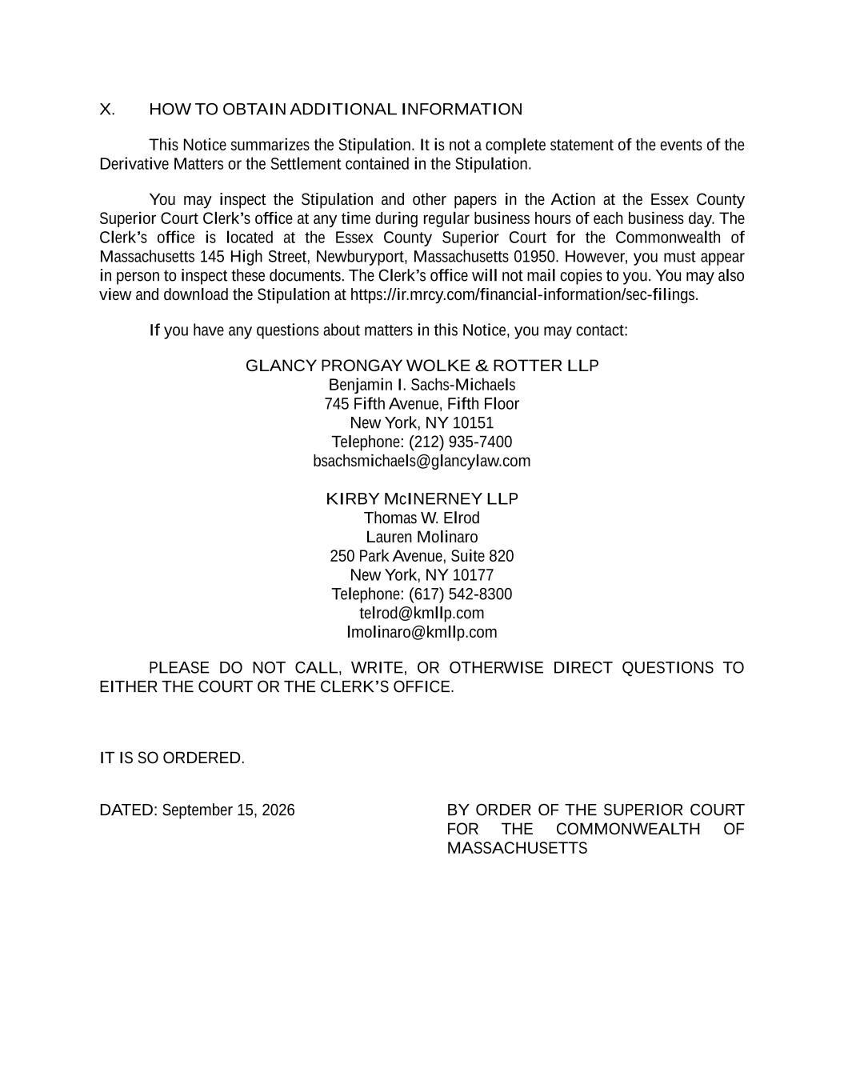
X. HOW TO OBTAIN ADDITIONAL INFORMATION This Notice summarizes the Stipulation. It is not a complete statement of the events of the Derivative Matters or the Settlement contained in the Stipulation. You may inspect the Stipulation and other papers in the Action at the Essex County Superior Court Clerk’s office at any time during regular business hours of each business day. The Clerk’s office is located at the Essex County Superior Court for the Commonwealth of Massachusetts 145 High Street, Newburyport, Massachusetts 01950. However, you must appear in person to inspect these documents. The Clerk’s office will not mail copies to you. You may also view and download the Stipulation at https://ir.mrcy.com/financial-information/sec-filings. If you have any questions about matters in this Notice, you may contact: GLANCY PRONGAY WOLKE & ROTTER LLP Benjamin I. Sachs-Michaels 745 Fifth Avenue, Fifth Floor New York, NY 10151 Telephone: (212) 935-7400 bsachsmichaels@glancylaw.com KIRBY McINERNEY LLP Thomas W. Elrod Lauren Molinaro 250 Park Avenue, Suite 820 New York, NY 10177 Telephone: (617) 542-8300 telrod@kmllp.com lmolinaro@kmllp.com PLEASE DO NOT CALL, WRITE, OR OTHERWISE DIRECT QUESTIONS TO EITHER THE COURT OR THE CLERK’S OFFICE. IT IS SO ORDERED. DATED: September 15, 2026 BY ORDER OF THE SUPERIOR COURT FOR THE COMMONWEALTH OF MASSACHUSETTS

