UNITED STATES
SECURITIES AND EXCHANGE COMMISSION
WASHINGTON, DC 20549
FORM 8-K
CURRENT REPORT
PURSUANT TO SECTION 13 OR 15(d) OF THE
SECURITIES EXCHANGE ACT OF 1934
Date of report (Date of earliest event reported): September 16, 2026
Mercury Systems, Inc.
(Exact Name of Registrant as Specified in its Charter)

Massachusetts |  |  |  |  |  | 001-41194 |  |  |  |  |  | 04-2741391
(State or Other Jurisdiction  of Incorporation) |  |  |  |  |  | (Commission File Number) |  |  |  |  |  | (IRS Employer  Identification No.)

50 Minuteman Road, |  |  | Andover, |  |  | Massachusetts |  |  |  |  |  | 01810
(Address of Principal Executive Offices) |  |  |  |  |  |  |  |  |  |  |  | (Zip Code)
Registrant’s telephone number, including area code: (978) 256-1300
Not Applicable
(Former Name or Former Address, if Changed Since Last Report)
Check the appropriate box below if the Form 8-K filing is intended to simultaneously satisfy the filing obligation of the registrant under any of the following provisions (see General Instruction A.2. below):

☐ |  |  | Written communications pursuant to Rule 425 under the Securities Act (17 CFR 230.425)
☐ |  |  | Soliciting material pursuant to Rule 14a-12 under the Exchange Act (17 CFR 240.14a-12)
☐ |  |  | Pre-commencement communications pursuant to Rule 14d-2(b) under the Exchange Act (17 CFR 240.14d-2(b))
☐ |  |  | Pre-commencement communications pursuant to Rule 13e-4(c) under the Exchange Act (17 CFR 240.13e-4(c))
Indicate by check mark whether the registrant is an emerging growth company as defined in Rule 405 of the Securities Act of 1933 (§230.405 of this chapter) or Rule 12b-2 of the Securities Exchange Act of 1934 (§240.12b-2 of this chapter).
Emerging growth company ☐

If an emerging growth company, indicate by check mark if the registrant has elected not to use the extended transition period for complying with any new or revised financial accounting standards provided pursuant to Section 13(a) of the Exchange Act. ☐
Securities registered pursuant to Section 12(b) of the Act:
Title of each class |  |  | Trading Symbol(s) |  |  | Name of each exchange on which registered
Common Stock, par value $0.01 |  |  | MRCY |  |  | Nasdaq Global Select Market

Item 1.01 Entry into a Material Definitive Agreement.

On September 15, 2026, the independent directors on the Board of Directors of Mercury Systems, Inc. (the “Company”), upon the recommendation of the Human Capital and Compensation Committee, approved Amendment No. 2 to the Employment Agreement for William L. Ballhaus, the Company’s Chairman and Chief Executive Officer. The amendment extends the initial term of the agreement to August 15, 2030. The Employment Agreement is otherwise unchanged by the amendment.

The foregoing description of the Amendment No. 2 to the Employment Agreement does not purport to be complete and is qualified in its entirety by reference to the full text of the Amendment No. 2, which is filed as Exhibit 10.1 to this Current Report on Form 8-K and is incorporated by reference into this Item 1.01.

Item 7.01 Regulation FD Disclosure.

On September 16, 2026, the Company issued a press release that announced the extension of Mr. Ballhaus’s employment agreement to August 15, 2030, and reaffirmed the financial guidance issued on the Company’s earnings call on August 18, 2026. A copy of the press release is attached hereto as Exhibit 99.1 and is incorporated into this Item 7.01 by reference.

The information contained in this Item 7.01, including Exhibit 99.1 attached hereto, is being furnished and shall not be deemed “filed” for purposes of Section 18 of the Securities Exchange Act of 1934, as amended (the “Exchange Act”), or otherwise subject to the liabilities of that section, nor shall it be deemed incorporated by reference in any filing under the Securities Act of 1933, as amended, or the Exchange Act, except as shall be expressly set forth by specific reference in such a filing.

Item 9.01. Financial Statements and Exhibits.

(d) Exhibits.

Exhibit No. |  |  | Description
10.1 |  |  | Amendment No 2. to Employment Agreement, dated September 15, 2026, between the Company and William L. Ballhaus
99.1 |  |  | Press Release dated September 16, 2026
104 |  |  | Cover Page Interactive Data File (embedded within the Inline XBRL document)

SIGNATURES
Pursuant to the requirements of the Securities Exchange Act of 1934, the registrant has duly caused this report to be signed on its behalf by the undersigned thereunto duly authorized.
Dated: September 16, 2026 |  |  | MERCURY SYSTEMS, INC.
By: /s/ David E. Farnsworth
David E. Farnsworth
Executive Vice President, Chief Financial Officer
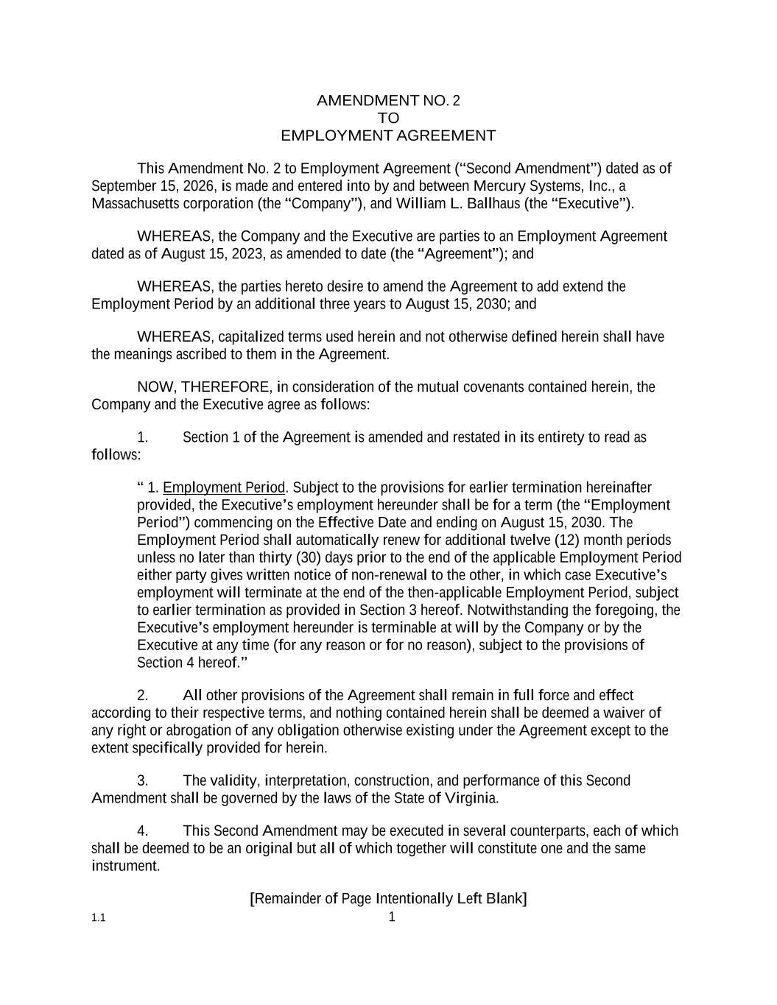

1.1 1 AMENDMENT NO. 2 TO EMPLOYMENT AGREEMENT This Amendment No. 2 to Employment Agreement (“Second Amendment”) dated as of September 15, 2026, is made and entered into by and between Mercury Systems, Inc., a Massachusetts corporation (the “Company”), and William L. Ballhaus (the “Executive”). WHEREAS, the Company and the Executive are parties to an Employment Agreement dated as of August 15, 2023, as amended to date (the “Agreement”); and WHEREAS, the parties hereto desire to amend the Agreement to add extend the Employment Period by an additional three years to August 15, 2030; and WHEREAS, capitalized terms used herein and not otherwise defined herein shall have the meanings ascribed to them in the Agreement. NOW, THEREFORE, in consideration of the mutual covenants contained herein, the Company and the Executive agree as follows: 1. Section 1 of the Agreement is amended and restated in its entirety to read as follows: “ 1. Employment Period. Subject to the provisions for earlier termination hereinafter provided, the Executive’s employment hereunder shall be for a term (the “Employment Period”) commencing on the Effective Date and ending on August 15, 2030. The Employment Period shall automatically renew for additional twelve (12) month periods unless no later than thirty (30) days prior to the end of the applicable Employment Period either party gives written notice of non-renewal to the other, in which case Executive’s employment will terminate at the end of the then-applicable Employment Period, subject to earlier termination as provided in Section 3 hereof. Notwithstanding the foregoing, the Executive’s employment hereunder is terminable at will by the Company or by the Executive at any time (for any reason or for no reason), subject to the provisions of Section 4 hereof.” 2. All other provisions of the Agreement shall remain in full force and effect according to their respective terms, and nothing contained herein shall be deemed a waiver of any right or abrogation of any obligation otherwise existing under the Agreement except to the extent specifically provided for herein. 3. The validity, interpretation, construction, and performance of this Second Amendment shall be governed by the laws of the State of Virginia. 4. This Second Amendment may be executed in several counterparts, each of which shall be deemed to be an original but all of which together will constitute one and the same instrument. [Remainder of Page Intentionally Left Blank]

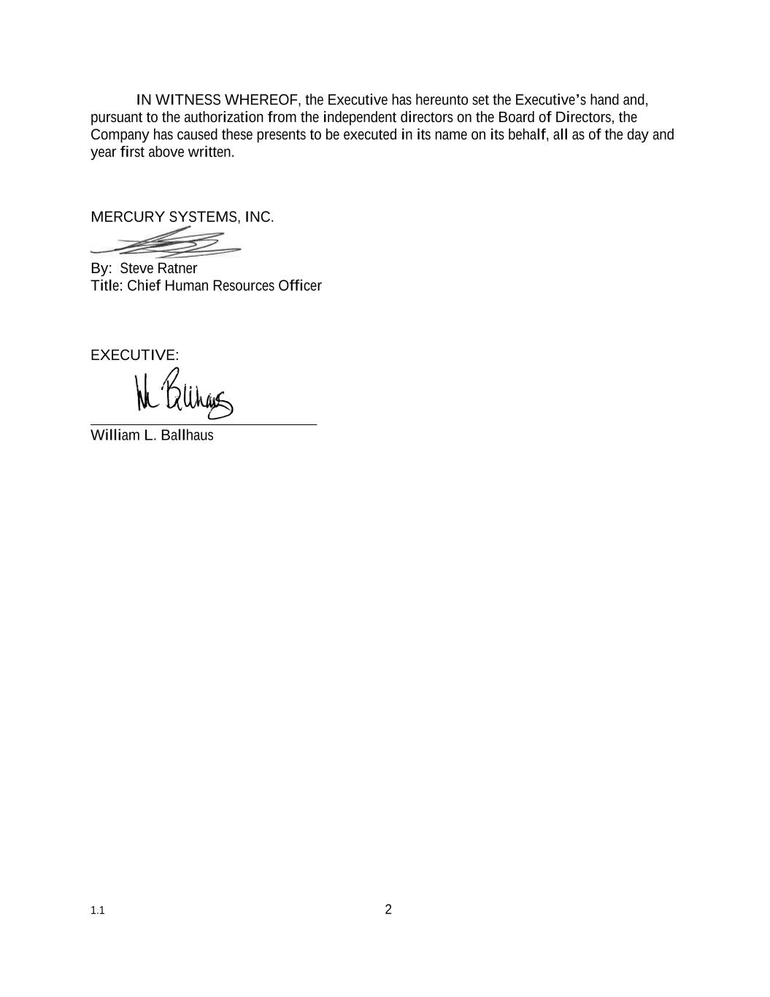
1.1 2 IN WITNESS WHEREOF, the Executive has hereunto set the Executive’s hand and, pursuant to the authorization from the independent directors on the Board of Directors, the Company has caused these presents to be executed in its name on its behalf, all as of the day and year first above written. MERCURY SYSTEMS, INC. By: Steve Ratner Title: Chief Human Resources Officer EXECUTIVE: William L. Ballhaus

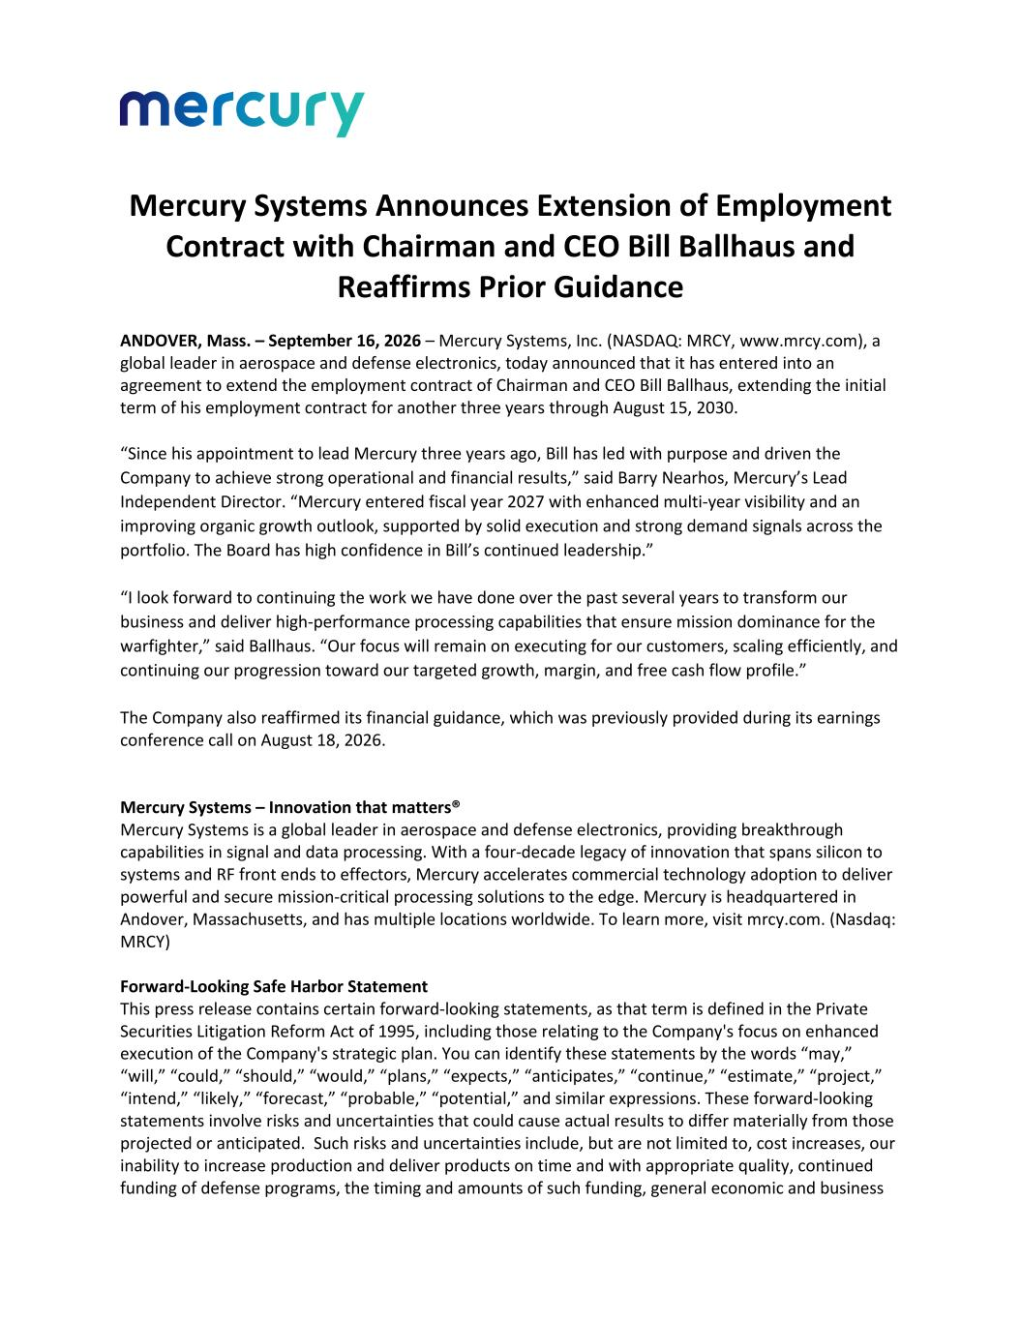
Mercury Systems Announces Extension of Employment Contract with Chairman and CEO Bill Ballhaus and Reaffirms Prior Guidance ANDOVER, Mass. – September 16, 2026 – Mercury Systems, Inc. (NASDAQ: MRCY, www.mrcy.com), a global leader in aerospace and defense electronics, today announced that it has entered into an agreement to extend the employment contract of Chairman and CEO Bill Ballhaus, extending the initial term of his employment contract for another three years through August 15, 2030. “Since his appointment to lead Mercury three years ago, Bill has led with purpose and driven the Company to achieve strong operational and financial results,” said Barry Nearhos, Mercury’s Lead Independent Director. “Mercury entered fiscal year 2027 with enhanced multi-year visibility and an improving organic growth outlook, supported by solid execution and strong demand signals across the portfolio. The Board has high confidence in Bill’s continued leadership.” “I look forward to continuing the work we have done over the past several years to transform our business and deliver high-performance processing capabilities that ensure mission dominance for the warfighter,” said Ballhaus. “Our focus will remain on executing for our customers, scaling efficiently, and continuing our progression toward our targeted growth, margin, and free cash flow profile.” The Company also reaffirmed its financial guidance, which was previously provided during its earnings conference call on August 18, 2026. Mercury Systems – Innovation that matters® Mercury Systems is a global leader in aerospace and defense electronics, providing breakthrough capabilities in signal and data processing. With a four-decade legacy of innovation that spans silicon to systems and RF front ends to effectors, Mercury accelerates commercial technology adoption to deliver powerful and secure mission-critical processing solutions to the edge. Mercury is headquartered in Andover, Massachusetts, and has multiple locations worldwide. To learn more, visit mrcy.com. (Nasdaq: MRCY) Forward-Looking Safe Harbor Statement This press release contains certain forward-looking statements, as that term is defined in the Private Securities Litigation Reform Act of 1995, including those relating to the Company's focus on enhanced execution of the Company's strategic plan. You can identify these statements by the words “may,” “will,” “could,” “should,” “would,” “plans,” “expects,” “anticipates,” “continue,” “estimate,” “project,” “intend,” “likely,” “forecast,” “probable,” “potential,” and similar expressions. These forward-looking statements involve risks and uncertainties that could cause actual results to differ materially from those projected or anticipated. Such risks and uncertainties include, but are not limited to, cost increases, our inability to increase production and deliver products on time and with appropriate quality, continued funding of defense programs, the timing and amounts of such funding, general economic and business

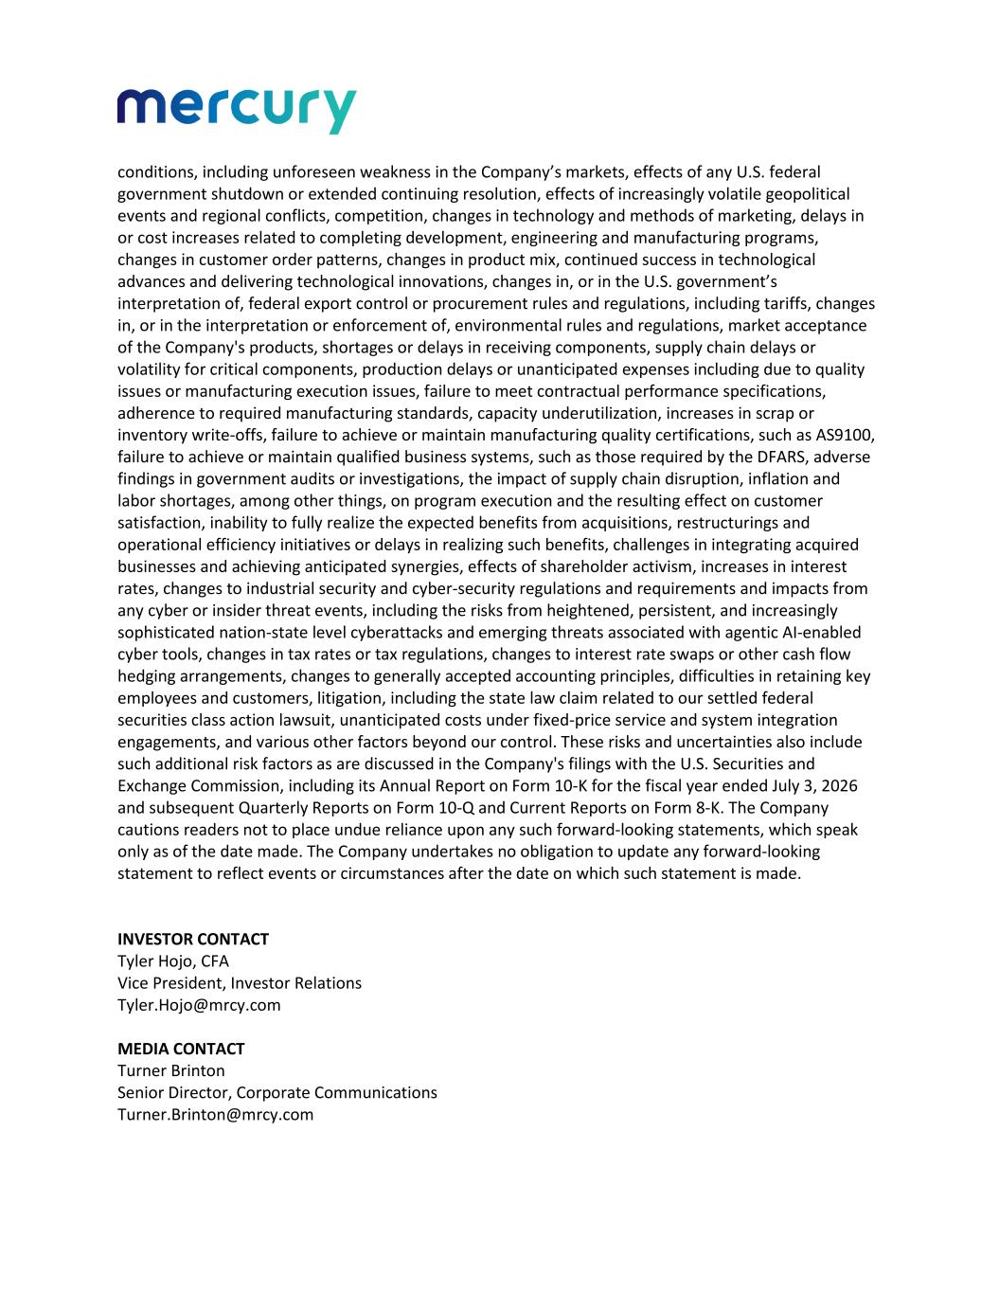
conditions, including unforeseen weakness in the Company’s markets, effects of any U.S. federal government shutdown or extended continuing resolution, effects of increasingly volatile geopolitical events and regional conflicts, competition, changes in technology and methods of marketing, delays in or cost increases related to completing development, engineering and manufacturing programs, changes in customer order patterns, changes in product mix, continued success in technological advances and delivering technological innovations, changes in, or in the U.S. government’s interpretation of, federal export control or procurement rules and regulations, including tariffs, changes in, or in the interpretation or enforcement of, environmental rules and regulations, market acceptance of the Company's products, shortages or delays in receiving components, supply chain delays or volatility for critical components, production delays or unanticipated expenses including due to quality issues or manufacturing execution issues, failure to meet contractual performance specifications, adherence to required manufacturing standards, capacity underutilization, increases in scrap or inventory write-offs, failure to achieve or maintain manufacturing quality certifications, such as AS9100, failure to achieve or maintain qualified business systems, such as those required by the DFARS, adverse findings in government audits or investigations, the impact of supply chain disruption, inflation and labor shortages, among other things, on program execution and the resulting effect on customer satisfaction, inability to fully realize the expected benefits from acquisitions, restructurings and operational efficiency initiatives or delays in realizing such benefits, challenges in integrating acquired businesses and achieving anticipated synergies, effects of shareholder activism, increases in interest rates, changes to industrial security and cyber-security regulations and requirements and impacts from any cyber or insider threat events, including the risks from heightened, persistent, and increasingly sophisticated nation-state level cyberattacks and emerging threats associated with agentic AI-enabled cyber tools, changes in tax rates or tax regulations, changes to interest rate swaps or other cash flow hedging arrangements, changes to generally accepted accounting principles, difficulties in retaining key employees and customers, litigation, including the state law claim related to our settled federal securities class action lawsuit, unanticipated costs under fixed-price service and system integration engagements, and various other factors beyond our control. These risks and uncertainties also include such additional risk factors as are discussed in the Company's filings with the U.S. Securities and Exchange Commission, including its Annual Report on Form 10-K for the fiscal year ended July 3, 2026 and subsequent Quarterly Reports on Form 10-Q and Current Reports on Form 8-K. The Company cautions readers not to place undue reliance upon any such forward-looking statements, which speak only as of the date made. The Company undertakes no obligation to update any forward-looking statement to reflect events or circumstances after the date on which such statement is made. INVESTOR CONTACT Tyler Hojo, CFA Vice President, Investor Relations Tyler.Hojo@mrcy.com MEDIA CONTACT Turner Brinton Senior Director, Corporate Communications Turner.Brinton@mrcy.com

